Get Started with UI5 Web Components for React
Bootstrap the app with the Vite template
UI5 Web Components for React provides various templates for starting your project. In this tutorial, we’ll use the Vite template.
Navigate to a folder where you want to create your Web App and open a terminal there. Then use the following command:
Shell
Copy
npx degit UI5/webcomponents-react/templates/vite-ts#main my-app
cd my-app
npm i
These commands sets up a Vite project, creating a React Application with TypeScript and incorporating all essential dependencies for UI5 Web Components for React.

- Create your new root component
  - Open the current directory with an editor of your choice (e.g. Visual Studio Code).
  - Inside your project folder, navigate to src. There, create a new file and name it MyApp.tsx.
  - Now, add the following lines of code to MyApp.tsx.
TypeScript / TSX
Copy
export function MyApp() {
return <div>My root component</div>;
}
- Structure of a React component
- This is a very simple component, but it already shows you the basic structure of all components. The file starts with the import statements in the first few lines. Then, the component will be defined as a function (React docs) in PascalCase notation. This function starts the definitions of the props and the logic, we’ll add them in a later tutorial, and ends by returning JSX or HTML components in a return statement.
- With this you created your first React component. To actually render the component you will have to add it to your src/App.tsx.
- Done
- STEP 3
Embed your new component
  - In App.tsx remove everything except for the React.Fragment (<></>) and the App component itself.
TypeScript / TSX
Copy
function App() {
return (<></>);
}

export default App;
  - Import your created component.
TypeScript / TSX
Copy
import { MyApp } from "./MyApp";
  - Add the component to the return value of App().
TypeScript / TSX
Copy
function App() {
return (
<>
<MyApp />
</>
);
}
Note that <MyApp /> is using a self-closing syntax and is equivalent to <MyApp></MyApp>. All tags in JSX must be closed explicitly, this applies to HTML tags (like img) and custom JSX tags. Here you can find out more about JSX in general.
  - Open main.tsx. This is your entry file, let’s take a look at the content in more detail.
Your file should look like this:
TypeScript / TSX
Copy
import '@ui5/webcomponents-react/dist/Assets.js';
import { ThemeProvider } from '@ui5/webcomponents-react';
import { StrictMode } from 'react';
import { createRoot } from 'react-dom/client';
import App from './App.tsx';
import './index.css';

createRoot(document.getElementById('root') as HTMLElement).render(
<StrictMode>
<ThemeProvider>
<App />
</ThemeProvider>
</StrictMode>
);
    - Assets.js': This includes assets like translation files (CLDR), theming, etc. of the required packages.
    - ThemeProvider: Inter alia, this provider makes your app react to theme and language changes and injects the CSS of used components.
    - StrictMode: The React StrictMode component enables addition development behaviors and warnings for the component tree inside. It is not required, but using it helps find common pitfalls and bugs in development. You can find out more about it here.
    - createRoot: This function lets you create the React root to display React components inside a browser DOM node (React docs). You will usually add this DOM node inside the index.html file.
    - App: A React component.
    - index.css: Global CSS file.
Done
- STEP 4
Launch the app to start developing
Now you can start the app in development mode. Execute the following command from the root directory of the project.
Shell
Copy
npm run dev
Open http://localhost:5173 to view it in the browser.

The page will automatically reload if you make changes to the code. You will see the build errors and lint warnings in the console.
TIP: You can put a browser window next to the editor in your screen to see the changes live in action.
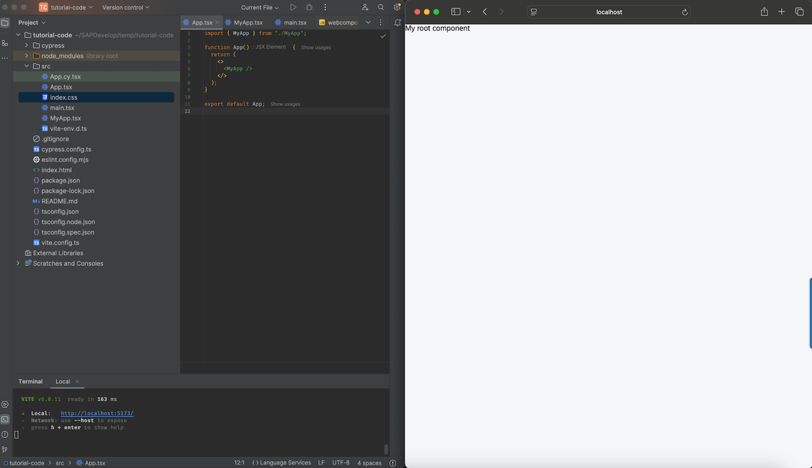

- Add components to MyApp.tsx
First you need to import the components you want to use.
You can check out all available components in the Storybook. Take your time to play around a little, change some props and take a look at the coding.
  - Start with importing a Card component into your MyApp.tsx file.
TypeScript / TSX
Copy
import { Card } from "@ui5/webcomponents-react";
  - So, you imported the Card component. Now it’s time to use it. Replace the content of your <div> with a <Card>.
In the Storybook, you can see that Cards can receive different props. For now only add some text as children.
TypeScript / TSX
Copy
<div>
<Card>This is the content area of the Card</Card>
</div>
Your webpage should now look like this.
And the file like this:
TypeScript / TSX
Copy
import { Card } from "@ui5/webcomponents-react";

export function MyApp() {
return (
<div>
<Card>This is the content area of the Card</Card>
</div>
);
}
Done
- STEP 2
Add content to the Card component
The heading area of the Card component is empty, this is because it didn’t receive the header prop. The header prop expects another component, the CardHeader.
  - Import the CardHeader.
TypeScript / TSX
Copy
import { Card, CardHeader } from "@ui5/webcomponents-react";
  - Add the CardHeader component to your Card and give it a title by setting the titleText prop:
TypeScript / TSX
Copy
<div>
<Card header={<CardHeader titleText="Card" />}>
This is the content area of the Card
</Card>
</div>
  - Our template applies the SAP defined font-family for all texts that don’t implement font-family themselves. (see index.css file) To enable this on a single text without using CSS, you can use the Text component. Let’s wrap the text content of the Card inside the Text component:
TypeScript / TSX
Copy
import { Card, CardHeader, Text } from "@ui5/webcomponents-react";
TypeScript / TSX
Copy
<div>
<Card header={<CardHeader titleText="Card" />}>
<Text>This is the content area of the Card</Text>
</Card>
</div>
Done
- STEP 3
Style your component
In this step, we will only apply inline-styling.You can also style your component using CSS (modules), but this and many more information regarding the styling approach of UI5 Web Components (for React) will be covered in chapter six of the tutorial series.
The Card now spreads across the whole screen, this behavior is intended, so it takes up the whole space of its container.
  - To restrict the width of the Card, add the style prop.
TypeScript / TSX
Copy
<Card header={<CardHeader titleText="Card" />} style={{ width: "300px" }}>
<Text>This is the content area of the Card</Text>
</Card>
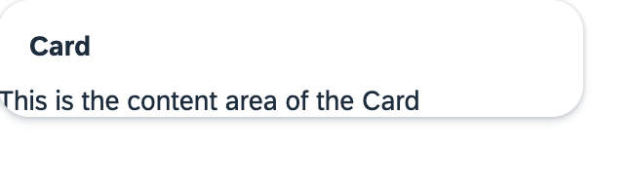
  - The content of the card is way too close to the border of the Card, so a padding is needed. You can define your own spacing, or use the standard SAP spacing variables. In this example we’re using one of the global CSS Variables from the theming-base-content repo, which are already included when using UI5 Web Components.
The CSS var in question is --sapContent_Space_S (1rem) and we’re going to apply it via inline-style again:
TypeScript / TSX
Copy
<Text style={{padding: "var(--sapContent_Space_S)"}}>
This is the content area of the Card
</Text>
Hereby you get a standardized content-padding.
After this step MyApp.tsx should look like this:
TypeScript / TSX
Copy
import { Card, CardHeader, Text } from "@ui5/webcomponents-react";

export function MyApp() {
return (
<div>
<Card header={<CardHeader titleText="Card" />} style={{ width: "300px" }}>
<Text style={{ padding: "var(--sapContent_Space_S)" }}>
This is the content area of the Card
</Text>
</Card>
</div>
);
}
And your application like this:
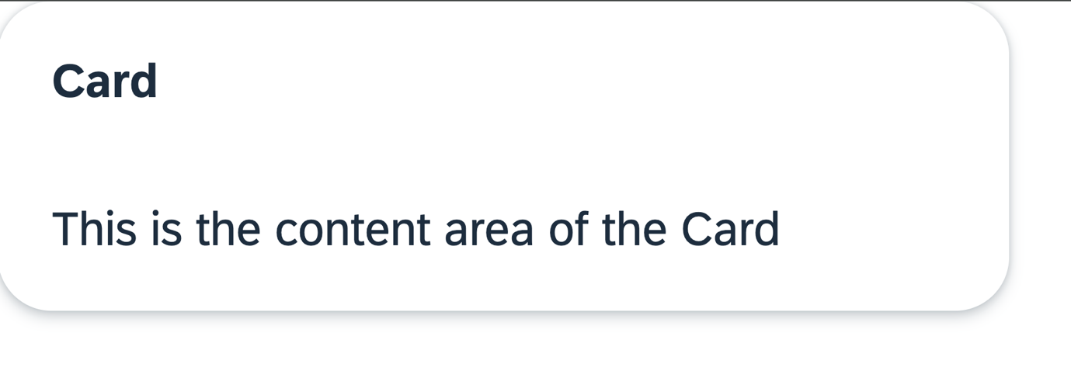
Done
- STEP 4
Event handling
  - The Card header can also be interactive, to enable this set interactive to true.
TypeScript / TSX
Copy
<Card
header={<CardHeader titleText="Card" interactive />}
...
</Card>
We didn’t pass a value to interactive, because it defaults to true if the value is omitted.
When you now click or focus the header, the appropriate styles are applied, so users know they can interact with it.
  - To make the header react to a click (or SPACE/ENTER press), add a function as value to the onClick prop.
TypeScript / TSX
Copy
<Card
header={
<CardHeader
titleText="Card"
interactive
onClick={handleHeaderClick}
/>
}
...
</Card>
  - Now, add the callback function right in the beginning of the component (definition function):
TypeScript / TSX
Copy
export function MyApp() {
const handleHeaderClick = () => {
alert("Header clicked");
};
...
The file should now look like this:
TypeScript / TSX
Copy
import { Card, CardHeader, Text } from "@ui5/webcomponents-react";

export function MyApp() {
const handleHeaderClick = () => {
alert("Header clicked");
};
return (
<div>
<Card
header={
<CardHeader
titleText="Card"
interactive
onClick={handleHeaderClick}
/>
}
style={{ width: "300px" }}
>
<Text style={{ padding: "var(--sapContent_Space_S)" }}>
This is the content area of the Card
</Text>
</Card>
</div>
);
}
- Install module and import charts
  - Install the chart library of UI5 Web Components for React.
Shell
Copy
npm install @ui5/webcomponents-react-charts
Note:When facing issues with installing, please ensure you’re using the same minor version as the other @ui5/webcomponents... packages.
  - Then, import LineChart and BarChart into MyApp.tsx.
TypeScript / TSX
Copy
import { BarChart, LineChart } from "@ui5/webcomponents-react-charts";
- Done
- STEP 2
Add charts to Card component
Charts only offer limited accessibility support with only basic built-in features, so it’s essential to ensure your implementation meets the accessibility standards of your application!
  - Start with the LineChart. You can add it underneath the Text component. Then pass the dimensions and measures prop with an empty array as value.
TypeScript / TSX
Copy
<Text style={{ padding: "var(--sapContent_Space_S)" }}>
This is the content area of the Card
</Text>
<LineChart measures={[]} dimensions={[]} />
Now you should see a placeholder for the LineChart within the Card content. The reason for this is that the chart has not received any data and therefore the placeholder is displayed.
  - Add data to your component. Since data is static you can define it outside the component, right above your MyApp component.
TypeScript / TSX
Copy
const dataset = [
{
month: "January",
data: 65
},
{
month: "February",
data: 59
},
{
month: "March",
data: 80
},
{
month: "April",
data: 81
},
{
month: "May",
data: 56
},
{
month: "June",
data: 55
},
{
month: "July",
data: 40
}
];
  - Now add the dataset to your LineChart and configure the dimensions and measures props.
TypeScript / TSX
Copy
<LineChart
dimensions={[{ accessor: "month" }]}
measures={[{ accessor: "data", label: "Price" }]}
dataset={dataset}
/>
Congratulation, you implemented your first Chart component.
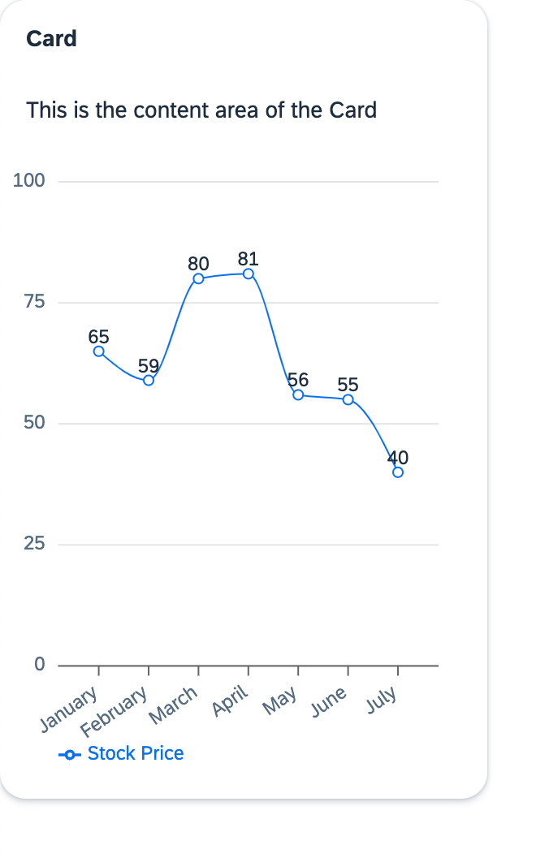
  - Add a BarChart to the Card.
We want the same data just with a different representation, therefore you can use the same props as you did with the LineChart.
TypeScript / TSX
Copy
<BarChart
dimensions={[{ accessor: "month" }]}
measures={[{ accessor: "data", label: "Price" }]}
dataset={dataset}
/>
Two charts are rendered now with equal datasets but different representation.
Your MyApp.tsx component should look like this:
TypeScript / TSX
Copy
import { Card, CardHeader, Text } from "@ui5/webcomponents-react";
import { BarChart, LineChart } from "@ui5/webcomponents-react-charts";

const dataset = [
{
month: "January",
data: 65,
},
{
month: "February",
data: 59,
},
{
month: "March",
data: 80,
},
{
month: "April",
data: 81,
},
{
month: "May",
data: 56,
},
{
month: "June",
data: 55,
},
{
month: "July",
data: 40,
},
];

export function MyApp() {
const handleHeaderClick = () => {
alert("Header clicked");
};
return (
<div>
<Card
header={
<CardHeader
titleText="Card"
interactive
onClick={handleHeaderClick}
/>
}
style={{ width: "300px" }}
>
<Text style={{ padding: "var(--sapContent_Space_S)" }}>
This is the content area of the Card
</Text>
<LineChart
dimensions={[{ accessor: "month" }]}
measures={[{ accessor: "data", label: "Price" }]}
dataset={dataset}
/>
<BarChart
dimensions={[{ accessor: "month" }]}
measures={[{ accessor: "data", label: "Price" }]}
dataset={dataset}
/>
</Card>
</div>
);
}
Done
- STEP 3
Add conditional rendering
Two charts in one Card is a bit too much, don’t you think? It would be nicer if the charts could be toggled by clicking on the header. Let’s implement that!
  - First add a state. It should control, which chart is going to be rendered. Use the State Hook logic to implement the state and set "lineChart" as default value. Don’t forget to import useState from React, otherwise you will get an error.
    - Import the useState function in the header of the MyApp.tsx file.
TypeScript / TSX
Copy
import { useState } from "react";
    - Use the useState function in the right after you start to define the MyApp function (before the click handler).
TypeScript / TSX
Copy
const [toggleCharts, setToggleCharts] = useState("lineChart");
  - By clicking on the CardHeader the state should be set corresponding to the chart which should be displayed.
Rewrite your onClick function so it will handle this logic.
TypeScript / TSX
Copy
const handleHeaderClick = () => {
if (toggleCharts === "lineChart") {
setToggleCharts("barChart");
} else {
setToggleCharts("lineChart");
}
};
  - To only render the current chart, add the following lines to the render of the component:
TypeScript / TSX
Copy
<Card
header={
<CardHeader
titleText="Card"
interactive
onClick={handleHeaderClick}
/>
}
style={{ width: "300px" }}
>
<Text style={spacing.sapUiContentPadding}>
This is the content area of the Card
</Text>
{toggleCharts === "lineChart" ? (
<LineChart
dimensions={[{ accessor: "month" }]}
measures={[{ accessor: "data", label: "Price" }]}
dataset={dataset}
/>
) : (
<BarChart
dimensions={[{ accessor: "month" }]}
measures={[{ accessor: "data", label: "Price" }]}
dataset={dataset}
/>
)}
</Card>
Done! Now you can toggle between charts by clicking on the header of the Card.
  - You can further improve your CardHeader component by using the avatar prop and adding an Icon to it.
Add the following import to your component:
TypeScript / TSX
Copy
import { Card, CardHeader, Text, Icon } from "@ui5/webcomponents-react";
Icons can be imported altogether (import '@ui5/webcomponents-icons/dist/AllIcons.js';), but to reduce bundle size and for better maintainability, it’s recommended importing each icon on its own:
TypeScript / TSX
Copy
import lineChartIcon from '@ui5/webcomponents-icons/dist/line-chart.js';
import barChartIcon from '@ui5/webcomponents-icons/dist/horizontal-bar-chart.js';
The Icons should also be conditionally rendered. Luckily, this is easy:
Add the avatar prop to the CardHeader, which receives an Icon as value:
TypeScript / TSX
Copy
<CardHeader
...
avatar={<Icon name={lineChartIcon} />}
/>
Then, change the name prop of the Icon to the following:
TypeScript / TSX
Copy
<CardHeader
avatar={ <Icon name={ toggleCharts === "lineChart" ? lineChartIcon : barChartIcon } /> }
...
/>
Here we go! Now the Card also changes the Icon by clicking on the header.
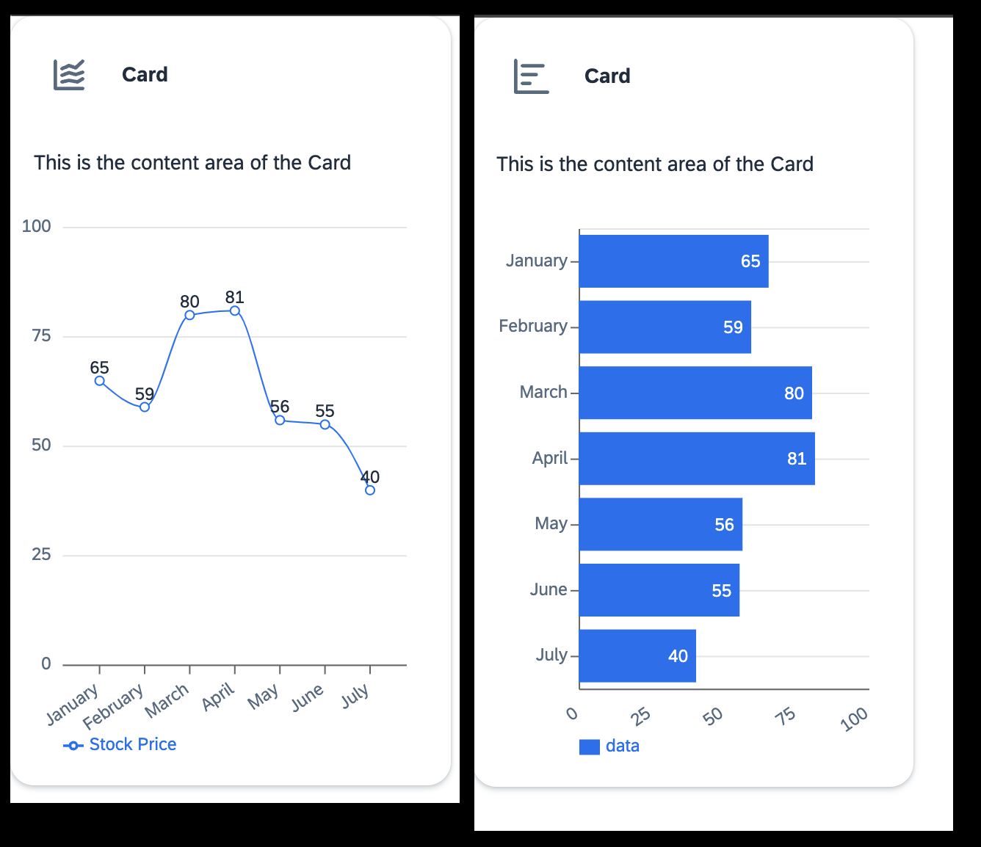
If something went wrong you can compare your component to this code snippet:
TypeScript / TSX
Copy
import lineChartIcon from "@ui5/webcomponents-icons/dist/line-chart.js";
import barChartIcon from "@ui5/webcomponents-icons/dist/horizontal-bar-chart.js";
import { useState } from "react";
import { Card, CardHeader, Text, Icon } from "@ui5/webcomponents-react";
import { BarChart, LineChart } from "@ui5/webcomponents-react-charts";

const dataset = [
{
month: "January",
data: 65,
},
{
month: "February",
data: 59,
},
{
month: "March",
data: 80,
},
{
month: "April",
data: 81,
},
{
month: "May",
data: 56,
},
{
month: "June",
data: 55,
},
{
month: "July",
data: 40,
},
];

export function MyApp() {
const [toggleCharts, setToggleCharts] = useState("lineChart");
const [loading, setLoading] = useState(false);

const handleHeaderClick = () => {
if (toggleCharts === "lineChart") {
setLoading(true);
setTimeout(() => {
setLoading(false);
setToggleCharts("barChart");
}, 2000);
} else {
setLoading(true);
setTimeout(() => {
setLoading(false);
setToggleCharts("lineChart");
}, 2000);
}
};

return (
<div>
<Card
header={
<CardHeader
titleText="Card"
interactive
avatar={
<Icon
name={
toggleCharts === "lineChart" ? lineChartIcon : barChartIcon
}
/>
}
onClick={handleHeaderClick}
/>
}
style={{ width: "300px" }}
>
<Text style={{ padding: "var(--sapContent_Space_S)" }}>
This is the content area of the Card
</Text>
{toggleCharts === "lineChart" ? (
<LineChart
dimensions={[{ accessor: "month" }]}
measures={[{ accessor: "data", label: "Price" }]}
dataset={dataset}
/>
) : (
<BarChart
dimensions={[{ accessor: "month" }]}
measures={[{ accessor: "data", label: "Price" }]}
dataset={dataset}
/>
)}
</Card>
</div>
);
}
Update a component in React - Loading Indicator
One of React’s main advantages is its efficient rendering mechanism: a component re-renders only when its state changes or when it receives new props from its parent. So it will not update the whole UI, but only components affected by changes.
- In order to demonstrate this behavior, add a new state (right after the definition of the previous state).
TypeScript / TSX
Copy
const [loading, setLoading] = useState(false);
- Then edit your handleHeaderClick function like this:
TypeScript / TSX
Copy
const handleHeaderClick = () => {
if (toggleCharts === "lineChart") {
setLoading(true);
setTimeout(() => {
setLoading(false);
setToggleCharts("barChart");
}, 2000);
} else {
setLoading(true);
setTimeout(() => {
setLoading(false);
setToggleCharts("lineChart");
}, 2000);
}
};
- Add loading to both of your charts.
TypeScript / TSX
Copy
<LineChart
dimensions={[{ accessor: "month" }]}
measures={[{ accessor: "data", label: "Price" }]}
dataset={dataset}
loading={loading}
/>
TypeScript / TSX
Copy
<BarChart
dimensions={[{ accessor: "month" }]}
measures={[{ accessor: "data", label: "Price" }]}
dataset={dataset}
loading={loading}
/>
This updates the component every time you switch between charts and simulates a data call.
As you can see, only the component affected by the state is updated, and the rest stays the same. If you’re working with data, you most probably will need a loading indicator. All UI5 web components that are able to display data have a loading prop and therefore also a loading indicator.

Add dynamic header and text
To make your Card look cleaner and to give the user the information that the header is clickable, you can add some more logic to your component.
- Add a dynamic content Text
The content text is not really informative. Let’s change that and display the type of the chart. Add the following constants to your component (e.g. after the state definitions):
TypeScript / TSX
Copy
const contentTitle = toggleCharts === 'lineChart' ? 'Line Chart' : 'Bar Chart';
const switchToChart = toggleCharts === 'lineChart' ? 'Bar Chart' : 'Line Chart';
- Change the title and add a subtitle to your Card
First change the value of titleText to something that explains the content of the Card (e.g., "Prices").Then add a subtitleText prop. Here you can give the users the information that they can switch between charts by clicking the header.
TypeScript / TSX
Copy
<Card
header={
<CardHeader
titleText="Prices"
subtitleText={`Click here to switch to ${switchToChart}`}
interactive
avatar={
<Icon
name={
toggleCharts === "lineChart" ? lineChartIcon : barChartIcon
}
/>
}
onClick={handleHeaderClick}
/>
}
style={{ width: "300px" }}
>
<Text style={{ padding: "var(--sapContent_Space_S)" }}>
{contentTitle}
</Text>
{toggleCharts === "lineChart" ? (
<LineChart
dimensions={[{ accessor: "month" }]}
measures={[{ accessor: "data", label: "Price" }]}
dataset={dataset}
loading={loading}
/>
) : (
<BarChart
dimensions={[{ accessor: "month" }]}
measures={[{ accessor: "data", label: "Price" }]}
dataset={dataset}
loading={loading}
/>
)}
</Card>
- Add accessibility attributes to the Icon
If the header alone does not sufficiently describe the currently visible Icon, you can define an accessibleName. Its value will be applied as the aria-label of the internal element, which screen readers will pick up.In case the header already explains the content and the icon is purely decorative, you can set its mode to "Decorative", so it will be ignored by screen readers.
<Icon
name={
toggleCharts === "lineChart" ? lineChartIcon : barChartIcon
}
accessibleName={contentTitle}
/>
- Add necessary imports
To make things easier, first import all the components and enums you will need in this step. Just copy the code below and replace the previous imported components in MyApp.tsx.
TypeScript / TSX
Copy
import {
Avatar,
Card,
CardHeader,
Text,
ShellBar,
ShellBarItem,
List,
ListItemStandard,
ListItemCustom,
ProgressIndicator,
FlexBox,
FlexBoxJustifyContent,
FlexBoxWrap,
FlexBoxDirection,
AnalyticalTable,
Icon,
} from "@ui5/webcomponents-react";
Done
- STEP 2
Add a `ShellBar`
The ShellBar is the central navigation element in your Web Application and should therefore be visible on all pages.
Again, you can try it out in the Storybook.
  - Start with adding the ShellBar above your Card component and add a primaryTitle prop.
TypeScript / TSX
Copy
<ShellBar primaryTitle="My App" />
  - Add some more properties
The logo of the application should be displayed and also a profile picture would be nice.
Use the logo and profile prop to achieve this. The logo prop accepts either an img tag or the Avatar component, the profile prop only accepts the Avatar component. First add the logo prop like this:
TypeScript / TSX
Copy
<ShellBar logo={<img src="" alt="Company Logo" />} primaryTitle="My App" />
Then pass the profile prop like this:
TypeScript / TSX
Copy
<ShellBar
logo={<img src="" alt="Company Logo"/>}
profile={<Avatar><img src="" alt="User Avatar" /></Avatar>}
primaryTitle="My App"
/>
You can use your own image, use a URL to an image or simply download the images below and add them inside your src folder and then import them.
reactLogo.png
profilePictureExample.png
Processed Assets:
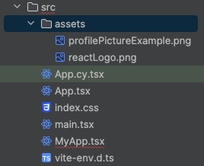
TypeScript / TSX
Copy
import reactLogo from "./assets/reactLogo.png";
import profilePictureExample from "./assets/profilePictureExample.png";
TypeScript / TSX
Copy
<ShellBar
logo={<img src={reactLogo} alt="Company Logo" />}
profile={
<Avatar>
<img src={profilePictureExample} alt="User Avatar" />
</Avatar>
}
primaryTitle="My App"
/>
  - Add custom items
By passing a ShellBarItem as child you are able to add custom items to your ShellBar. The element is basically a Button with responsive behavior and styling adapted to the ShellBar.
TypeScript / TSX
Copy
<ShellBar
logo={<img src="reactLogo.png" />}
profile={
<Avatar>
<img src="profilePictureExample.png" />
</Avatar>
}
primaryTitle="My App"
>
<ShellBarItem icon="activate" text="Activate" tooltip="activate" />
</ShellBar>
That is strange – when you render your component, the ShellBarItem is not shown.
Every Icon that is used in a component has to be imported manually. All available icons can be found here.
Add this line to your imports:
TypeScript / TSX
Copy
import activateIcon from "@ui5/webcomponents-icons/dist/activate.js";
Now your ShellBarItem shows up on the right side of the ShellBar.
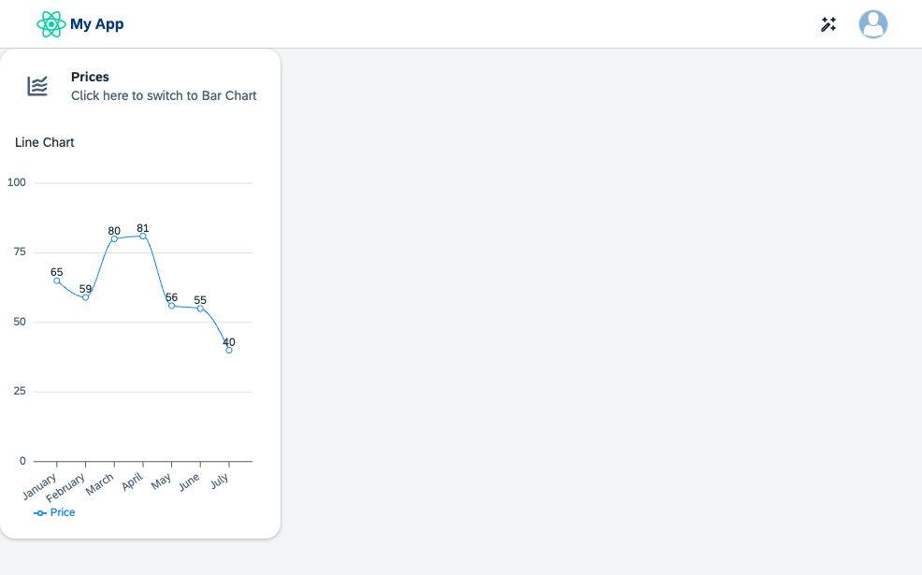
For maintainability reasons, replace icon="activate" with the import name icon={activateIcon}. Now if you replace the icon but forget to remove the import, modern IDEs or linters like eslint will tell you that there is an unused import in your file.
Your component should now look like this:
TypeScript / TSX
Copy
import activateIcon from "@ui5/webcomponents-icons/dist/activate.js";
import lineChartIcon from "@ui5/webcomponents-icons/dist/line-chart.js";
import barChartIcon from "@ui5/webcomponents-icons/dist/horizontal-bar-chart.js";
import { useState } from "react";
import {
Avatar,
Card,
CardHeader,
Text,
ShellBar,
ShellBarItem,
List,
ListItemStandard,
ListItemCustom,
ProgressIndicator,
FlexBox,
FlexBoxJustifyContent,
FlexBoxWrap,
FlexBoxDirection,
AnalyticalTable,
Icon,
} from "@ui5/webcomponents-react";
import { BarChart, LineChart } from "@ui5/webcomponents-react-charts";
import reactLogo from "./assets/reactLogo.png";
import profilePictureExample from "./assets/profilePictureExample.png";

const dataset = [
{
month: "January",
data: 65,
},
{
month: "February",
data: 59,
},
{
month: "March",
data: 80,
},
{
month: "April",
data: 81,
},
{
month: "May",
data: 56,
},
{
month: "June",
data: 55,
},
{
month: "July",
data: 40,
},
];

export function MyApp() {
const [toggleCharts, setToggleCharts] = useState("lineChart");
const [loading, setLoading] = useState(false);

const contentTitle =
toggleCharts === "lineChart" ? "Line Chart" : "Bar Chart";
const switchToChart =
toggleCharts === "lineChart" ? "Bar Chart" : "Line Chart";

const handleHeaderClick = () => {
if (toggleCharts === "lineChart") {
setLoading(true);
setTimeout(() => {
setLoading(false);
setToggleCharts("barChart");
}, 2000);
} else {
setLoading(true);
setTimeout(() => {
setLoading(false);
setToggleCharts("lineChart");
}, 2000);
}
};

return (
<div>
<ShellBar
logo={<img src={reactLogo} alt="Company Logo" />}
profile={
<Avatar>
<img src={profilePictureExample} alt="User Avatar" />
</Avatar>
}
primaryTitle="My App"
>
<ShellBarItem icon={activateIcon} text="Activate" />
</ShellBar>
<Card
header={
<CardHeader
titleText="Prices"
subtitleText={`Click here to switch to ${switchToChart}`}
interactive
avatar={
<Icon
name={
toggleCharts === "lineChart" ? lineChartIcon : barChartIcon
}
accessibleName={contentTitle}
/>
}
onClick={handleHeaderClick}
/>
}
style={{ width: "300px" }}
>
<Text style={{ padding: "var(--sapContent_Space_S)" }}>
{contentTitle}
</Text>
{toggleCharts === "lineChart" ? (
<LineChart
dimensions={[{ accessor: "month" }]}
measures={[{ accessor: "data", label: "Price" }]}
dataset={dataset}
loading={loading}
/>
) : (
<BarChart
dimensions={[{ accessor: "month" }]}
measures={[{ accessor: "data", label: "Price" }]}
dataset={dataset}
loading={loading}
/>
)}
</Card>
</div>
);
}
Done
- STEP 3
Add a `List`
  - To wrap the List add a Card (right after the first one).
TypeScript / TSX
Copy
<Card
header={
<CardHeader
titleText="Progress"
subtitleText="List"
avatar={<Icon name={listIcon} />}
/>
}
style={{ width: "300px" }}
></Card>
  - Add the list Icon to your imports.
TypeScript / TSX
Copy
import listIcon from "@ui5/webcomponents-icons/dist/list.js";
  - Add the List component as child of the Card.
TypeScript / TSX
Copy
<List></List>
  - To render elements of the list, use the ListItemStandard and pass a string as child.
TypeScript / TSX
Copy
<List>
<ListItemStandard>Activity 1</ListItemStandard>
</List>
  - Users should know the status of the activities. Add the additionalText prop to the StandardListItem. To visualize if the status is neutral, positive or negative, also add the additionalTextState prop.
You can either pass a supported string directly, or use the ValueState enum:
TypeScript / TSX
Copy
import ValueState from '@ui5/webcomponents-base/dist/types/ValueState.js';
TypeScript / TSX
Copy
<ListItemStandard
additionalText="finished"
additionalTextState={ValueState.Positive}
>
Activity 1
</ListItemStandard>
<ListItemStandard
additionalText="failed"
additionalTextState={ValueState.Negative}
>
Activity 2
</ListItemStandard>
  - The “Progress” card shows two list items, but both of them are already completed. Let’s create two more activities which are still in progress.
First, create two ListItemCustoms below the completed items.
TypeScript / TSX
Copy
<ListItemCustom></ListItemCustom>
<ListItemCustom></ListItemCustom>
The ListItemCustom allows customizing the content of the list item and for this reason doesn’t offer props like additionalText.
To show the progress, add the ProgressIndicator as child of the items, with the following props:
    - value: The value, which indicates the progress
    - valueState: The value-state (color) of the indicator
TypeScript / TSX
Copy
<ListItemCustom>
<ProgressIndicator value={89} valueState={ValueState.Positive} />
</ListItemCustom>
<ListItemCustom>
<ProgressIndicator value={5} valueState={ValueState.Negative} />
</ListItemCustom>
  - The indicators are displayed as part of the list item, but the title and status of the activities is still missing.For this, add two Text components above the indicator:
TypeScript / TSX
Copy
<ListItemCustom>
<Text>Activity 3</Text>
<Text>in progress</Text>
<ProgressIndicator value={89} valueState={ValueState.Positive} />
</ListItemCustom>
  - All necessary information are now available in each item, but the formatting looks terrible. Let’s fix that by using a flex-box:
TypeScript / TSX
Copy
<ListItemCustom>
<FlexBox direction={FlexBoxDirection.Column} fitContainer>
<FlexBox justifyContent={FlexBoxJustifyContent.SpaceBetween}>
<Text>Activity 3</Text>
<Text>in progress</Text>
</FlexBox>
<ProgressIndicator value={89} valueState={ValueState.Positive} />
</FlexBox>
</ListItemCustom>
The FlexBox implements most of the CSS Flexbox behavior without being forced to actually use CSS or other styling methods.
  - The content of the list item is now aligned correctly, but doesn’t apply the correct padding, colors and dimensions. To fix this as well, pass the style prop, to use the default React inlineStyle syntax. Again, we’re using global CSS variables for this:
TypeScript / TSX
Copy
<ListItemCustom>
<FlexBox
direction={FlexBoxDirection.Column}
fitContainer
style={{ paddingBlock: "var(--sapContent_Space_S)" }}
>
<FlexBox justifyContent={FlexBoxJustifyContent.SpaceBetween}>
<Text style={{ fontSize: "var(--sapFontLargeSize)" }}>
Activity 3
</Text>
<Text style={{ color: "var(--sapCriticalTextColor)" }}>
in progress
</Text>
</FlexBox>
<ProgressIndicator
value={89}
valueState={ValueState.Positive}
style={{ marginBlockStart: "0.5rem" }}
/>
</FlexBox>
</ListItemCustom>
  - Finally, apply the same layout and styles to the content of the second ListItemCustom.
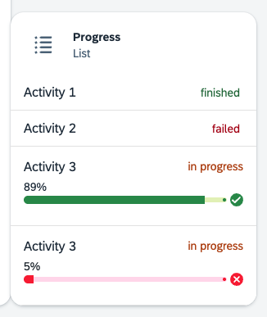
Done
- STEP 4
Add an `AnalyticalTable`
  - The last tile should contain a AnalyticalTable component. Again, create a Card to wrap the Table and set the max-width to 900px.
TypeScript / TSX
Copy
<Card
header={
<CardHeader
titleText="AnalyticalTable"
avatar={<Icon name={tableViewIcon} />}
/>
}
style={{ maxWidth: "900px" }}
>
<AnalyticalTable />
</Card>
Also import the table-view Icon.
TypeScript / TSX
Copy
import tableViewIcon from "@ui5/webcomponents-icons/dist/table-view.js";
  - Add data and columns to the table. The columns prop expects an array of objects that include at least the accessor to the data or a unique id property. The value of Header will be shown as column header.
You can create your own data or just use the code below and paste it right after the definition of the dataset of the chart.
TypeScript / TSX
Copy
const tableData = new Array(500).fill(null).map((_, index) => {
return {
name: `name${index}`,
age: Math.floor(Math.random() * 100),
friend: {
name: `friend.Name${index}`,
age: Math.floor(Math.random() * 100)
}
};
});

const tableColumns = [
{
Header: "Name",
accessor: "name" // String-based value accessors!
},
{
Header: "Age",
accessor: "age"
},
{
Header: "Friend Name",
accessor: "friend.name"
},
{
Header: "Friend Age",
accessor: "friend.age"
}
];
  - Display the data by replacing the current table with.
TypeScript / TSX
Copy
<AnalyticalTable data={tableData} columns={tableColumns} />
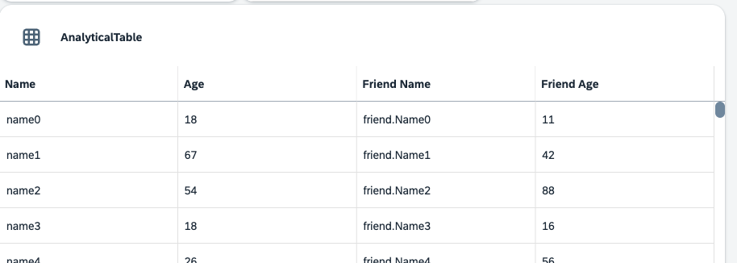
  - Add more properties
You can add many more properties to the AnalyticalTable component. For example, you can allow sorting, filtering and grouping via sortable, filterable and groupable, enable different selection modes with selectionMode, control how the table splits up available space between the columns with scaleWidthMode and many more.Feel free to take a look at the documentation and explore the different examples before continuing.
The default visible rows count is at 15. This number is a bit to high for a dashboard table. Reduce the visibleRows count to 5 by setting the corresponding prop.
TypeScript / TSX
Copy
<AnalyticalTable
data={tableData}
columns={tableColumns}
visibleRows={5}/>
Done
- STEP 5
Dashboard layout
At the moment, the dashboard doesn’t really look like a dashboard. The components are way too close to each other and not aligned correctly. Let’s change that.
  - Add margin to each Card
To add a margin to the cards, you can use the global CSS vars again:
TypeScript / TSX
Copy
<Card
header={
<CardHeader
titleText="Stock Prices"
...
/>
}
style={{ width: "300px", margin: "var(--sapContent_Margin_Small)" }}
>
TypeScript / TSX
Copy
<Card
header={
<CardHeader
titleText="Progress"
...
/>
}
style={{ width: "300px", margin: "var(--sapContent_Margin_Small)" }}
>
TypeScript / TSX
Copy
<Card
header={
<CardHeader
titleText="AnalyticalTable"
...
/>
}
style={{ maxWidth: "900px", margin: "var(--sapContent_Margin_Small)" }}
>
  - Align the elements
To properly align the tiles, use a FlexBox component and wrap your Cards inside of it. Use the justifyContent prop to center align all elements and wrap to make them move to the next line if not enough space is available, also apply the style prop to add a padding to the whole content area.
TypeScript / TSX
Copy
<FlexBox
justifyContent={FlexBoxJustifyContent.Center}
wrap={FlexBoxWrap.Wrap}
style={spacing.sapUiContentPadding}
...
</FlexBox>
Note: You could also use the gap prop of the FlexBox component to apply the spacing.
Your component should now look like this:
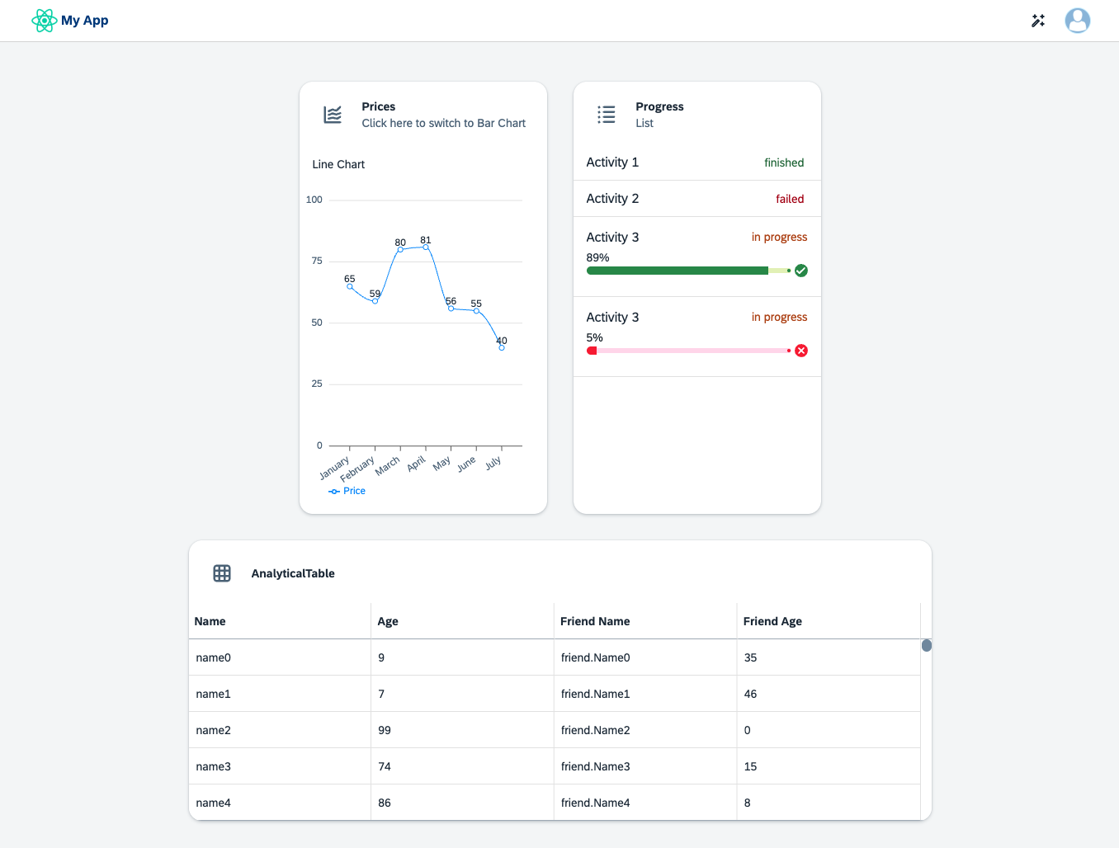
TypeScript / TSX
Copy
import tableViewIcon from "@ui5/webcomponents-icons/dist/table-view.js";
import listIcon from "@ui5/webcomponents-icons/dist/list.js";
import activateIcon from "@ui5/webcomponents-icons/dist/activate.js";
import lineChartIcon from "@ui5/webcomponents-icons/dist/line-chart.js";
import barChartIcon from "@ui5/webcomponents-icons/dist/horizontal-bar-chart.js";
import { useState } from "react";
import {
Avatar,
Card,
CardHeader,
Text,
ShellBar,
ShellBarItem,
List,
ListItemStandard,
ListItemCustom,
ProgressIndicator,
FlexBox,
FlexBoxJustifyContent,
FlexBoxWrap,
FlexBoxDirection,
AnalyticalTable,
Icon,
} from "@ui5/webcomponents-react";
import { BarChart, LineChart } from "@ui5/webcomponents-react-charts";
import reactLogo from "./assets/reactLogo.png";
import profilePictureExample from "./assets/profilePictureExample.png";
import ValueState from "@ui5/webcomponents-base/dist/types/ValueState.js";

const tableData = new Array(500).fill(null).map((_, index) => {
return {
name: `name${index}`,
age: Math.floor(Math.random() * 100),
friend: {
name: `friend.Name${index}`,
age: Math.floor(Math.random() * 100),
},
};
});

const tableColumns = [
{
Header: "Name",
accessor: "name", // String-based value accessors!
},
{
Header: "Age",
accessor: "age",
},
{
Header: "Friend Name",
accessor: "friend.name",
},
{
Header: "Friend Age",
accessor: "friend.age",
},
];

const dataset = [
{
month: "January",
data: 65,
},
{
month: "February",
data: 59,
},
{
month: "March",
data: 80,
},
{
month: "April",
data: 81,
},
{
month: "May",
data: 56,
},
{
month: "June",
data: 55,
},
{
month: "July",
data: 40,
},
];

export function MyApp() {
const [toggleCharts, setToggleCharts] = useState("lineChart");
const [loading, setLoading] = useState(false);

const contentTitle =
toggleCharts === "lineChart" ? "Line Chart" : "Bar Chart";
const switchToChart =
toggleCharts === "lineChart" ? "Bar Chart" : "Line Chart";

const handleHeaderClick = () => {
if (toggleCharts === "lineChart") {
setLoading(true);
setTimeout(() => {
setLoading(false);
setToggleCharts("barChart");
}, 2000);
} else {
setLoading(true);
setTimeout(() => {
setLoading(false);
setToggleCharts("lineChart");
}, 2000);
}
};

return (
<div>
<ShellBar
logo={<img src={reactLogo} alt="Company Logo" />}
profile={
<Avatar>
<img src={profilePictureExample} alt="User Avatar" />
</Avatar>
}
primaryTitle="My App"
>
<ShellBarItem icon={activateIcon} text="Activate" />
</ShellBar>
<FlexBox
justifyContent={FlexBoxJustifyContent.Center}
wrap={FlexBoxWrap.Wrap}
style={{ padding: "var(--sapContent_Space_M)" }}
>
<Card
header={
<CardHeader
titleText="Prices"
subtitleText={`Click here to switch to ${switchToChart}`}
interactive
avatar={
<Icon
name={
toggleCharts === "lineChart" ? lineChartIcon : barChartIcon
}
accessibleName={contentTitle}
/>
}
onClick={handleHeaderClick}
/>
}
style={{ width: "300px", margin: "var(--sapContent_Margin_Small)" }}
>
<Text style={{ padding: "var(--sapContent_Space_S)" }}>
{contentTitle}
</Text>
{toggleCharts === "lineChart" ? (
<LineChart
dimensions={[{ accessor: "month" }]}
measures={[{ accessor: "data", label: "Price" }]}
dataset={dataset}
loading={loading}
/>
) : (
<BarChart
dimensions={[{ accessor: "month" }]}
measures={[{ accessor: "data", label: "Price" }]}
dataset={dataset}
loading={loading}
/>
)}
</Card>
<Card
header={
<CardHeader
titleText="Progress"
subtitleText="List"
avatar={<Icon name={listIcon} />}
/>
}
style={{ width: "300px", margin: "var(--sapContent_Margin_Small)" }}
>
<List>
<ListItemStandard
additionalText="finished"
additionalTextState={ValueState.Positive}
>
Activity 1
</ListItemStandard>
<ListItemStandard
additionalText="failed"
additionalTextState={ValueState.Negative}
>
Activity 2
</ListItemStandard>
<ListItemCustom>
<FlexBox
direction={FlexBoxDirection.Column}
fitContainer
style={{ paddingBlock: "var(--sapContent_Space_S)" }}
>
<FlexBox justifyContent={FlexBoxJustifyContent.SpaceBetween}>
<Text style={{ fontSize: "var(--sapFontLargeSize)" }}>
Activity 3
</Text>
<Text style={{ color: "var(--sapCriticalTextColor)" }}>
in progress
</Text>
</FlexBox>
<ProgressIndicator
value={89}
valueState={ValueState.Positive}
style={{ marginBlockStart: "0.5rem" }}
/>
</FlexBox>
</ListItemCustom>
<ListItemCustom>
<FlexBox
direction={FlexBoxDirection.Column}
fitContainer
style={{ paddingBlock: "var(--sapContent_Space_S)" }}
>
<FlexBox justifyContent={FlexBoxJustifyContent.SpaceBetween}>
<Text style={{ fontSize: "var(--sapFontLargeSize)" }}>
Activity 3
</Text>
<Text style={{ color: "var(--sapCriticalTextColor)" }}>
in progress
</Text>
</FlexBox>
<ProgressIndicator
value={5}
valueState={ValueState.Negative}
style={{ marginBlockStart: "0.5rem" }}
/>
</FlexBox>
</ListItemCustom>
</List>
</Card>
<Card
header={
<CardHeader
titleText="AnalyticalTable"
avatar={<Icon name={tableViewIcon} />}
/>
}
style={{
maxWidth: "900px",
margin: "var(--sapContent_Margin_Small)",
}}
>
<AnalyticalTable
data={tableData}
columns={tableColumns}
visibleRows={5}
/>
</Card>
</FlexBox>
</div>
);
}
- Create a Detail page
In src create a Detail.tsx file.
Inside of that file, create the Detail component that will return a title to your liking.
TypeScript / TSX
Copy
import { Title } from "@ui5/webcomponents-react";

export function Detail() {
return <Title>Hello World!</Title>;
}
Done
- STEP 2
Add Router
  - Install react-router-dom.
React Router is a collection of navigational components that compose declaratively with your application.
Execute the following line in the terminal in your root location of the project.
Shell
Copy
npm install react-router-dom
  - Import HashRouter in src/App.tsx.
TypeScript / TSX
Copy
import { HashRouter } from "react-router-dom";
And wrap your root component inside of it:
TypeScript / TSX
Copy
<HashRouter>
<MyApp />
</HashRouter>
Done
- STEP 3
Create Home component
  - In src, create a new Home.tsx file.
For now only create a Home component that returns null.
TypeScript / TSX
Copy
export function Home() {
return null;
}
  - Refactor MyApp.tsx.
Some refactoring is necessary now. Extract every component and the corresponding logic except for the ShellBar from MyApp.tsx and move it to Home.tsx.
MyApp.tsx should now look like this:
TypeScript / TSX
Copy
import activateIcon from "@ui5/webcomponents-icons/dist/activate.js";
import { Avatar, ShellBar, ShellBarItem } from "@ui5/webcomponents-react";
import profilePictureExample from "./assets/profilePictureExample.png";
import reactLogo from "./assets/reactLogo.png";

export function MyApp() {
return (
<div>
<ShellBar
logo={<img src={reactLogo} alt="Company Logo" />}
profile={
<Avatar>
<img src={profilePictureExample} alt="User Avatar" />
</Avatar>
}
primaryTitle="My App"
>
<ShellBarItem icon={activateIcon} text="Activate" />
</ShellBar>
</div>
);
}
And Home.tsx like this:
TypeScript / TSX
Copy
import tableViewIcon from "@ui5/webcomponents-icons/dist/table-view.js";
import listIcon from "@ui5/webcomponents-icons/dist/list.js";
import lineChartIcon from "@ui5/webcomponents-icons/dist/line-chart.js";
import barChartIcon from "@ui5/webcomponents-icons/dist/horizontal-bar-chart.js";
import { useState } from "react";
import {
Card,
CardHeader,
Text,
List,
ListItemStandard,
ListItemCustom,
ProgressIndicator,
FlexBox,
FlexBoxJustifyContent,
FlexBoxWrap,
FlexBoxDirection,
AnalyticalTable,
Icon,
} from "@ui5/webcomponents-react";
import { BarChart, LineChart } from "@ui5/webcomponents-react-charts";
import ValueState from "@ui5/webcomponents-base/dist/types/ValueState.js";

const tableData = new Array(500).fill(null).map((_, index) => {
return {
name: `name${index}`,
age: Math.floor(Math.random() * 100),
friend: {
name: `friend.Name${index}`,
age: Math.floor(Math.random() * 100),
},
};
});

const tableColumns = [
{
Header: "Name",
accessor: "name", // String-based value accessors!
},
{
Header: "Age",
accessor: "age",
},
{
Header: "Friend Name",
accessor: "friend.name",
},
{
Header: "Friend Age",
accessor: "friend.age",
},
];

const dataset = [
{
month: "January",
data: 65,
},
{
month: "February",
data: 59,
},
{
month: "March",
data: 80,
},
{
month: "April",
data: 81,
},
{
month: "May",
data: 56,
},
{
month: "June",
data: 55,
},
{
month: "July",
data: 40,
},
];

export function Home() {
const [toggleCharts, setToggleCharts] = useState("lineChart");
const [loading, setLoading] = useState(false);

const contentTitle =
toggleCharts === "lineChart" ? "Line Chart" : "Bar Chart";
const switchToChart =
toggleCharts === "lineChart" ? "Bar Chart" : "Line Chart";

const handleHeaderClick = () => {
if (toggleCharts === "lineChart") {
setLoading(true);
setTimeout(() => {
setLoading(false);
setToggleCharts("barChart");
}, 2000);
} else {
setLoading(true);
setTimeout(() => {
setLoading(false);
setToggleCharts("lineChart");
}, 2000);
}
};
return (
<FlexBox
justifyContent={FlexBoxJustifyContent.Center}
wrap={FlexBoxWrap.Wrap}
style={{ padding: "var(--sapContent_Space_M)" }}
>
<Card
header={
<CardHeader
titleText="Prices"
subtitleText={`Click here to switch to ${switchToChart}`}
interactive
avatar={
<Icon
name={
toggleCharts === "lineChart" ? lineChartIcon : barChartIcon
}
accessibleName={contentTitle}
/>
}
onClick={handleHeaderClick}
/>
}
style={{ width: "300px", margin: "var(--sapContent_Margin_Small)" }}
>
<Text style={{ padding: "var(--sapContent_Space_S)" }}>
{contentTitle}
</Text>
{toggleCharts === "lineChart" ? (
<LineChart
dimensions={[{ accessor: "month" }]}
measures={[{ accessor: "data", label: "Price" }]}
dataset={dataset}
loading={loading}
/>
) : (
<BarChart
dimensions={[{ accessor: "month" }]}
measures={[{ accessor: "data", label: "Price" }]}
dataset={dataset}
loading={loading}
/>
)}
</Card>
<Card
header={
<CardHeader
titleText="Progress"
subtitleText="List"
avatar={<Icon name={listIcon} />}
/>
}
style={{ width: "300px", margin: "var(--sapContent_Margin_Small)" }}
>
<List>
<ListItemStandard
additionalText="finished"
additionalTextState={ValueState.Positive}
>
Activity 1
</ListItemStandard>
<ListItemStandard
additionalText="failed"
additionalTextState={ValueState.Negative}
>
Activity 2
</ListItemStandard>
<ListItemCustom>
<FlexBox
direction={FlexBoxDirection.Column}
fitContainer
style={{ paddingBlock: "var(--sapContent_Space_S)" }}
>
<FlexBox justifyContent={FlexBoxJustifyContent.SpaceBetween}>
<Text style={{ fontSize: "var(--sapFontLargeSize)" }}>
Activity 3
</Text>
<Text style={{ color: "var(--sapCriticalTextColor)" }}>
in progress
</Text>
</FlexBox>
<ProgressIndicator
value={89}
valueState={ValueState.Positive}
style={{ marginBlockStart: "0.5rem" }}
/>
</FlexBox>
</ListItemCustom>
<ListItemCustom>
<FlexBox
direction={FlexBoxDirection.Column}
fitContainer
style={{ paddingBlock: "var(--sapContent_Space_S)" }}
>
<FlexBox justifyContent={FlexBoxJustifyContent.SpaceBetween}>
<Text style={{ fontSize: "var(--sapFontLargeSize)" }}>
Activity 3
</Text>
<Text style={{ color: "var(--sapCriticalTextColor)" }}>
in progress
</Text>
</FlexBox>
<ProgressIndicator
value={5}
valueState={ValueState.Negative}
style={{ marginBlockStart: "0.5rem" }}
/>
</FlexBox>
</ListItemCustom>
</List>
</Card>
<Card
header={
<CardHeader
titleText="AnalyticalTable"
avatar={<Icon name={tableViewIcon} />}
/>
}
style={{
maxWidth: "900px",
margin: "var(--sapContent_Margin_Small)",
}}
>
<AnalyticalTable
data={tableData}
columns={tableColumns}
visibleRows={5}
/>
</Card>
</FlexBox>
);
}
Done
- STEP 4
Import Router components
  - In MyApp.tsx, import Routes, Route and Navigate from react-router-dom and the Home and Detail components.
TypeScript / TSX
Copy
import { Routes, Route, Navigate } from "react-router-dom";
import { Home } from "./Home";
import { Detail } from "./Detail";
  - Wrap your ShellBar component inside of Fragments and set up paths with Routes and the component (element) displayed respectively.
TypeScript / TSX
Copy
return (
<>
<ShellBar
logo={<img src={reactLogo} alt="Company Logo" />}
profile={
<Avatar>
<img src={profilePictureExample} alt="User Avatar" />
</Avatar>
}
primaryTitle="My App"
>
<ShellBarItem icon={activateIcon} text="Activate" />
</ShellBar>
<Routes>
<Route path="/home" element={<Home />} />
<Route path="/detail" element={<Detail />} />
<Route path="*" element={<Navigate replace to="/home" />} />
</Routes>
</>
);
The Navigate component will redirect the user if the URL doesn’t match any given paths.
Your current URL now displays the #/home path. If you replace home with detail, you will be routed to the detail page.
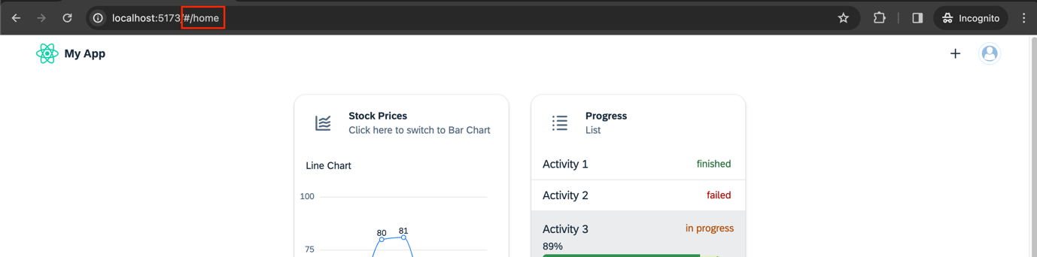
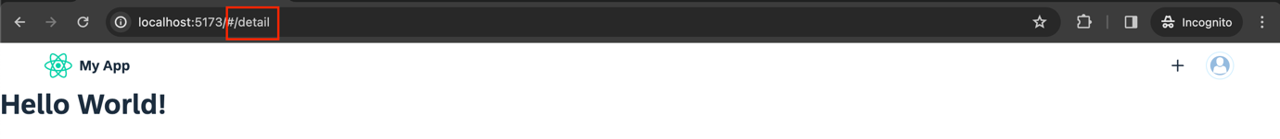
Done
- STEP 5
Handle navigation
Except for changing the URL of the App users don’t have options to navigate to the Detail page. The page could contain some more information about activities and should therefore be connected to the Progress Card.
  - Go into your Home component and add interactive and onClick={handleProgressHeaderClick} to your second CardHeader component.
TypeScript / TSX
Copy
<Card
header={
<CardHeader
titleText="Progress"
subtitleText="List"
avatar={<Icon name={listIcon} />}
interactive
onClick={handleProgressHeaderClick}
/>
}
style={{ width: "300px", margin: "var(--sapContent_Margin_Small)" }}
>
  - Define the handleProgressHeaderClick function as follows. And import the useNavigate hook from react-router-dom.
TypeScript / TSX
Copy
import { useNavigate } from "react-router-dom";
TypeScript / TSX
Copy
const navigate = useNavigate();
const handleProgressHeaderClick = () => {
navigate("/detail");
};
Now it is possible to navigate to the Details component, but right now, there is no way to go back except for the back button of the browser and typing in the URL manually.
  - Navigate back to the Home Screen
Normally when you click on the Logo of the app, it should send you back to your Home screen. Let’s implement that.
Go into your MyApp.tsx file where your ShellBar is located and add an onLogoClick prop. The function is almost the same as for the onHeaderClick, but this time the destination should be the default page.
TypeScript / TSX
Copy
const navigate = useNavigate();
const handleLogoClick = () => {
navigate("./");
};
TypeScript / TSX
Copy
<ShellBar
logo={<img src={reactLogo} alt="Company Logo" />}
profile={
<Avatar>
<img src={profilePictureExample} alt="User Avatar" />
</Avatar>
}
primaryTitle="My App"
onLogoClick={handleLogoClick}
>
Code overview
If needed, you can compare your files with the following code references:
MyApp.tsx:
TypeScript / TSX
Copy
import activateIcon from "@ui5/webcomponents-icons/dist/activate.js";
import { Avatar, ShellBar, ShellBarItem } from "@ui5/webcomponents-react";
import profilePictureExample from "./assets/profilePictureExample.png";
import reactLogo from "./assets/reactLogo.png";
import { Routes, Route, Navigate } from "react-router-dom";
import { Home } from "./Home";
import { Detail } from "./Detail";
import { useNavigate } from "react-router-dom";

export function MyApp() {
const navigate = useNavigate();
const handleLogoClick = () => {
navigate("./");
};
return (
<>
<ShellBar
logo={<img src={reactLogo} alt="Company Logo" />}
profile={
<Avatar>
<img src={profilePictureExample} alt="User Avatar" />
</Avatar>
}
primaryTitle="My App"
onLogoClick={handleLogoClick}
>
<ShellBarItem icon={activateIcon} text="Activate" />
</ShellBar>
<Routes>
<Route path="/home" element={<Home />} />
<Route path="/detail" element={<Detail />} />
<Route path="*" element={<Navigate replace to="/home" />} />
</Routes>
</>
);
}
Home.tsx:
TypeScript / TSX
Copy
import tableViewIcon from "@ui5/webcomponents-icons/dist/table-view.js";
import listIcon from "@ui5/webcomponents-icons/dist/list.js";
import lineChartIcon from "@ui5/webcomponents-icons/dist/line-chart.js";
import barChartIcon from "@ui5/webcomponents-icons/dist/horizontal-bar-chart.js";
import { useState } from "react";
import {
Card,
CardHeader,
Text,
List,
ListItemStandard,
ListItemCustom,
ProgressIndicator,
FlexBox,
FlexBoxJustifyContent,
FlexBoxWrap,
FlexBoxDirection,
AnalyticalTable,
Icon,
} from "@ui5/webcomponents-react";
import { BarChart, LineChart } from "@ui5/webcomponents-react-charts";
import ValueState from "@ui5/webcomponents-base/dist/types/ValueState.js";
import { useNavigate } from "react-router-dom";

const tableData = new Array(500).fill(null).map((_, index) => {
return {
name: `name${index}`,
age: Math.floor(Math.random() * 100),
friend: {
name: `friend.Name${index}`,
age: Math.floor(Math.random() * 100),
},
};
});

const tableColumns = [
{
Header: "Name",
accessor: "name", // String-based value accessors!
},
{
Header: "Age",
accessor: "age",
},
{
Header: "Friend Name",
accessor: "friend.name",
},
{
Header: "Friend Age",
accessor: "friend.age",
},
];

const dataset = [
{
month: "January",
data: 65,
},
{
month: "February",
data: 59,
},
{
month: "March",
data: 80,
},
{
month: "April",
data: 81,
},
{
month: "May",
data: 56,
},
{
month: "June",
data: 55,
},
{
month: "July",
data: 40,
},
];

export function Home() {
const [toggleCharts, setToggleCharts] = useState("lineChart");
const [loading, setLoading] = useState(false);
const navigate = useNavigate();

const contentTitle =
toggleCharts === "lineChart" ? "Line Chart" : "Bar Chart";
const switchToChart =
toggleCharts === "lineChart" ? "Bar Chart" : "Line Chart";

const handleHeaderClick = () => {
if (toggleCharts === "lineChart") {
setLoading(true);
setTimeout(() => {
setLoading(false);
setToggleCharts("barChart");
}, 2000);
} else {
setLoading(true);
setTimeout(() => {
setLoading(false);
setToggleCharts("lineChart");
}, 2000);
}
};

const handleProgressHeaderClick = () => {
navigate("/detail");
};

return (
<FlexBox
justifyContent={FlexBoxJustifyContent.Center}
wrap={FlexBoxWrap.Wrap}
style={{ padding: "var(--sapContent_Space_M)" }}
>
<Card
header={
<CardHeader
titleText="Prices"
subtitleText={`Click here to switch to ${switchToChart}`}
interactive
avatar={
<Icon
name={
toggleCharts === "lineChart" ? lineChartIcon : barChartIcon
}
accessibleName={contentTitle}
/>
}
onClick={handleHeaderClick}
/>
}
style={{ width: "300px", margin: "var(--sapContent_Margin_Small)" }}
>
<Text style={{ padding: "var(--sapContent_Space_S)" }}>
{contentTitle}
</Text>
{toggleCharts === "lineChart" ? (
<LineChart
dimensions={[{ accessor: "month" }]}
measures={[{ accessor: "data", label: "Price" }]}
dataset={dataset}
loading={loading}
/>
) : (
<BarChart
dimensions={[{ accessor: "month" }]}
measures={[{ accessor: "data", label: "Price" }]}
dataset={dataset}
loading={loading}
/>
)}
</Card>
<Card
header={
<CardHeader
titleText="Progress"
subtitleText="List"
avatar={<Icon name={listIcon} />}
interactive
onClick={handleProgressHeaderClick}
/>
}
style={{ width: "300px", margin: "var(--sapContent_Margin_Small)" }}
>
<List>
<ListItemStandard
additionalText="finished"
additionalTextState={ValueState.Positive}
>
Activity 1
</ListItemStandard>
<ListItemStandard
additionalText="failed"
additionalTextState={ValueState.Negative}
>
Activity 2
</ListItemStandard>
<ListItemCustom>
<FlexBox
direction={FlexBoxDirection.Column}
fitContainer
style={{ paddingBlock: "var(--sapContent_Space_S)" }}
>
<FlexBox justifyContent={FlexBoxJustifyContent.SpaceBetween}>
<Text style={{ fontSize: "var(--sapFontLargeSize)" }}>
Activity 3
</Text>
<Text style={{ color: "var(--sapCriticalTextColor)" }}>
in progress
</Text>
</FlexBox>
<ProgressIndicator
value={89}
valueState={ValueState.Positive}
style={{ marginBlockStart: "0.5rem" }}
/>
</FlexBox>
</ListItemCustom>
<ListItemCustom>
<FlexBox
direction={FlexBoxDirection.Column}
fitContainer
style={{ paddingBlock: "var(--sapContent_Space_S)" }}
>
<FlexBox justifyContent={FlexBoxJustifyContent.SpaceBetween}>
<Text style={{ fontSize: "var(--sapFontLargeSize)" }}>
Activity 3
</Text>
<Text style={{ color: "var(--sapCriticalTextColor)" }}>
in progress
</Text>
</FlexBox>
<ProgressIndicator
value={5}
valueState={ValueState.Negative}
style={{ marginBlockStart: "0.5rem" }}
/>
</FlexBox>
</ListItemCustom>
</List>
</Card>
<Card
header={
<CardHeader
titleText="AnalyticalTable"
avatar={<Icon name={tableViewIcon} />}
/>
}
style={{
maxWidth: "900px",
margin: "var(--sapContent_Margin_Small)",
}}
>
<AnalyticalTable
data={tableData}
columns={tableColumns}
visibleRows={5}
/>
</Card>
</FlexBox>
);
}

- Change style for existing components
You can change the appearance of the UI5 Web Components by using CSS Variables.Per default, the Horizon theme parameters are added to the adoptedStyleSheets of the document.For example, if you want to change the color of all texts that use the --sapTile_TitleTextColor variable, you can create an additional style rule overriding the value of the CSS variable.
Open the index.css file inside your src folder and add the following content:
CSS
Copy
* {
--sapTile_TitleTextColor: limegreen;
}
The sapTile_TitleTextColor CSS Variable is used in the CardHeader component to set the color of the title. With the * selector, you can apply styles to all elements in the subtree and therefore change the color of all components using sapTile_TitleTextColor.
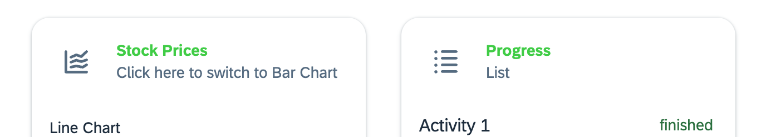
As a consequence, all HTML Elements in the subtree where this style was applied are now displaying their texts in limegreen instead of rgb(29, 45, 62) which would be the default value for Horizon. You can change CSS Variables on any level - in the head, or on every single element by using either CSS classes or element style.
A full list of all supported CSS Variables can be found in the ThemingParameters object or in the theming-base-content repository.
Warning: Overriding the value of CSS variables changes it for all themes and therefore can cause inconsistencies!
Done
- STEP 2
Style your own component
If you want to add a custom component to your app, but still want to use the styling approach of the UI5 Web Components, you can use the global CSS vars (ThemingParameters). If you want to style your components with a CSS-in-JS library like react-jss, or want to use the React inline styling, you can use the ThemingParameters directly.
In this step we will use CSS Modules and inline styling to style a custom component.
Note: The Vite template already includes support for CSS Modules, so you can use them out of the box.
  - Create a custom component MyCustomElement.tsx under ./src with following content:
TypeScript / TSX
Copy
import { ThemingParameters } from "@ui5/webcomponents-react-base";

export const MyCustomElement = () => {
return (
<div >
<span>My custom Text Element</span>
</div>
);
};
  - Explicitly import @ui5/webcomponents-react-base package
@ui5/webcomponents-react-base is already installed by @ui5/webcomponents-react, but as we want to import the ThemingParameters in the following step, it’s recommended adding the package to the dependencies as well.
shell
Copy
npm install @ui5/webcomponents-react-base
  - Add inline-styles to apply ThemingParameters to the <span>
TypeScript / TSX
Copy
<span style={{ color: ThemingParameters.sapNegativeColor, fontSize: ThemingParameters.sapFontHeader1Size }}>
My custom Text Element
</span>
The global CSS variables contain all publicly available styling parameters. With this it is possible to style custom components with the standardized styles of the UI5 Web Components.
  - Add styling using CSS Modules
First create a new file MyCustomElement.module.css in the same folder as MyCustomElement.tsx with the following content:
CSS
Copy
.container {
background-color: var(--sapBackgroundColor);
font-family: var(--sapFontFamily);
height: 50px;
display: flex;
justify-content: center;
align-items: center;
}
Then import the CSS file in your MyCustomElement.tsx file and add the class to the div element.
TypeScript / TSX
Copy
import { ThemingParameters } from '@ui5/webcomponents-react-base';
import classes from './MyCustomElement.module.css';

export const MyCustomElement = () => {
return (
<div className={classes.container}>
<span
style={{
color: ThemingParameters.sapNegativeColor,
fontSize: ThemingParameters.sapFontHeader1Size,
}}
>
My custom Text Element
</span>
</div>
);
};
  - Import the custom component and add it to your Home component.
TypeScript / TSX
Copy
import { MyCustomElement } from "./MyCustomElement";
TypeScript / TSX
Copy
return (
<FlexBox
justifyContent={FlexBoxJustifyContent.Center}
wrap={FlexBoxWrap.Wrap}
>
<MyCustomElement />
...
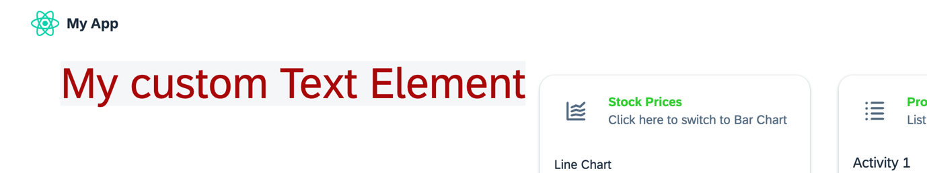
Now you can see, that the element has the same fontFamily and uses the same semantic colors as UI5 Web Components for React.
- STEP 3
SAP UI Common CSS
It’s often required setting more complex styles for e.g. layouting. For this it’s recommended using CSS classes of the SAP UI Common CSS library which is also following the Fiori design guidelines.
One example is applying a responsive content padding to the content of the dashboard:
  - Install Common CSS
shell
Copy
npm i @sap-ui/common-css
  - Import the required classes in Home.tsx
ts
Copy
import '@sap-ui/common-css/dist/sap-content-paddings.css';
import '@sap-ui/common-css/dist/sap-container-type.css';
  - Apply the classes on elements
Add div that is wrapping the outer FlexBox and apply the sap-container-type-inline-size class:
tsx
Copy
<div className="sap-container-type-inline-size">
<FlexBox
justifyContent={FlexBoxJustifyContent.Center}
wrap={FlexBoxWrap.Wrap}
...
Remove style from the outer FlexBox and apply the sap-content-paddings-container class:
tsx
Copy
<FlexBox
justifyContent={FlexBoxJustifyContent.Center}
wrap={FlexBoxWrap.Wrap}
className="sap-content-paddings-container"
>
Now, the padding of the FlexBox is adjusted automatically according to the viewport size.

