Go to tcode: IH01->Enter the equipment-> RI01-UT01-100MW-ELV00
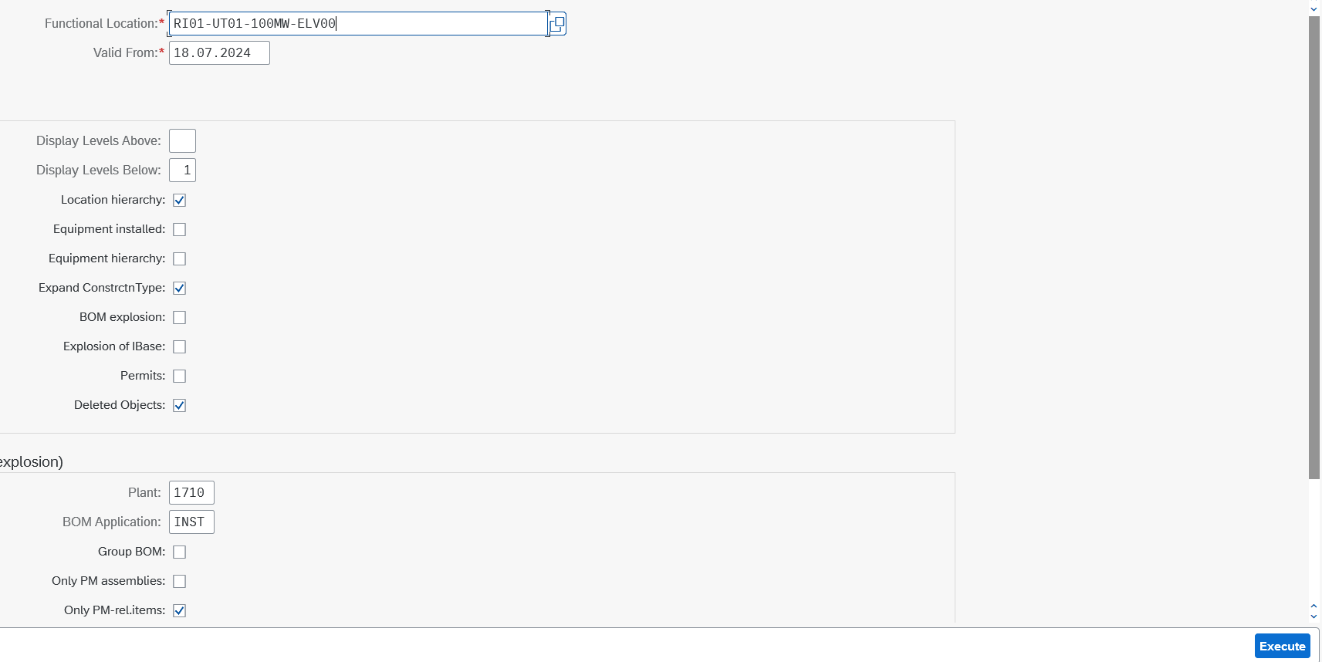
Execute
Equipment: 10003024
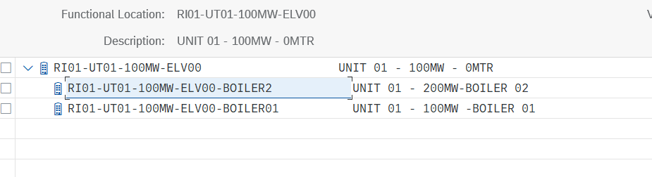
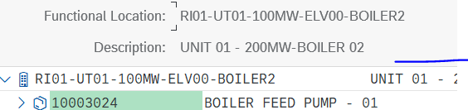
Go to Create Order
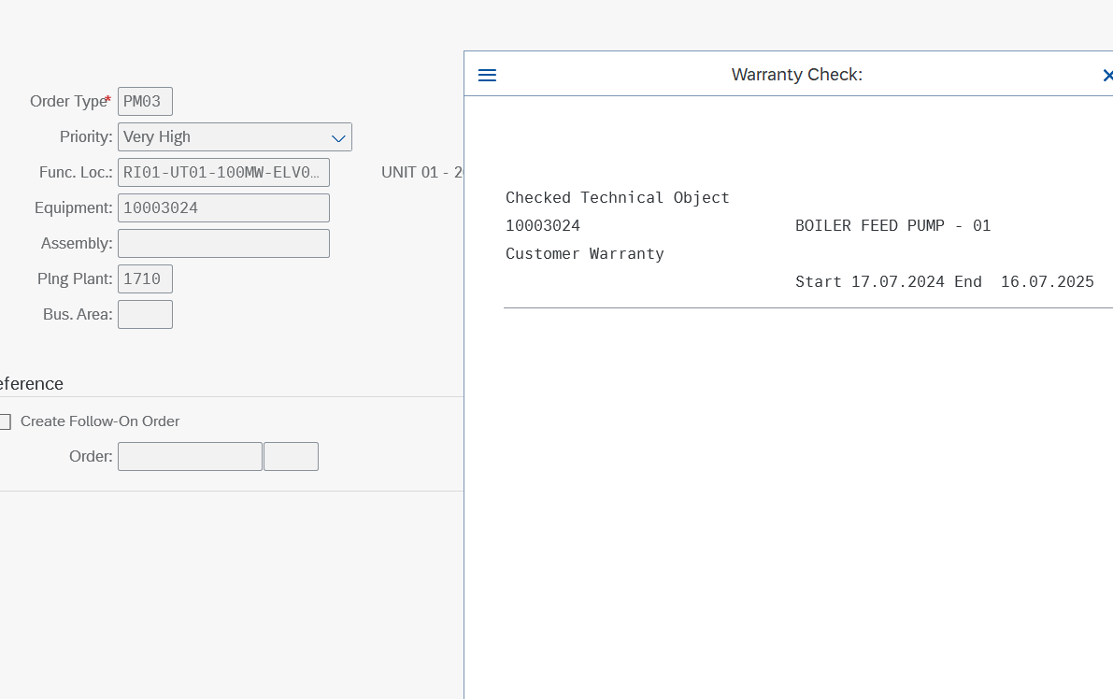
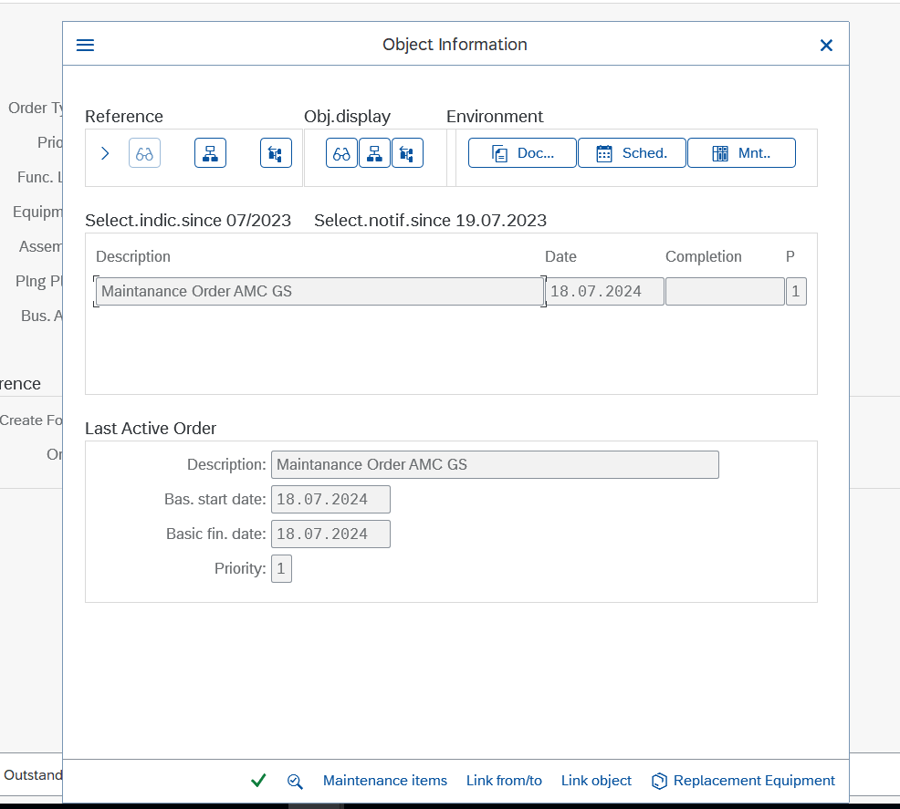
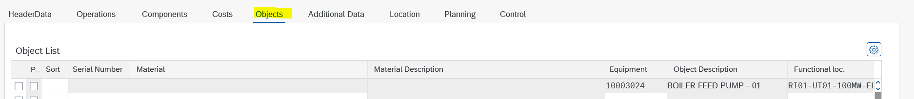
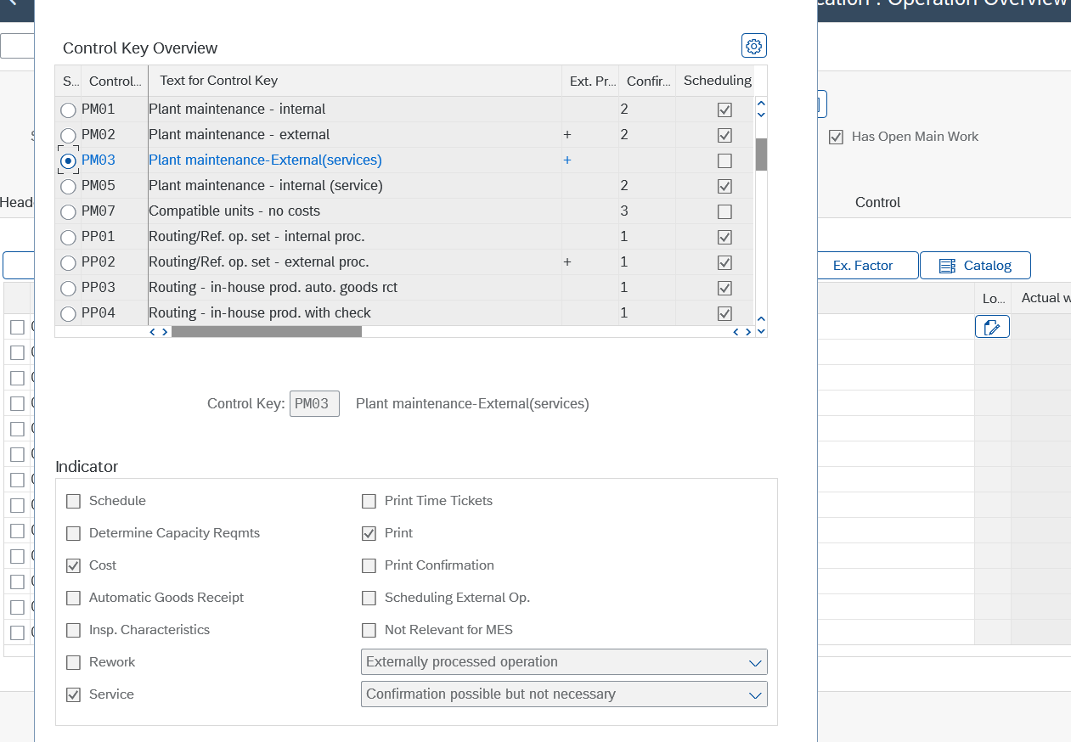

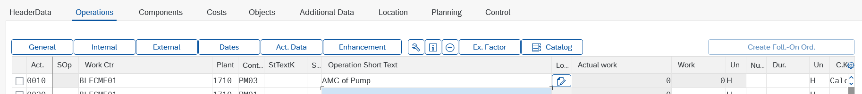
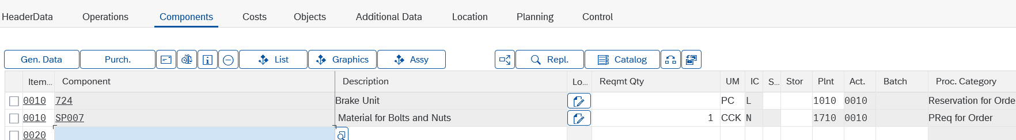
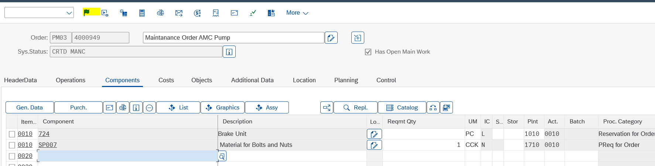
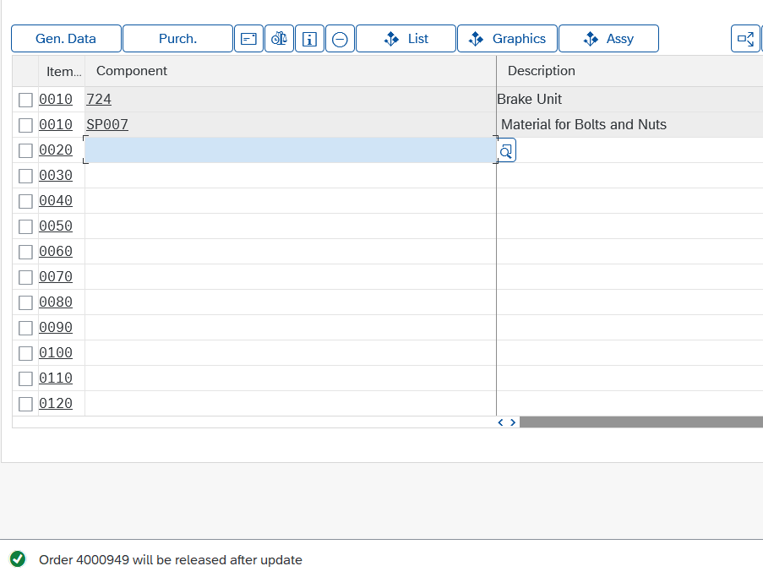
Document Flow
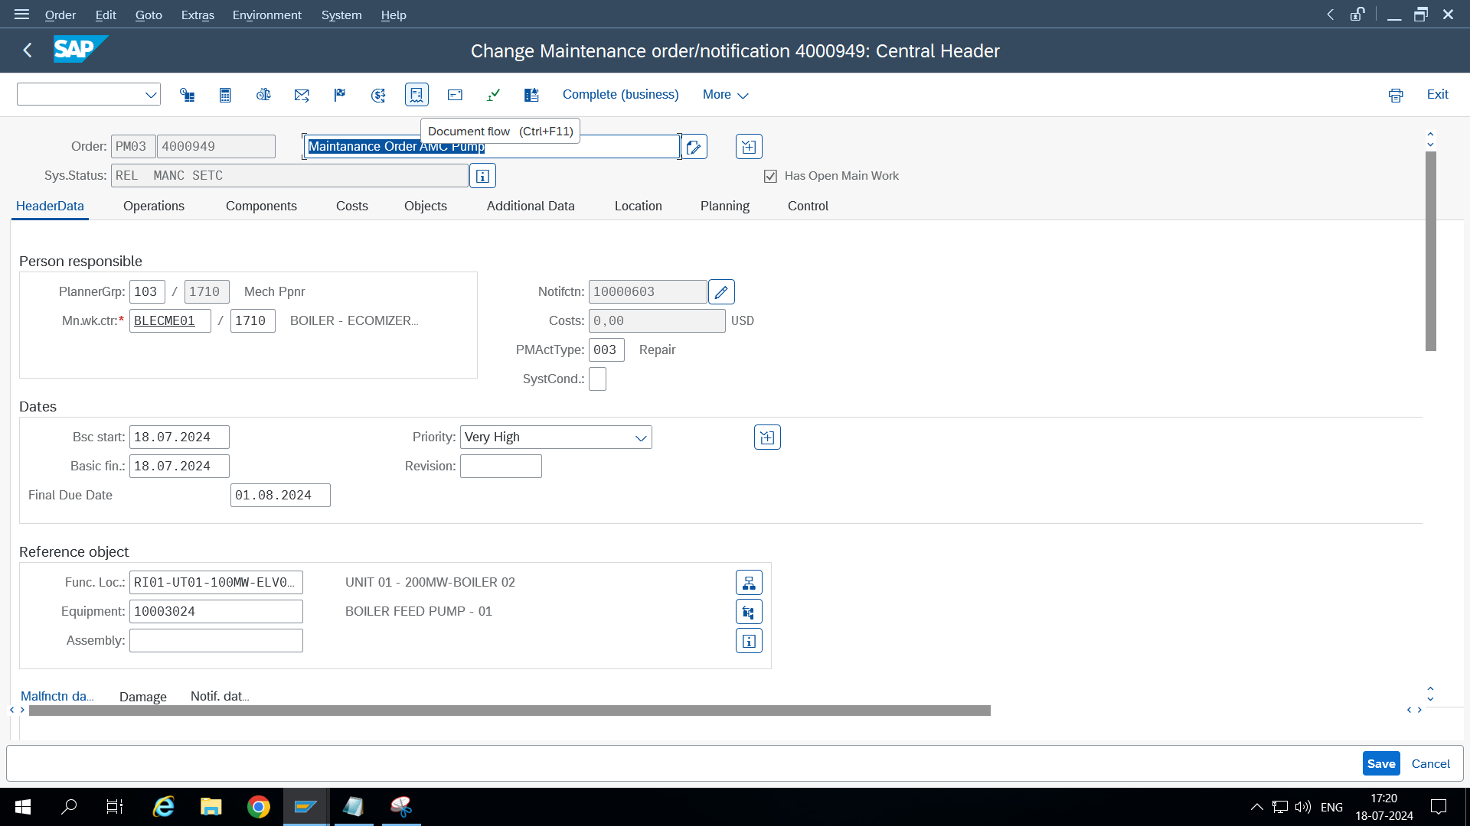
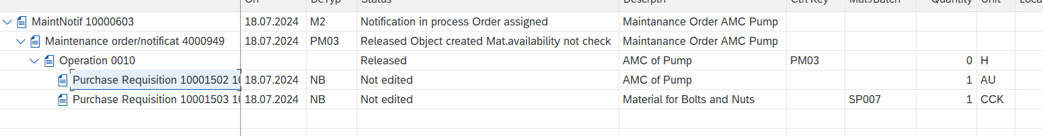Go to ME54N: Release the purchase requisition
Now comes to the creation of agreement Advanced PO
Go to ME31K
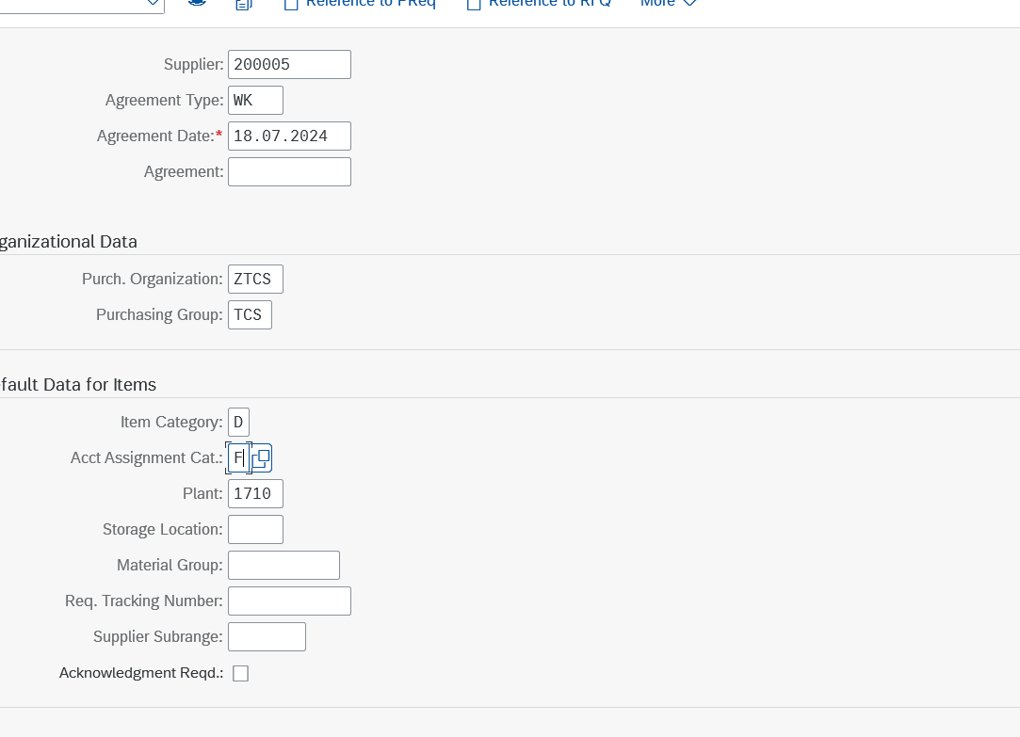

ME35k approval of contract
