Create a CAP Service with BAS Productivity Tools
- Step 1
Create SAP Business Application Studio project
  - Use BAS Directly
These steps open SAP Business Application Studio in the traditional way, without using SAP Build’s lobby.
  - Open the your subaccount, making sure Instances and Subscriptions on the left-side menu is selected.
Click SAP Business Application Studio.
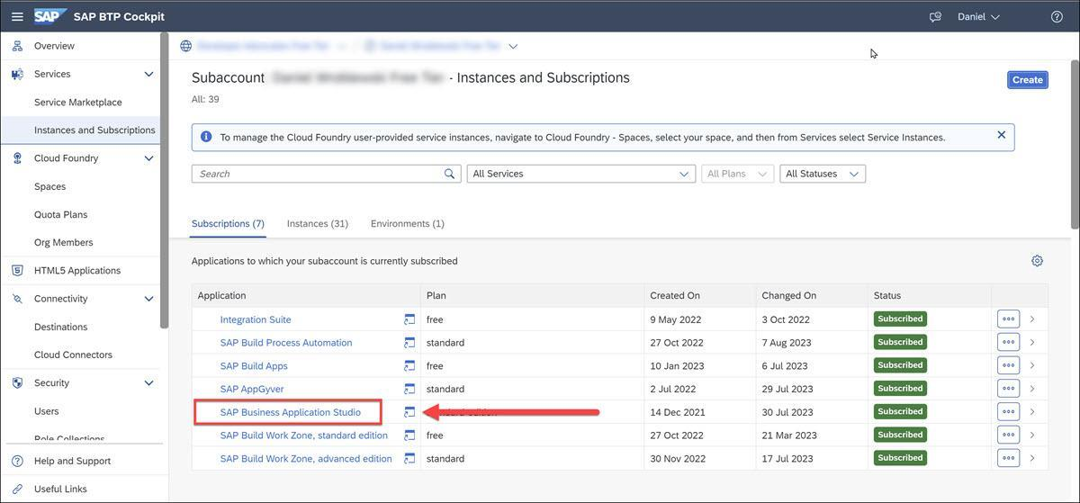
  - After opening SAP Business Application Studio, click Create Dev Space.
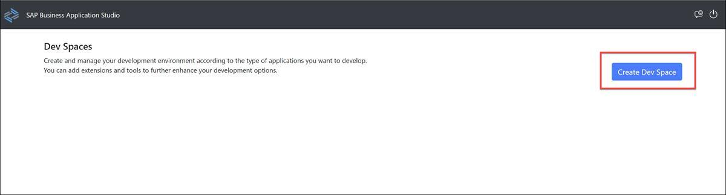
Enter a name for your dev space, select Full-Stack Application Using Productivity Tools, and then click Create Dev Space.
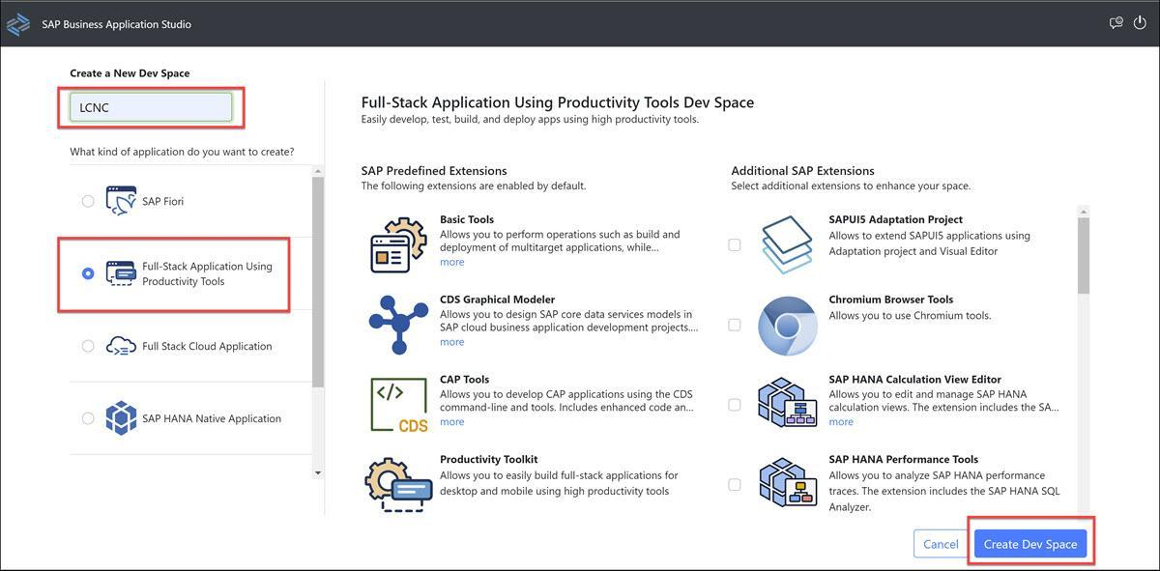
The dev space will be created, and you will see that is being started.
Soon it will say Running.
  - Click the dev space name to open it, and you will the main canvas of SAP Business Application Studio.
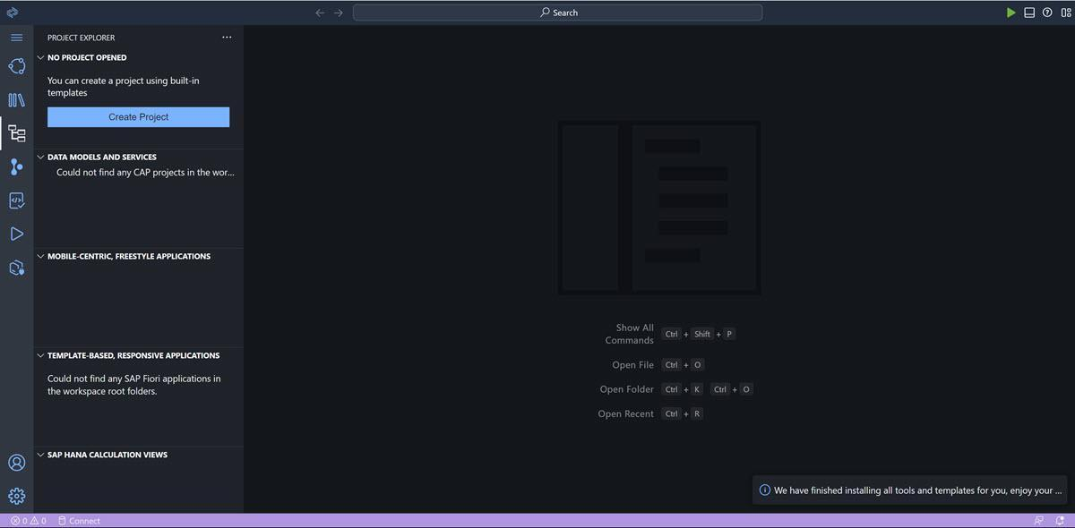
  - Click Create Project.
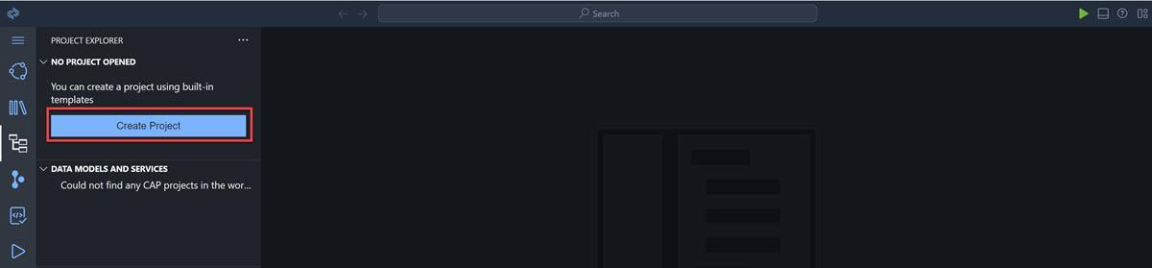
Select the Full-Stack Project generator, and click Start.
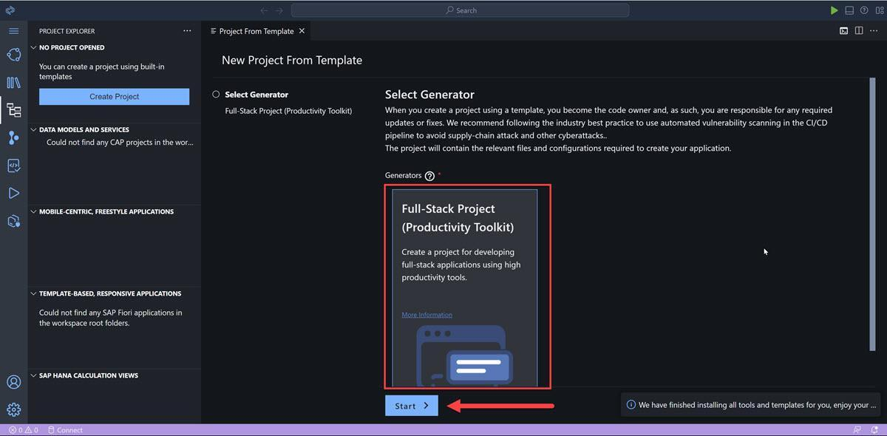
For the name of the project, enter RiskManagement, and then click Finish.
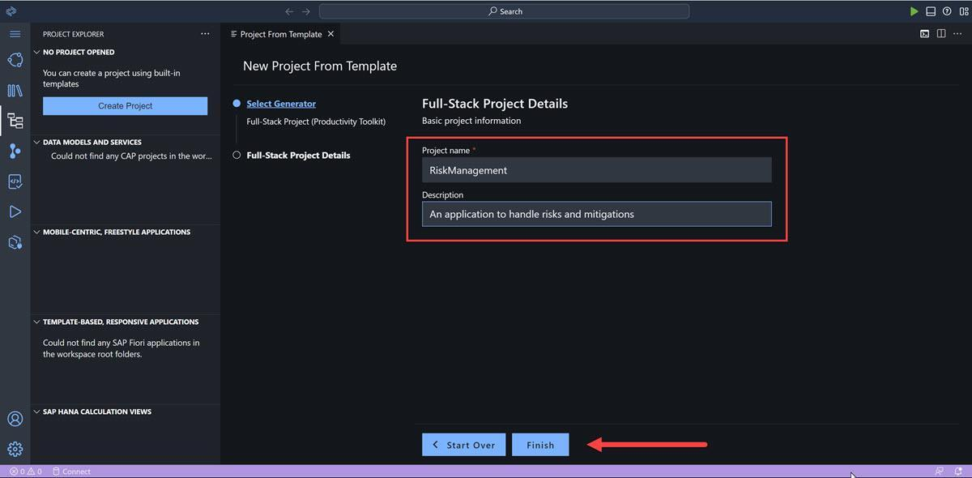
BAS will generate the project and all the files, and you will see the following, where you can create data models, the services that will expose the data, and more:
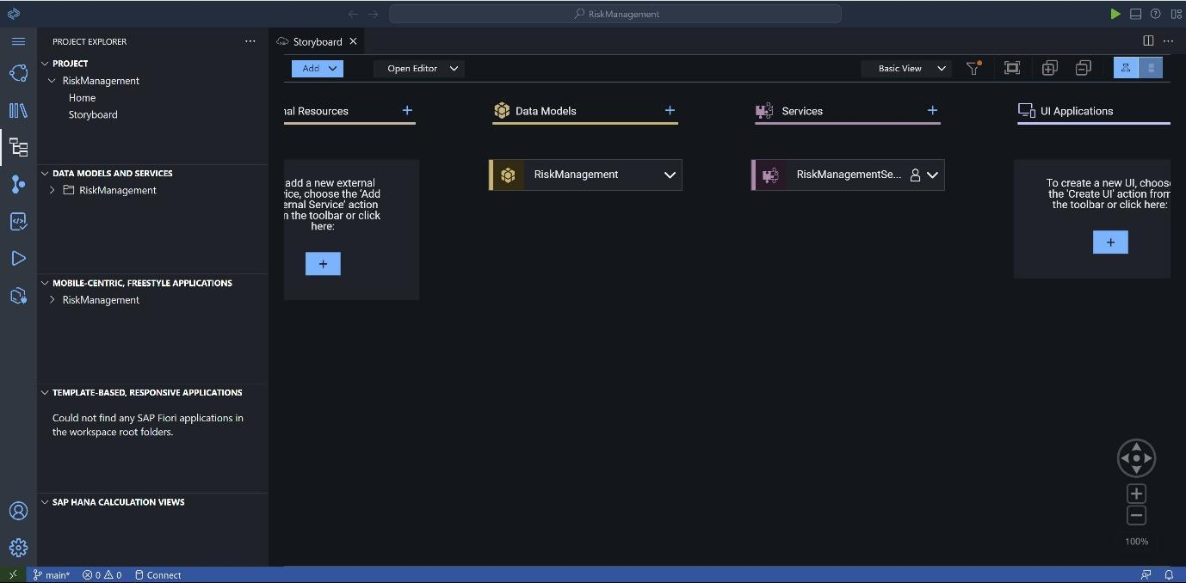
Done
- Step 2
Create data model
  - In the storyboard, click the plus sign ( + ) above Data Models.
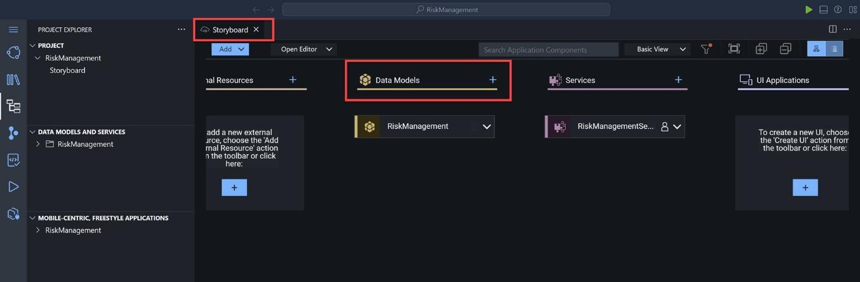
This will display the data model canvas, with a new data entity called Entity1. You will now change the name and add the fields.
Click the Show Details icon to open the editor.
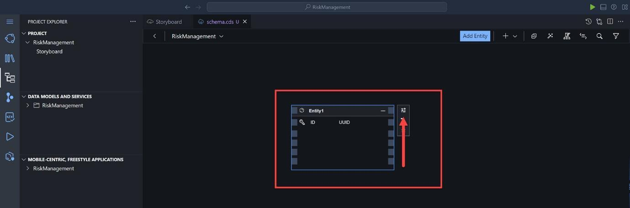
  - In the editor, change the name of the entity to Risks (save by clicking the checkmark ☑️) and add the following fields:
Property name | Property Type | Max Length
title | string | 100
prio | string | 5
descr | string | 100
impact | integer
criticality | integer
  - Close the editor by clicking the top-right X.
  - 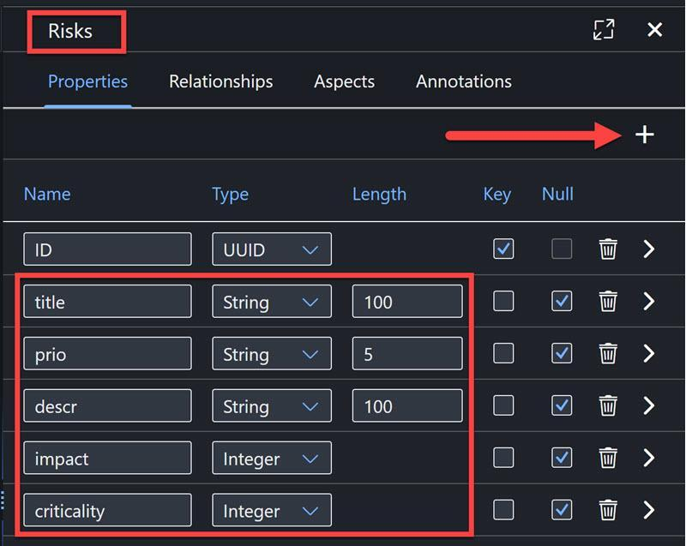
  - Create another entity called Mitigations by clicking Add Entity and dropping the new entity on the canvas.
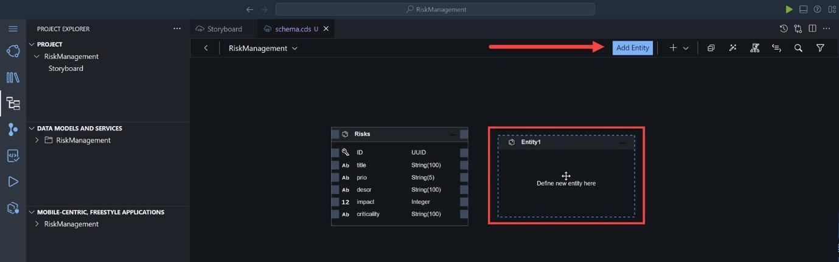
Again, click the Show Details icon (select the entity to see its side menu).
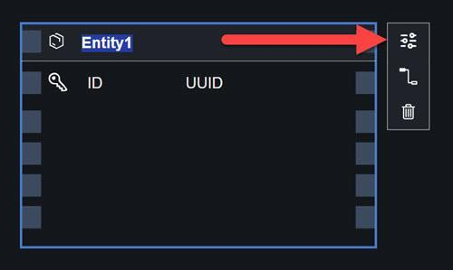
Change the name of the entity to Mitigations (and click ☑️) and add the following fields:
Property name | Property Type | Max Length
description | string | 100
owner | string | 100
timeline | string | 100
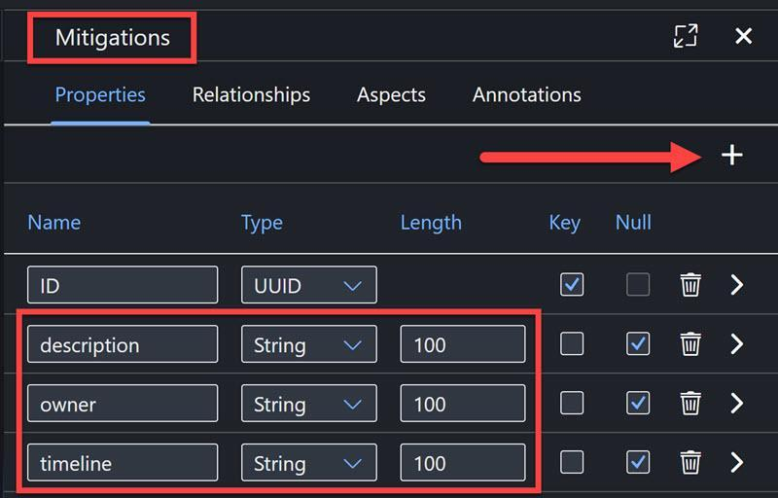
Close the editor by clicking the top-right X.
  - Add relationship between the entities by selecting the Mitigations entity, and clicking the Relationship icon.
This will create an arrow for you to indicate the other entity with which to form a relationship.
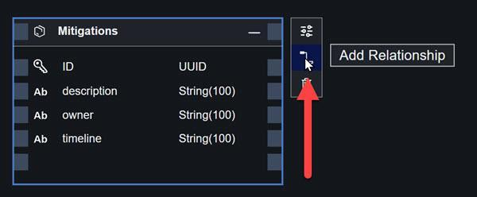
Drag the icon and drop it on the Risks entity, and click.
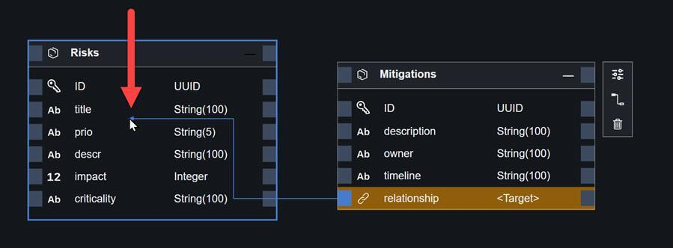
This will open the relationship editor.
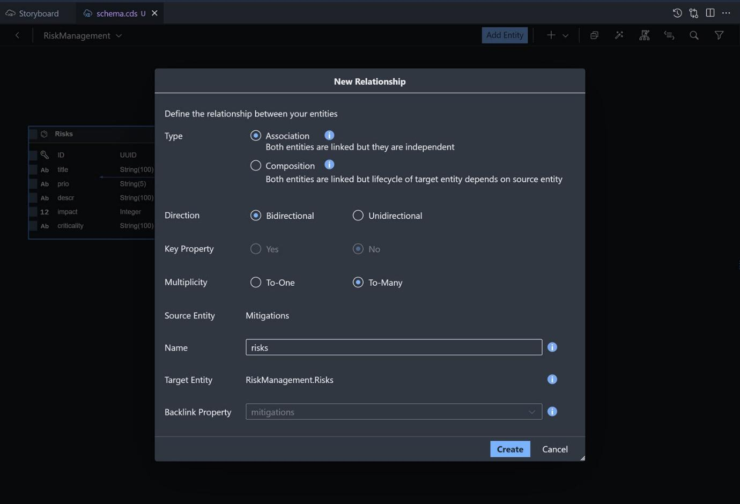
All of the following properties will be set:
Field | Value
Type | Association
Multiplicity | To-many
Name | risks
Target Entity | RiskManagement.Risks
Backlink Property | mitigations
Click Create.
This will create a relationship.
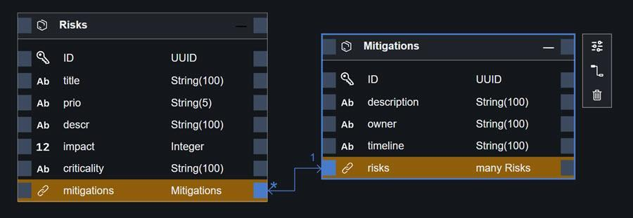
  - For both entities, open the Show Details pane again.
Select the Aspects tab, and enable the managed aspect.
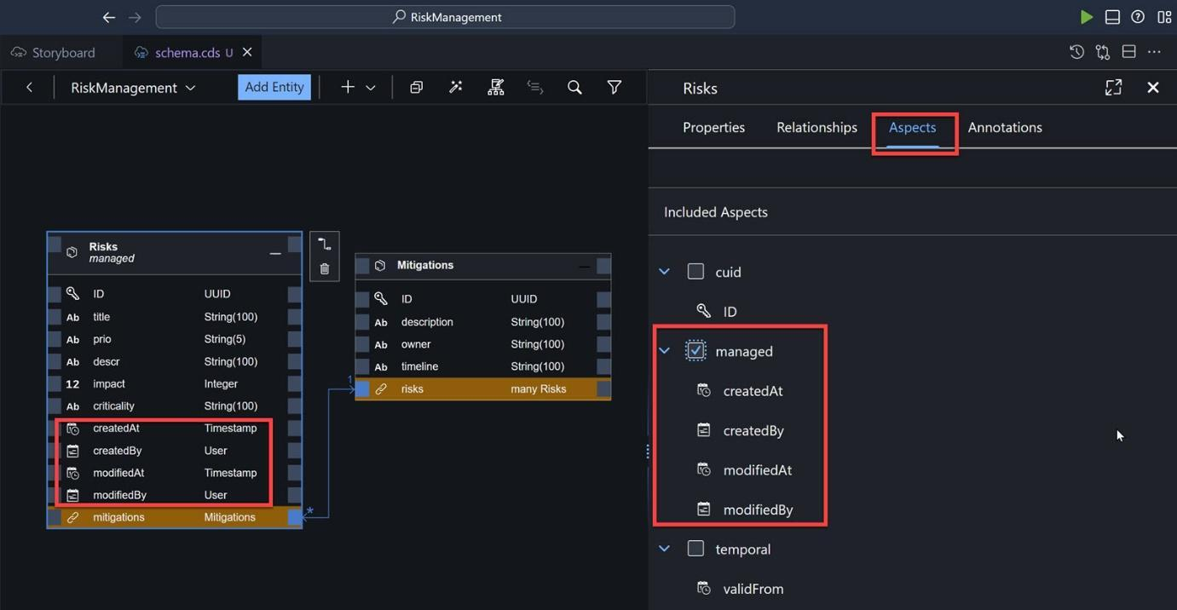
Repeat for Mitigations entity.
Done
- Step 3
Create service
  - Back in the storyboard, click the plus ( + ) next to Services to add a service.
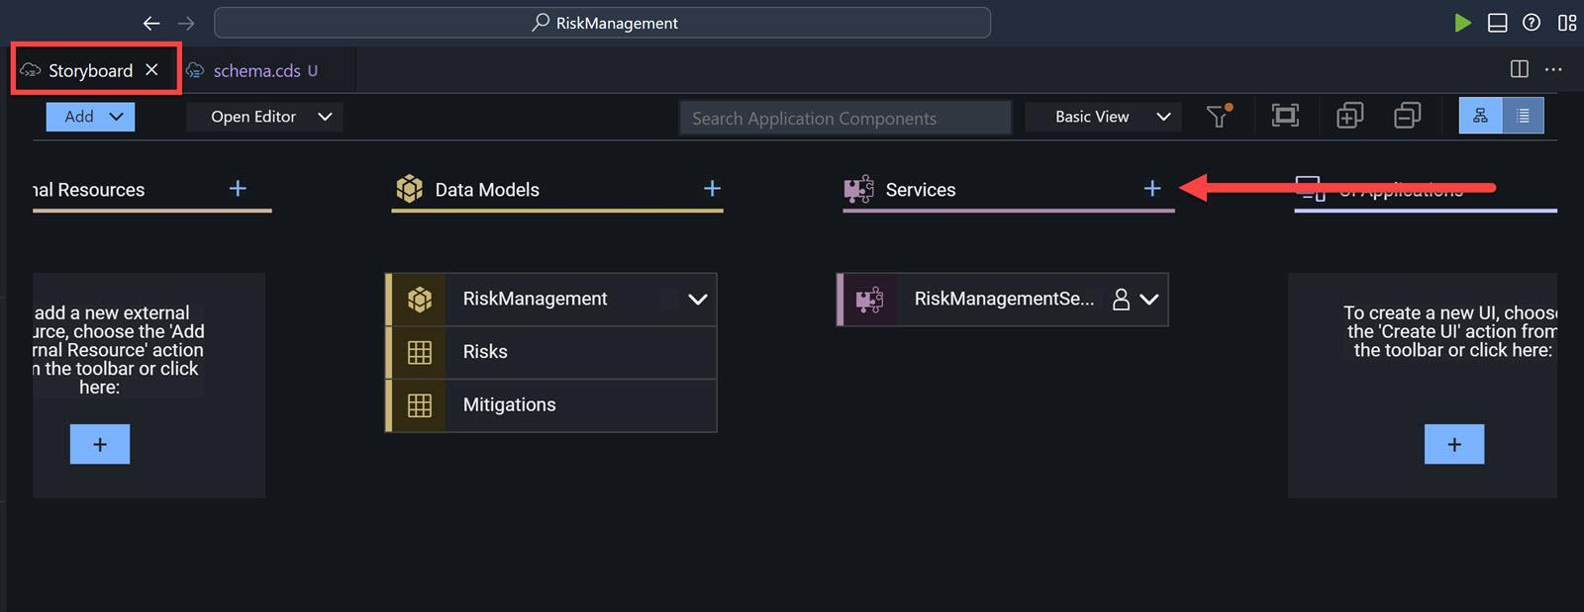
Choose the Risks entity, disable the Enable Draft Editing, and click OK.
IMPORTANT: Please make sure that the Enable Draft Editing checkbox is disabled, as this will prevent you from adding records and seeing the data in the following tutorials. Note that if you disable the checkbox and then select an entity, the checkbox will be re-enabled.
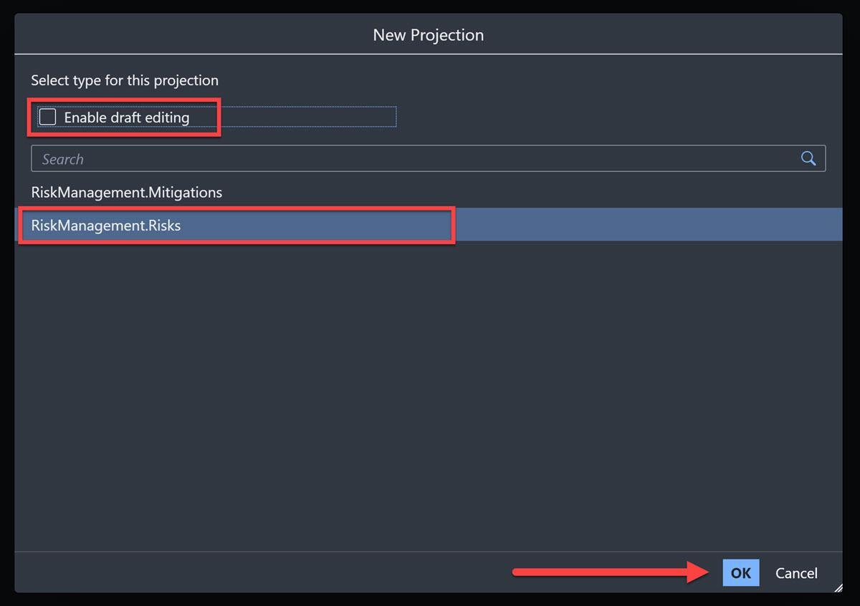
  - Click Add Entity and place the new entity in the canvas.
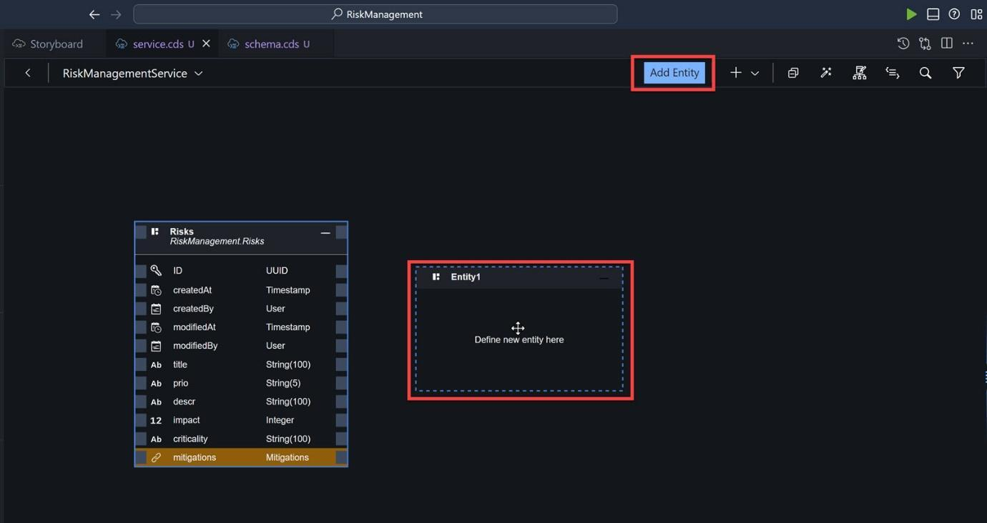
Choose the Mitigations entity, disable the Enable Draft Editing, and click OK.
Done
- Step 4
Add sample data
  - Download the CSV data files RiskManagement-Risks.csv and RiskManagement-Mitigations.csv.
  - Go back to the storyboard.
  - Right-click the Mitigations entity, and select Add Sample Data.
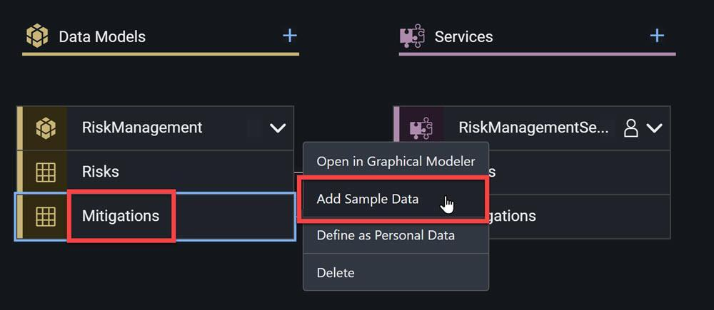
  - Choose Import, and click Add.
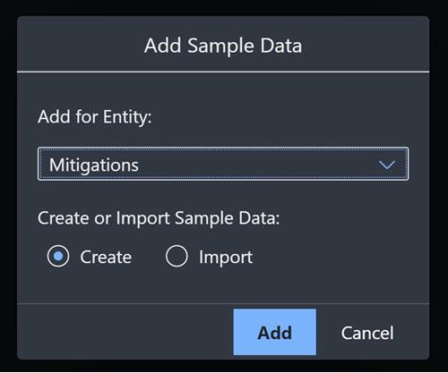
  - Select the downloaded RiskManagement-Mitigations.csv file.
The data is automatically added and saved.
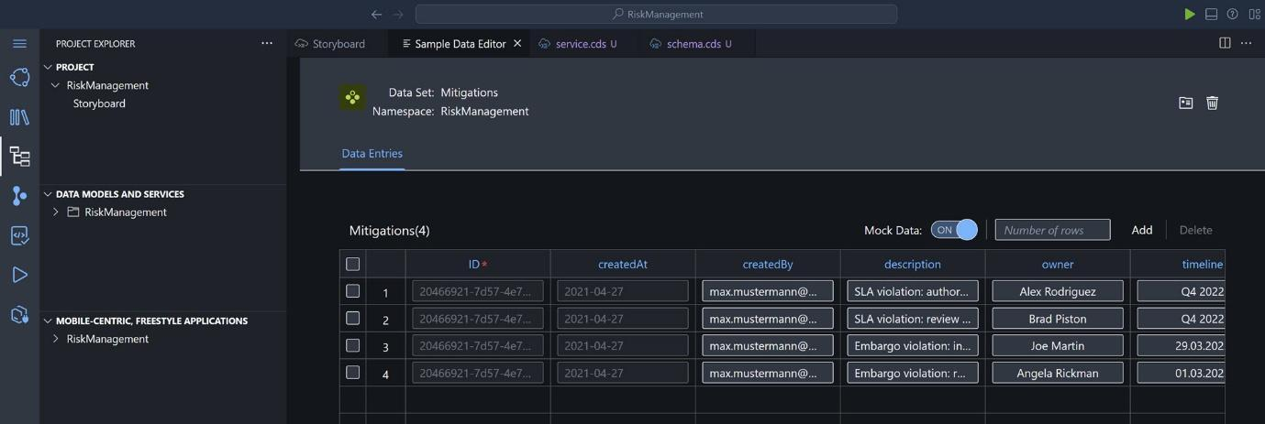
  - Go back to the storyboard, and do the same for the Risks entity with the RiskManagement-Risks.csv file.
Done
- Step 5
Add user roles
  - On the storyboard, select the little person icon next to RiskManagementService.
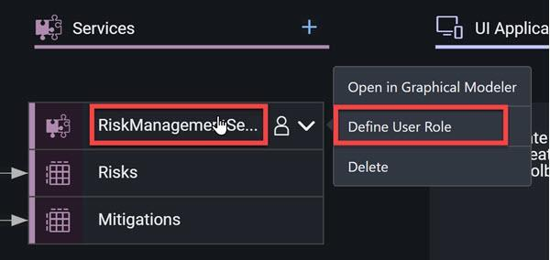
You can also open the User Roles editor by selecting the Open Editor dropdown and choosing User Roles.
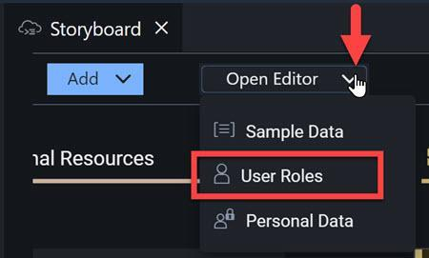
  - Add a role by clicking the plus sign ( + ) next to User Roles.
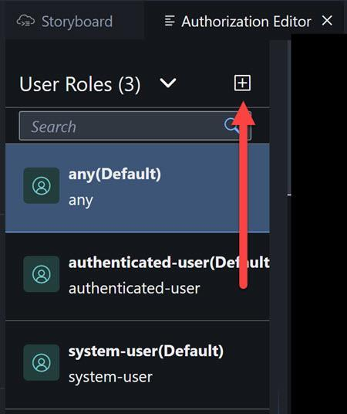
Call the role RiskViewer and keep the privilege at Read.
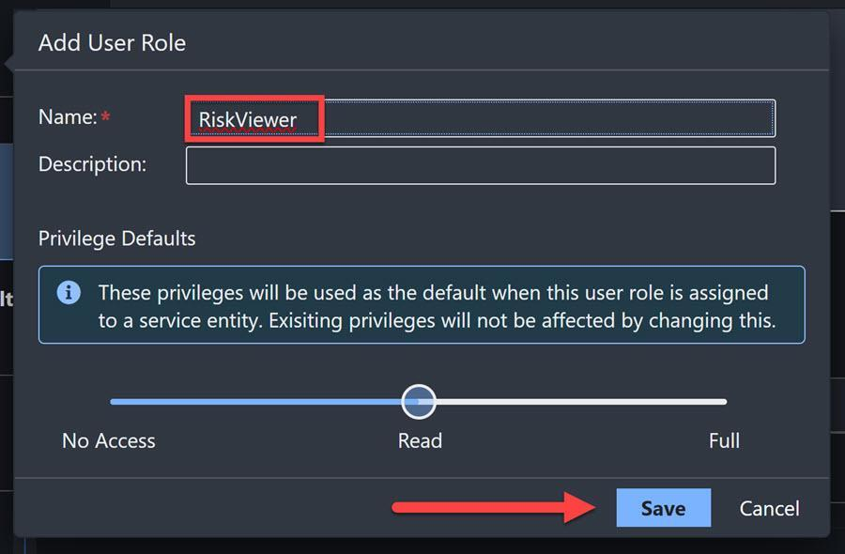
Click Save.
  - Select the new role, and then select your service, RiskManagementService from the dropdown.
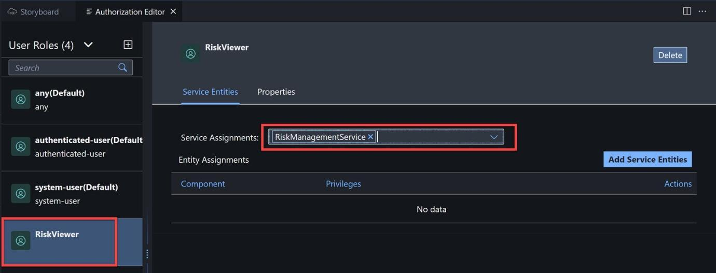
Click Add Service Entities, and toggle on the two entities. The privileges should already be set to Read.
Click Save.
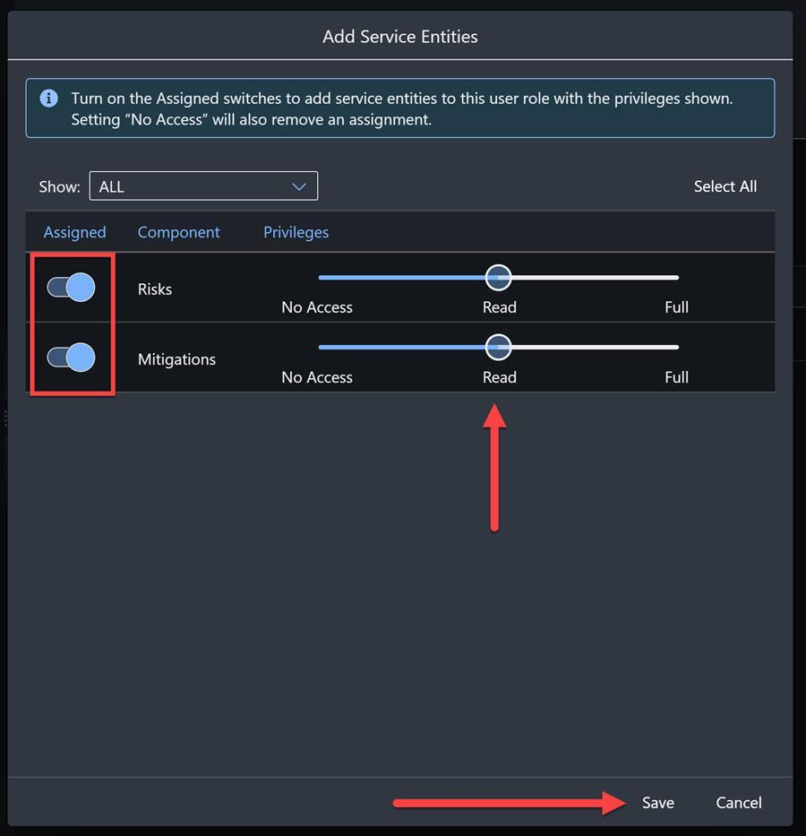
  - Add another role by clicking the plus sign ( + ).
Call the role RiskManager and change the privilege to Full.
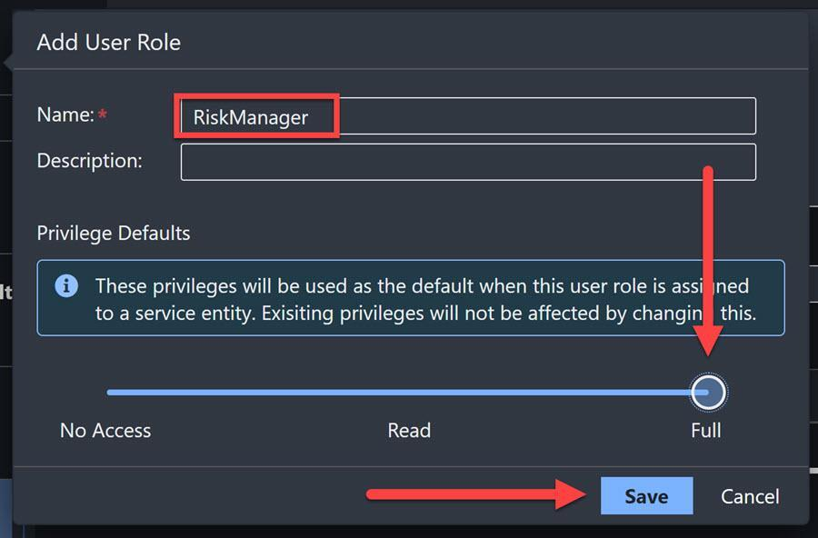
Click Save.
  - Select the new role, and then select your service, RiskManagementService from the dropdown.
Click Add Service Entities, and toggle on the two entities. The privileges should already be set to Full.
Click Save.
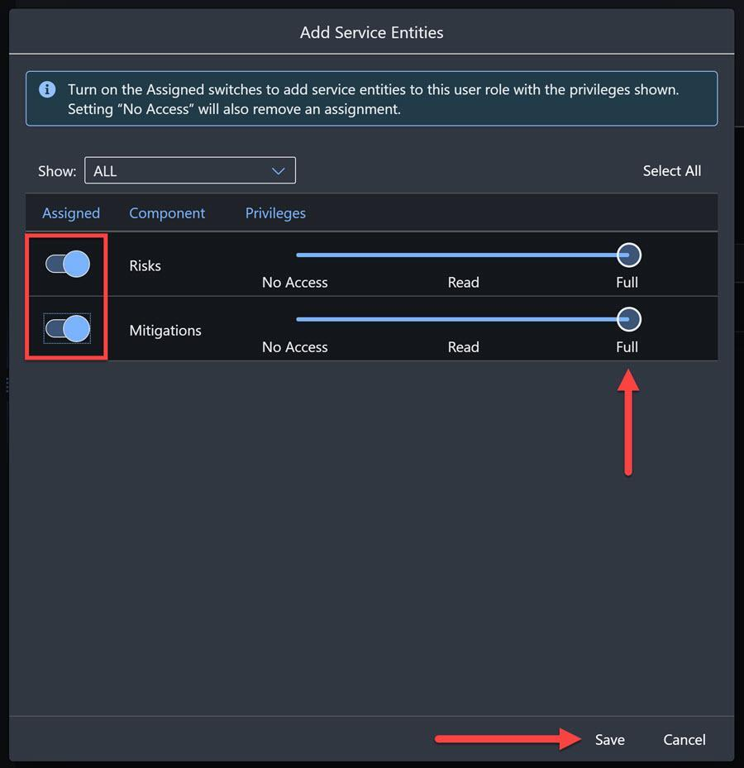
Done
- Step 6
Deploy project to SAP BTP
  - Open the Task Explorer by clicking on the side panel.

Expand the Deploy node to see your project.
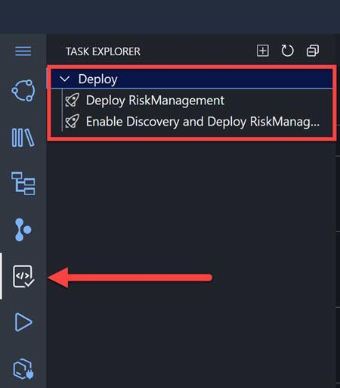
  - Hover over Enable Discovery and Deploy RiskManagement and click the Run icon next to your project.
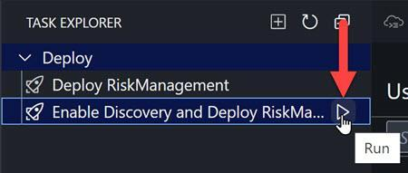
The deployment process will run briefly, a Terminal window will open at the bottom of the screen, and then the Cloud Foundry login screen will appear. (You may need to make the Terminal area smaller to see the login screen.)
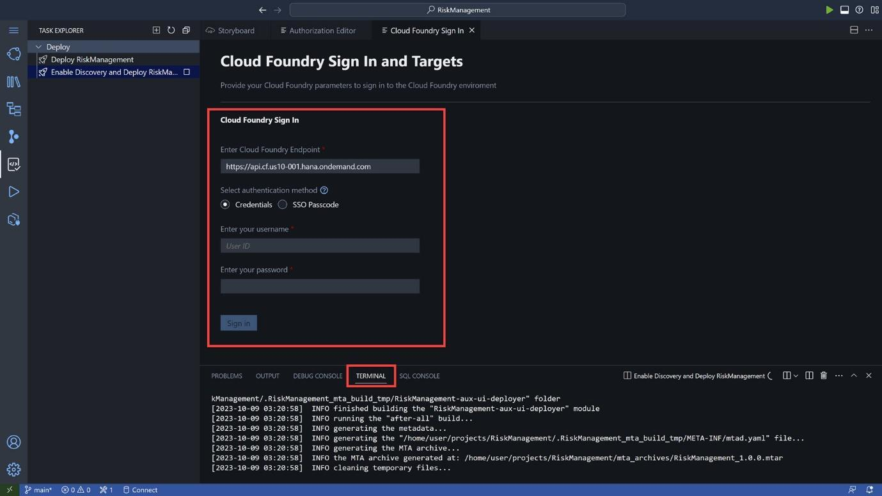
You are deploying to Cloud Foundry, so you must login and tell BAS to which Cloud Foundry to deploy.
  - Enter your Cloud Foundry endpoint, and your username and password for SAP BTP trial, and click Sign-in.
Once you login to Cloud Foundry in general, BAS will want to know to which subaccount and space you want to deploy to.
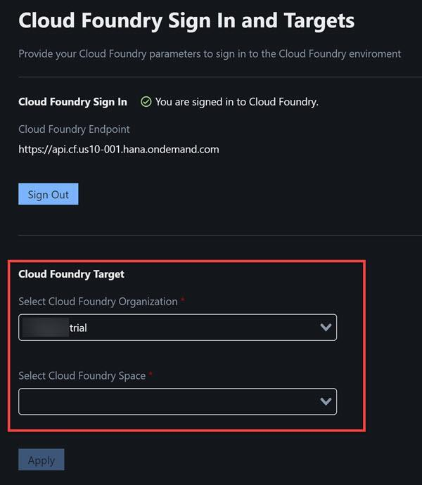
Select the subaccount (Cloud Foundry organization), and then the space.
If you are working on trial, you will likely have only one choice for each.
Click Apply.
The deployment will take about 5 minutes to finish. When complete, you will get the URL to your service, though you will not have permissions to view it.
TROUBLESHOOTING:
  - In a SAP BTP trial account, SAP Business Application Studio allows only 2 deployments using a Full-Stack Application Using Productivity Tools dev space. If you created the application from the SAP Build lobby, this is the type of dev space used behind the scenes.
  - If you have trouble redeploying the CAP service, you may want to remove the previous deployment by running the following command in a terminal window:
cf undeploy RiskManagement --delete-services --delete-service-keys
The above assumes your app is named RiskManagement. You can check all deployed apps by running the command cf mtas.

Check service
- In your trial account, on the left-side menu, click Cloud Foundry > Spaces. You likely will have only one space, called dev.
Click the space, and you will now see your application.
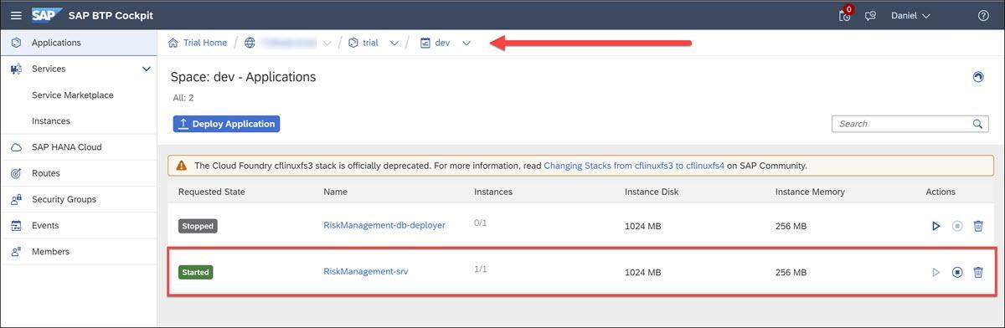
Click on the link RickManagement-srv, and you will see a link. Click on it.
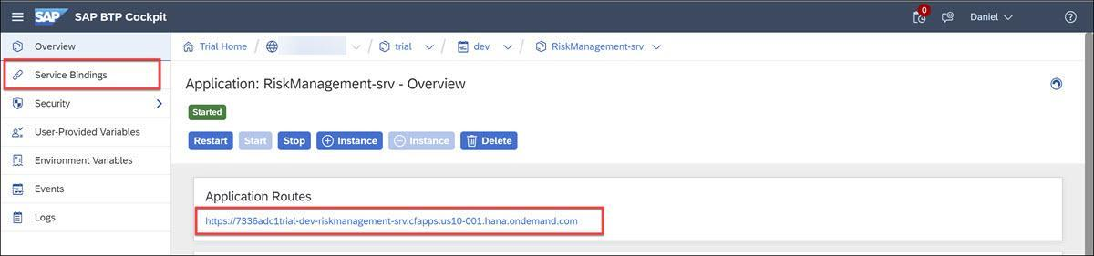
You will get a page with information about your service, with a link to the service (service/RiskManagement).
- Open SAP Build Apps
Open SAP Build Apps, by going to the SAP BTP cockpit, and under Instances and Subscriptions, click SAP Build Apps.
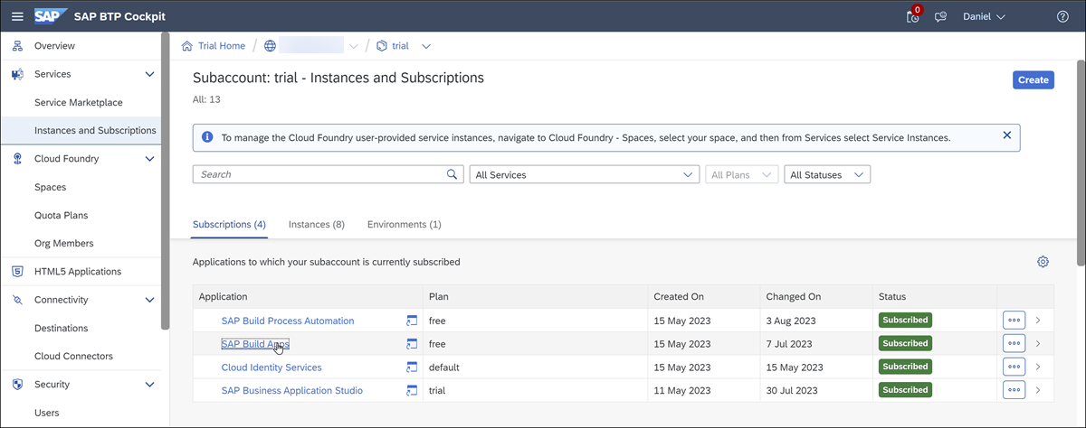
The SAP Build lobby should open.
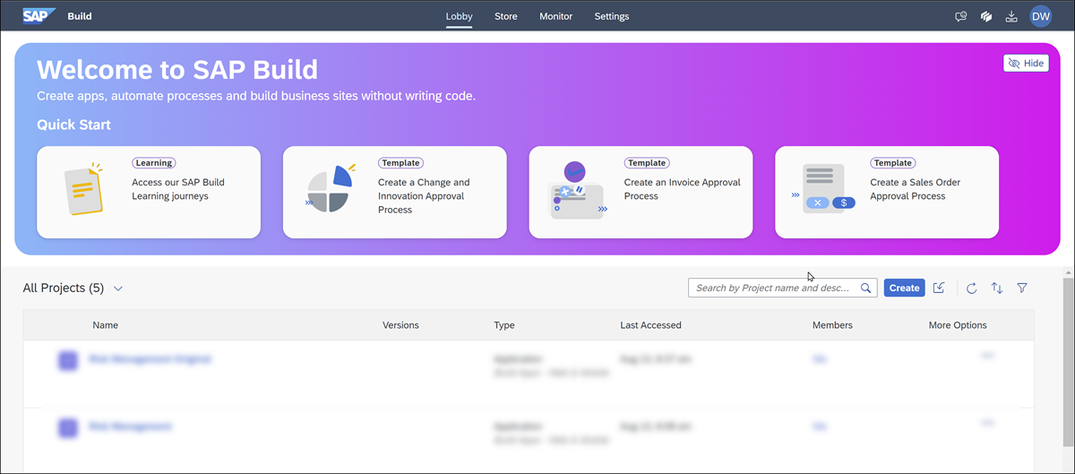
Done
- Step 2
Import project
First, download the skeleton project from RiskManagement.mtar.
Second, go to the SAP Build lobby and click on the Import button.
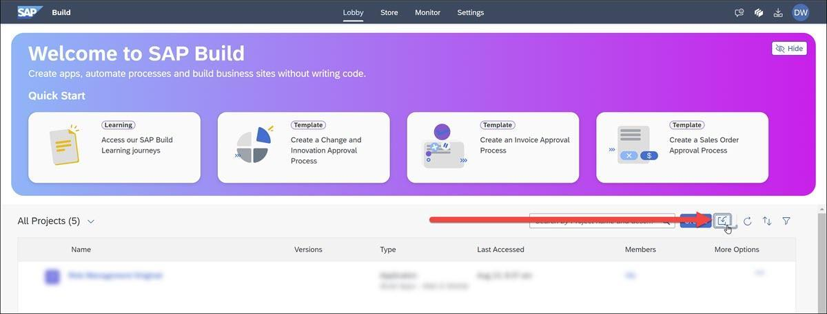
In the dialog, select the downloaded project file, and click Import.
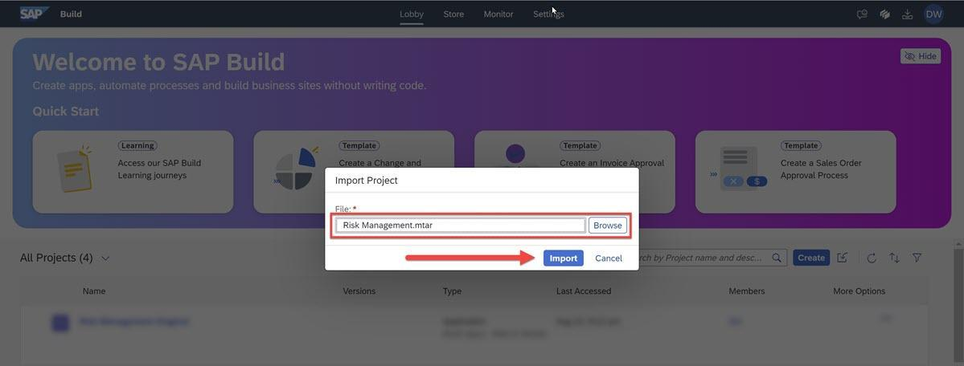
The project should be added to the lobby.
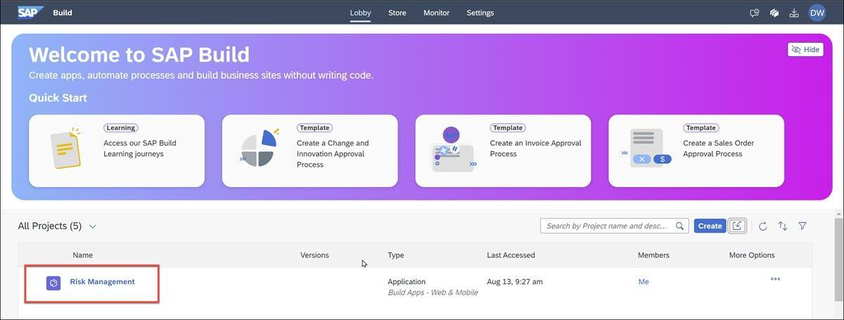
Click the project to open it.
If the project cannot load because it conflicts with an existing project or you already imported it, there is a second way to import projects (from within an existing project), and we have provided a second version of the project for this purpose.
Download the file RiskManagement.zip.gpg.
From within an open SAP Build Apps project, make sure the project is saved. Then go to the upper-right corner, select the 3 dots and then Replace – this import replaces and deletes the current content of the project.
Select the gpg file and click Replace.
Done
- Step 3
Create data resource for CAP app
The first thing you need to do is connect the project to your CAP service via our destination, to retrieve the data. And in order to do this we need to enable SAP BTP authentication.
  - Go to the Auth tab.
  - Click Enable Authentication, then select SAP BTP Authentication.
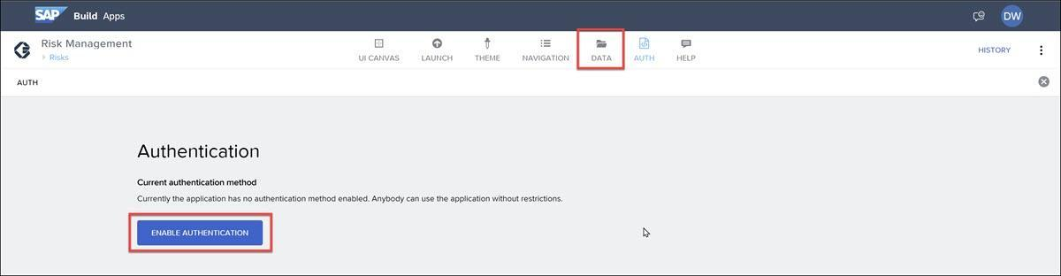
Click OK.
  - Go to the Data tab.
  - Click Add Integration.
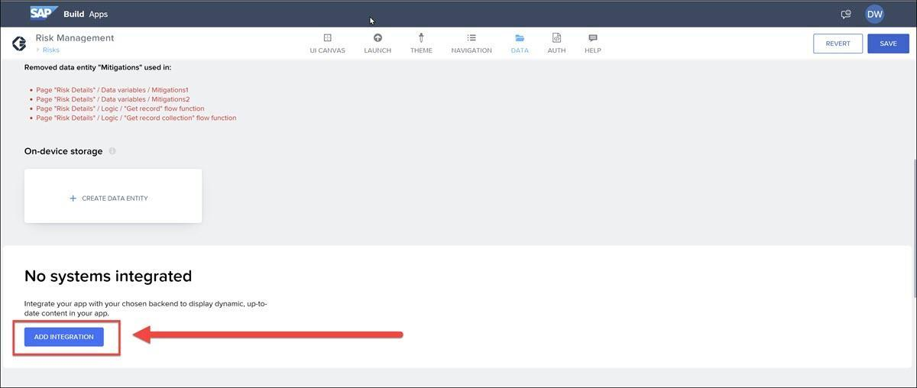
Note that there will be many error messages. This is because we already created data variables as well as bindings with those variables, but we deleted the data resources because we wanted you to do that part.
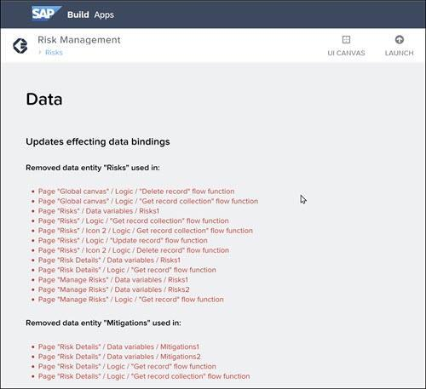
You can ignore these error messages. As soon as you create the data resources, they will go away.
  - Click BTP Destinations, and then select the the destination.
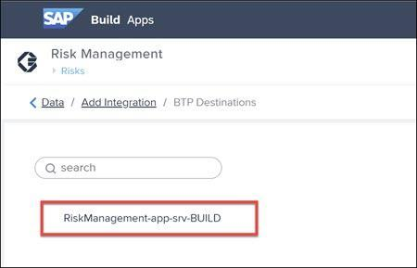
  - Click Install Integration (upper right).
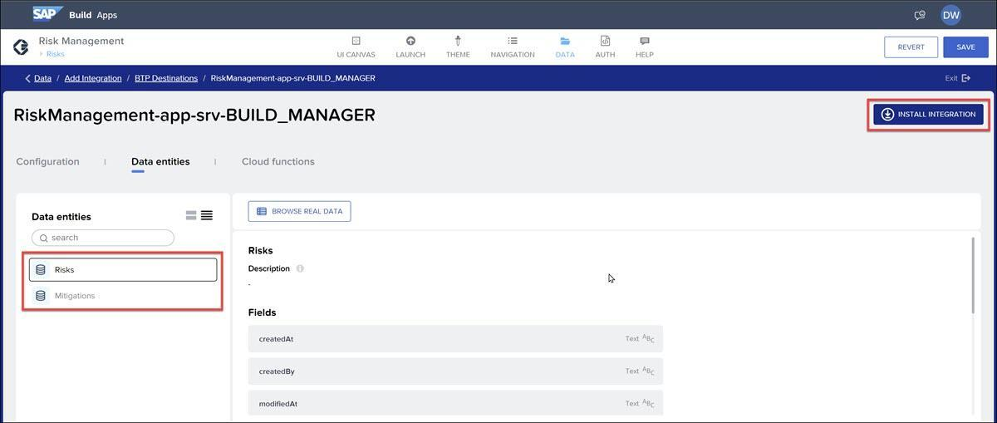
  - For each of the two entities, Risks and Mitigations, click the entity and then click Enable Data Entity.
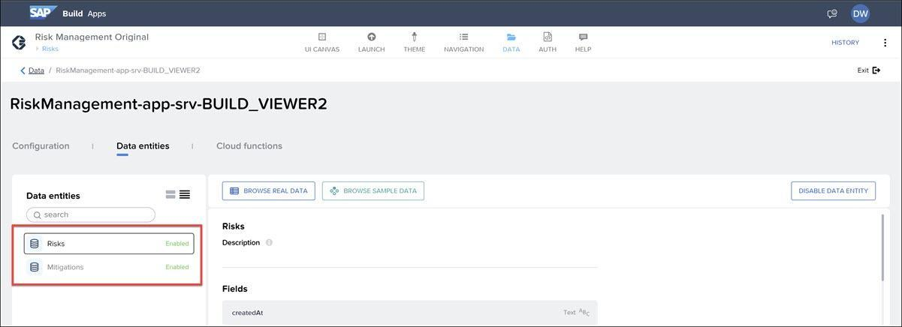
You can now click Browse Real Data to see live data from the CAP service.
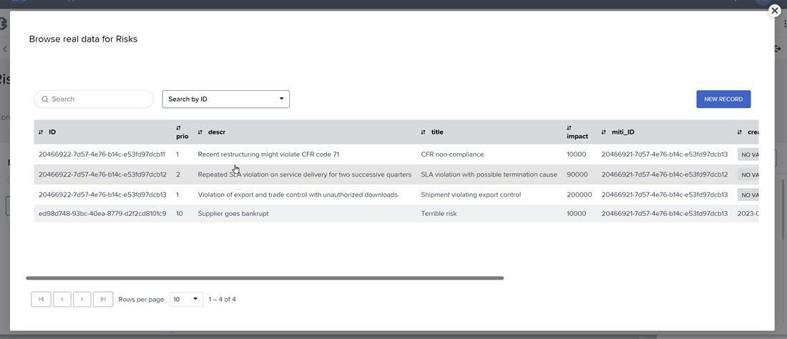
In addition, the errors should now be gone. Data variables were already set up on all 3 pages of the app, and now should be functioning properly.
Done
- Step 4
Risks – Review logic to check permissions
When the first page loads, we want to do 2 things:
  - Load the list of risks
  - Check whether user has permission to read / write.
Click the UI Canvas tab again to go back to the UI, and then open the logic canvas.
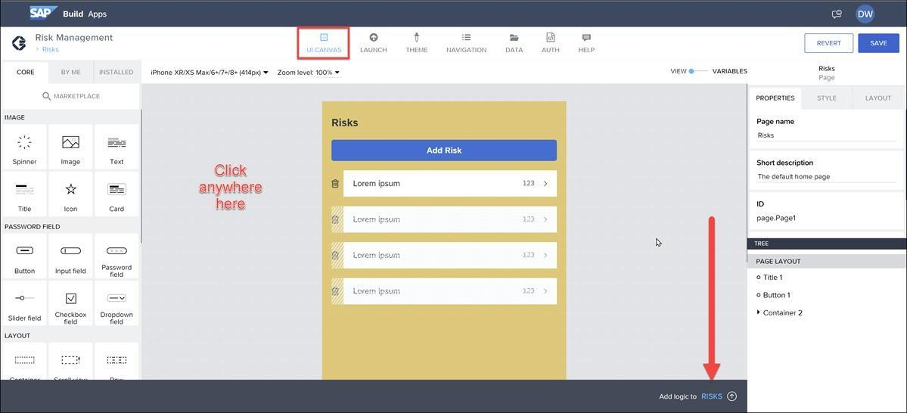
You should see the page’s main canvas page (the one you get if you click away from any component/variable, that is, in the open gray area). We’ve added the following logic:
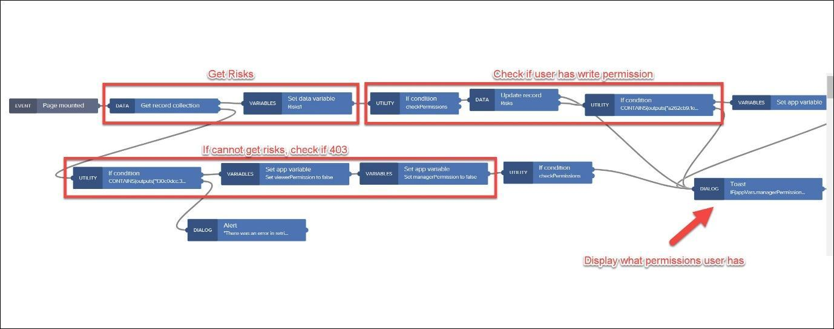
The logic is triggered when the page opens, and the following is performed:
  - Retrieve Risks: A call is made to the CAP service to get all the risks.
  - Check Write Permissions: If reading the CAP service succeeded, we now check if the user has write permission by making an empty update to the first record (the update does not change the record – PATCH update with no values). If the update fails, we set a page variable to indicate the user does not have write permission.
  - Check Read Permissions: If reading the CAP service failed, we check if the reason was because of permissions (403 status error). If yes, we set page variables to indicate the user has neither read nor write permissions.
  - Display User Permissions: After checking permissions, we display a toast message indicating what permission the user has.
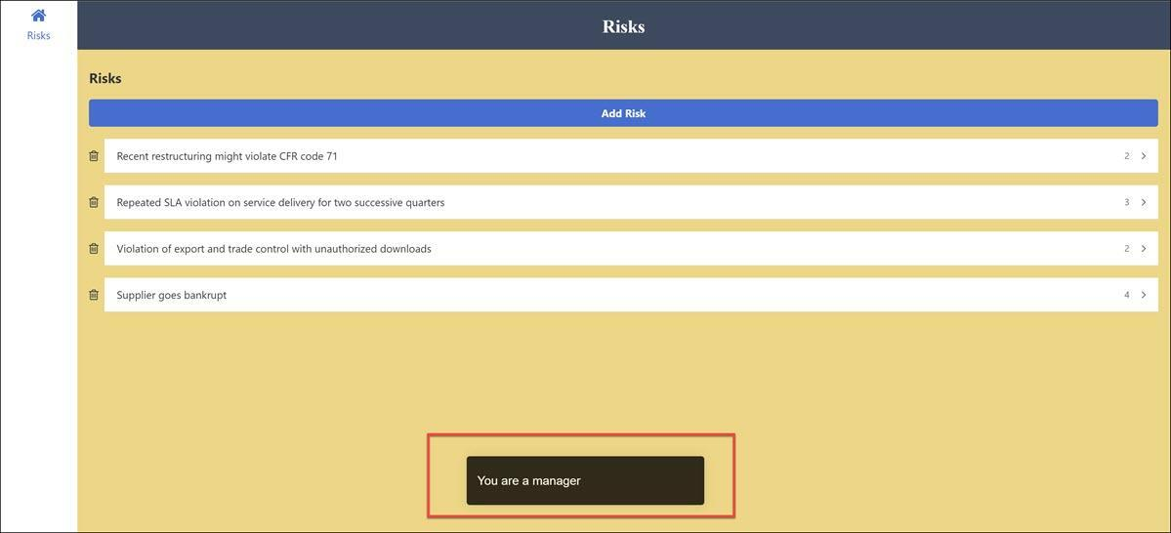
Done
- Step 5
Risks – Add logic to navigate to add risk
Now we just want to enable the Add Risk button to navigate to the Manage Risks page.
Select the Add Risk button and open the logic panel.
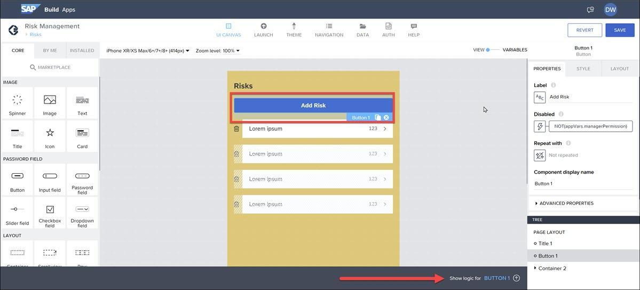
Add an Open page flow function, and connect it to the Page mount event.
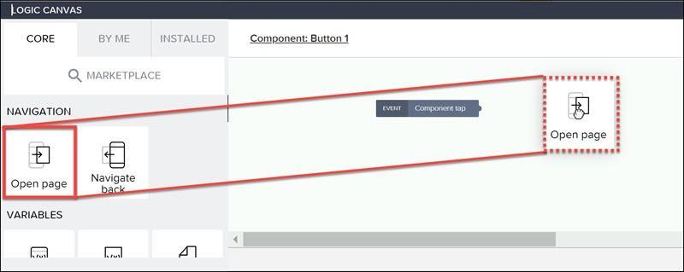
Set the page to open as Manage Risks.
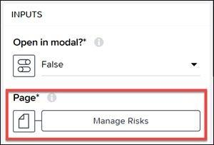
Click Save (upper right).
Done
- Step 6
Test app
Go to the Launch tab, then Open Preview Portal, then Web Preview.
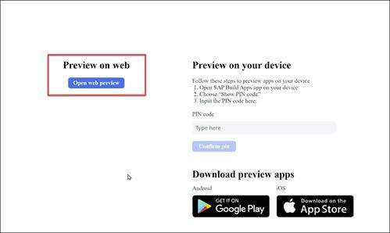
Click Risk Management to open the app. You should see the first page with a list of risks.
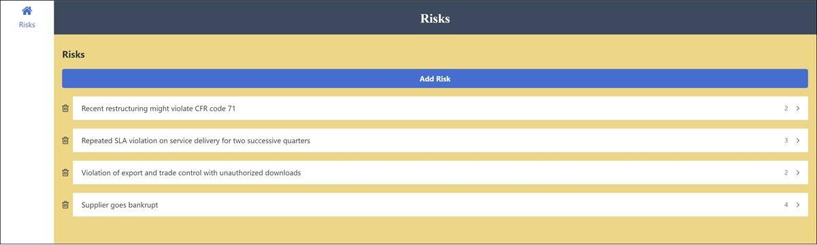
In addition, you see a toast message indicating what permissions you. In this case, since you gave yourself manager permissions, it should say you are a manager.
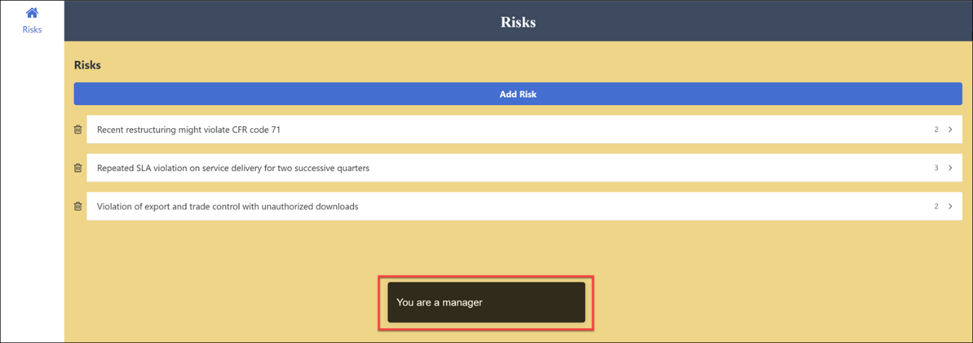
Also, the Add Risk button should take you to the Manage Risks page (though that page will not let you add a risk yet, and clicking Create Risk will not do anything).
When the app loads, logic is executed to tell if the user has read or write permission. How does the logic work?
  - The logic calls SAP BTP CLI to check the roles of the current user
  - The logic checks the system.user variable to see what permissions they have
  - The logic reads data and writes data and checks whether these operations were successful
  - The logic calls the UAA service and makes a query about the current user
Check answer
- Step 7
Manage Risks – Add logic to load data
The Manage Risks page can be used to add a new risk or update an existing risk if navigating from an existing risk.
The page has a page parameter. If sent, the page is for updating; if it’s null, the page will be used to add a risk.
  - In the upper left, click the link for the Risks page.
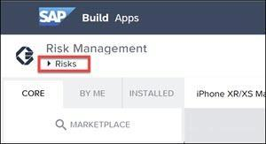
This will take you to the area for managing the app’s pages.
  - Click on the Manage Risks page.
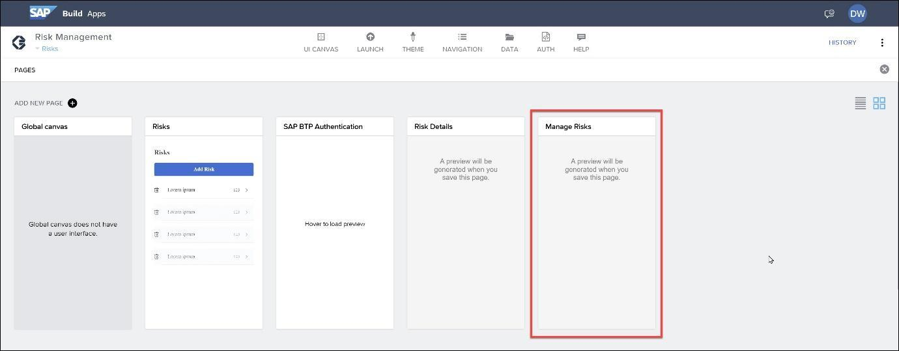
If you don’t go to the Manage Risks page, make sure to save your project (upper right).
  - Open the Variables.
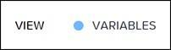
Click Data Variables. You have 2 data variables related to the Risks entity:
    - Risks1: This variable is specified as a New data record, meaning it is empty but has the schema appropriate for this data entity.
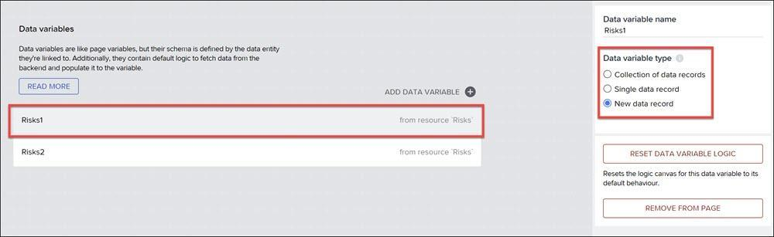
    - Risks2: This variable is specified as a Single data record, meaning it will retrieve the data of an existing risk if we navigated from an existing risk and we want to update that risk.
We will be calling the CAP service using Risks1. But if we are updating an existing risk, we want to copy the existing values into Risks1 from Risks2.
  - Click Risk2 and open the logic canvas. You should see the basic logic flow for data variables of type Single data record (except we already deleted the Delay flow function).
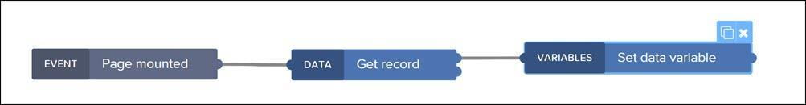
    - Click the Get record flow function, and set the ID to the page parameter RiskID.
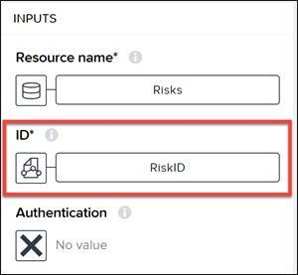
    - Add another Set data variable flow function to the end of the flow.
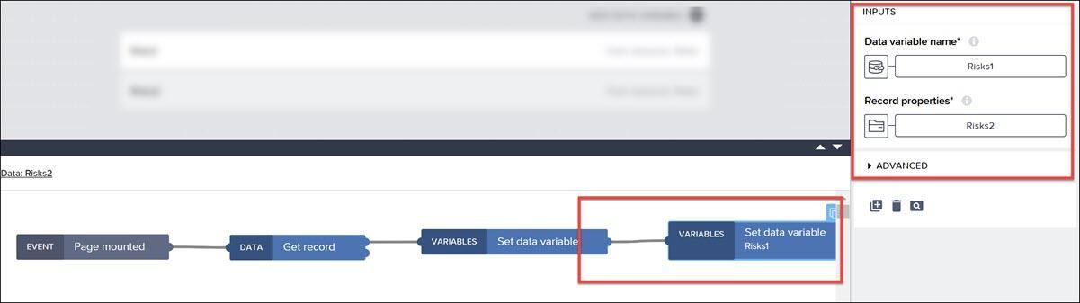
Set Data variable name to the data variable Risks1.
Set Record properties to the data variable Risks2 > Risks2.
Done
- Step 8
Manage Risks – Add logic to add/update risk
  - Back on the View tab, click the Update Risk button and open its logic canvas.
  - Add logic flow functions and connect them as in the following:
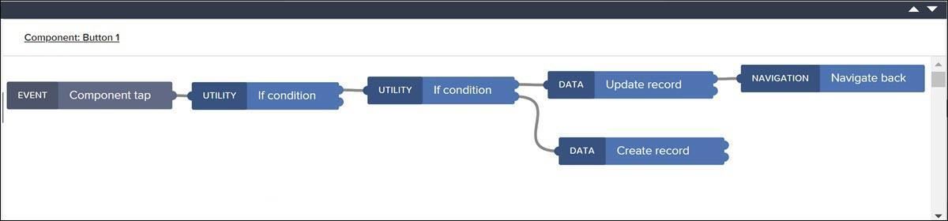
Be careful to use the top or bottom output of a flow function, as shown in the image.
  - Configure the flow functions as follows:
    - IF condition (first): Set the condition to the following formula (validates the prio field):
JavaScript
Copy
NOT(LENGTH(data.Risks1.prio)>5)
    - IF condition (second): Set the condition to the following formula (checks if we are updating a risk or creating a new one):
JavaScript
Copy
NOT(IS_NULLY(params.RiskID))
    - Update record: Set the following:
      - Resource name: Risks
      - Risk ID: page parameter RiskID
      - Record: Set the following formula (allows us to make sure the integer fields receive a number value):
JavaScript
Copy
{impact: NUMBER(data.Risks1.impact), title: data.Risks1.title, descr: data.Risks1.descr, prio: data.Risks1.prio, criticality: NUMBER(data.Risks1.criticality)}
    - Create record: Set the following:
      - Resource name: Risks
      - Record: Set the following formula:
JavaScript
Copy
{impact: NUMBER(data.Risks1.impact), title: data.Risks1.title, descr: data.Risks1.descr, prio: data.Risks1.prio, criticality: NUMBER(data.Risks1.criticality)}
This formula will show as read because we are not supplying an ID value. But the CAP service will assign an ID automatically when it is created. You can still save the formula.
  - Add Alert flow functions as follows:``
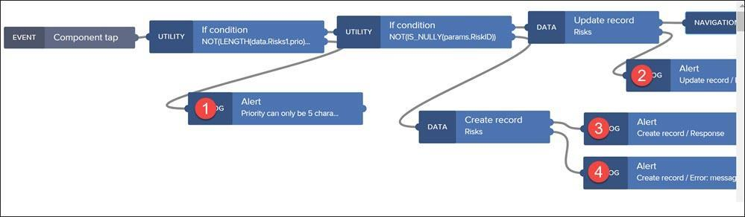
Set the texts for each alert as follows:
    - 1
Text
Copy
Priority can only be 5 characters
    - 2 (if update fails)
Set to Output value of another node > Update record > Error > Message.
    - 3
Text
Copy
New risk created
    - 4 (if create fails)
Set to Output value of another node > Create record > Error > Message.
  - Click Save (upper right).
Done
- Step 9
Test app
Again, go to the Launch tab, then Open Preview Portal, then Web Preview.
Click Risk Management to open the app.
Click Add a risk and enter values for the fields (test that priority cannot be more than 5 characters).
Click Create Risk.
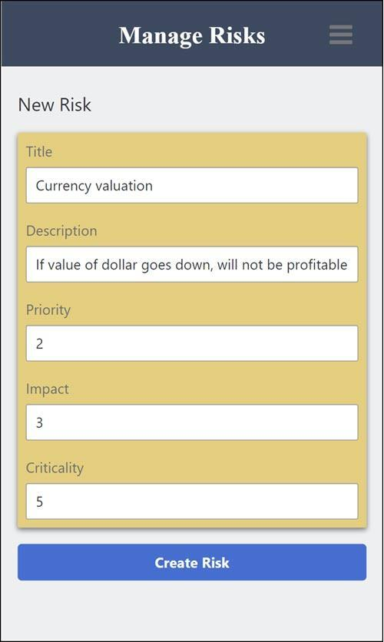
Troubleshooting: If your risk does not get added, you may have inadvertently enabled draft mode. Go back to your CAP service, select the Risk entity, and check its settings.
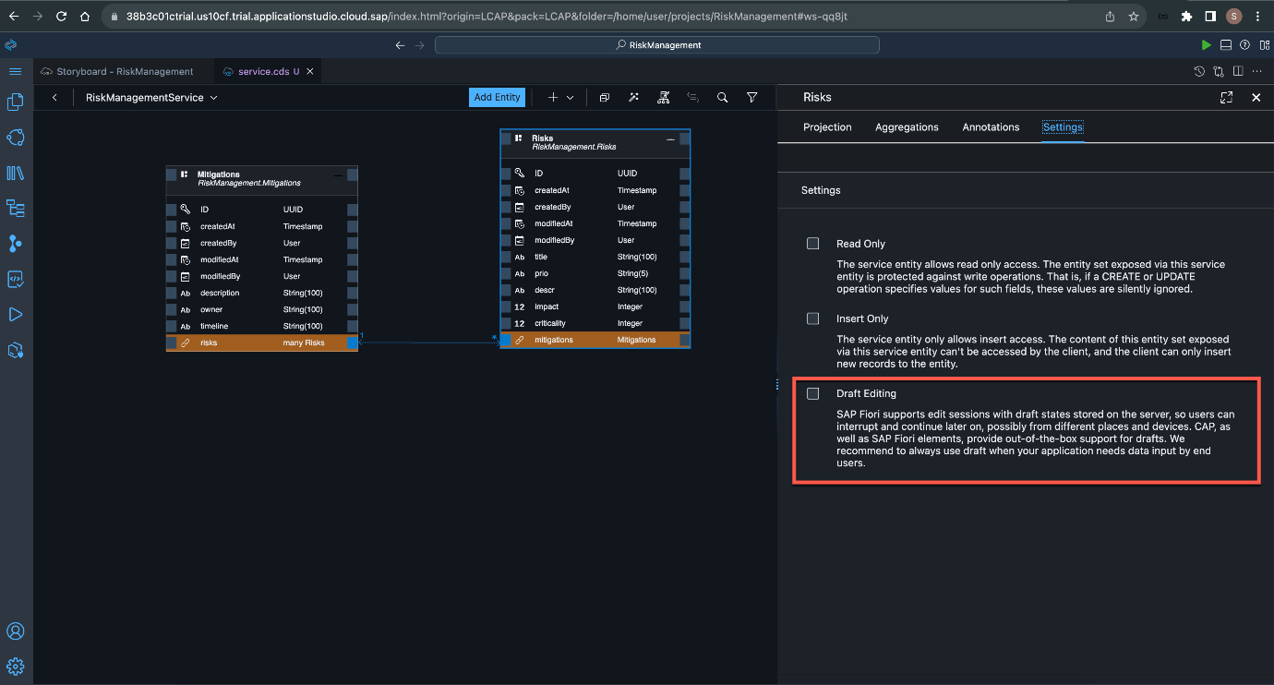
If draft mode is enabled, uncheck the option and redeploy the CAP service.
Now use the navigation menu to return to the main page with all the risks, and make sure your new risk is there.
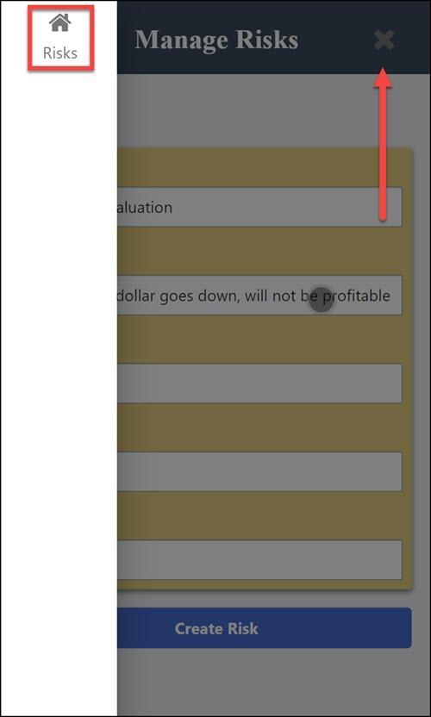
You should see your new risk.
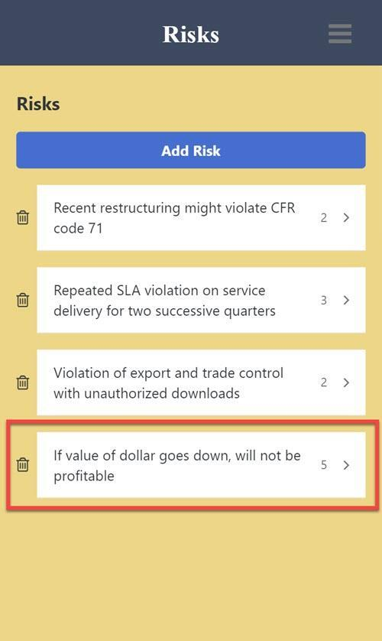
We will check the update functionality later.
In the Manage Risks page, how does the page know whether the user is updating an existing risk or creating a new one?
  - By knowing the page that called it
  - By checking if the RiskID page parameter was passed to it
  - By checking the contents of the risk data variable
  - By checking the contents of the mitigation data variable
  - By keeping track in the action page variable
Check answer
- Step 10
Risk Details – Add logic to edit risk
  - In the upper left, click the link for the Manage Risks page.
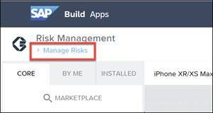
This will take you to the area for managing the app’s pages.
  - Click on the Risk Details page.
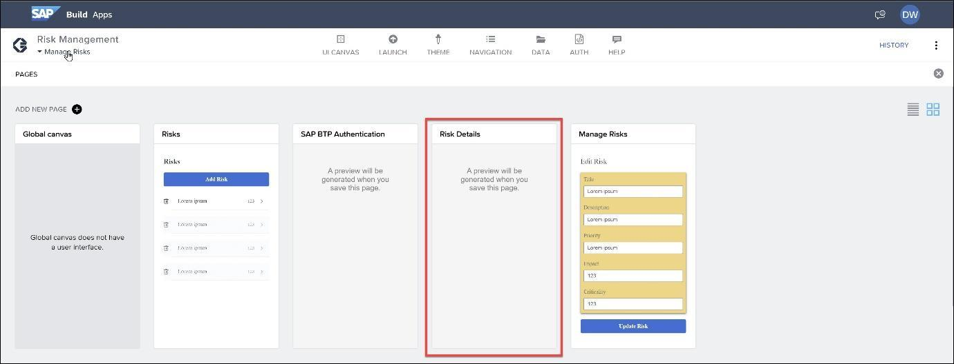
If you don’t go to the Risk Details page, make sure to save your project (upper right) and try again.
  - Click on the Edit button, and open the logic canvas.
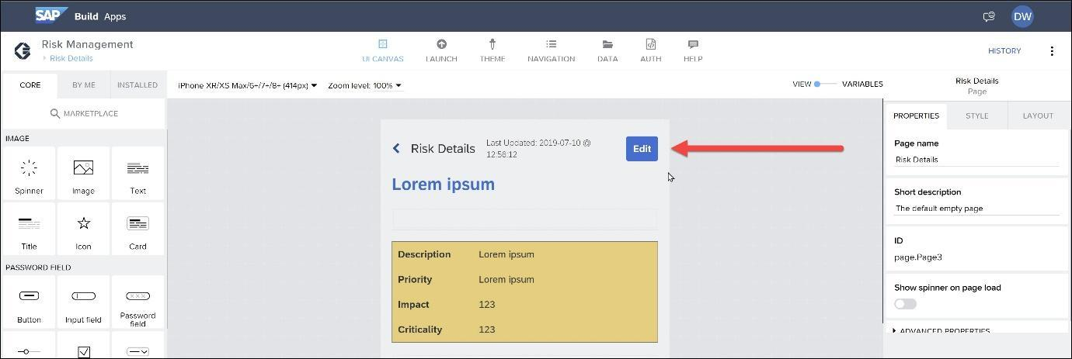
  - Add an Open page flow function, and connect it to the Component tap event.
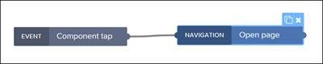
Configure the Open page flow function to open the Manage Risks page, and set the ID to the RiskID page parameter.
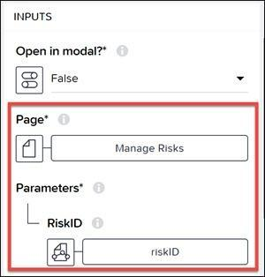
Done
- Step 11
Risk Details – Review logic to change mitigation
We want to enable the user to see all the existing mitigations, and to click on one to make it the mitigation for the current risk.
Select the list item component (just under the All Mitigations text) and open the logic pane.
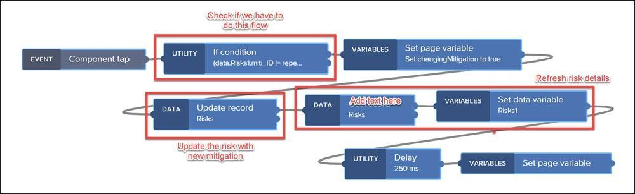
In this logic flow, we do the following:
  - Check Need for Update: We check 2 things to see if we need to do the update at all:
    - Does the user have write permission?
    - Did the user select a different mitigation?
  - Update Risk: If both checks are true, we update the risk.
  - Refresh Risk Details: We retrieve the risk details in order o refresh the page.
The other flow functions set the changingMigration variable in order to display a spinner while we are updating the record.
Done
- Step 12
Test app
Again, go to the Launch tab, then Open Preview Portal, then Web Preview.
Click Risk Management to open the app.
Click the risk we added earlier.
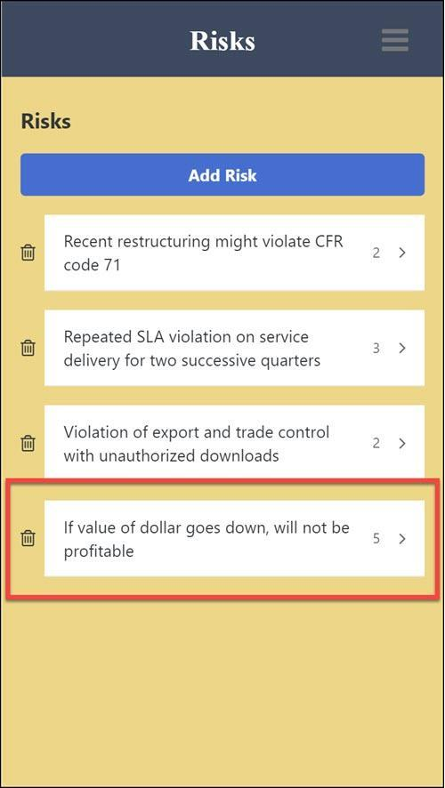
The risk will not have any mitigation. Click one of the mitigations to select it for this risk.
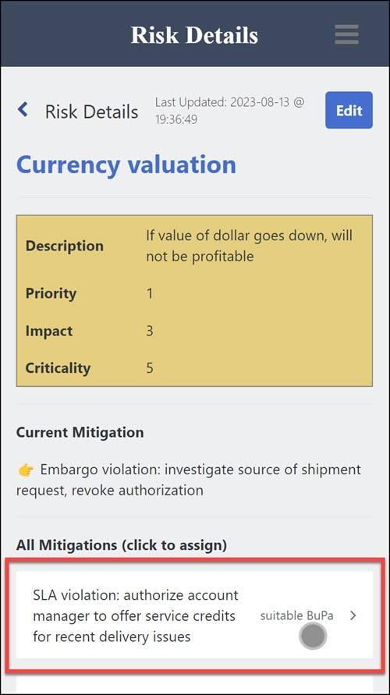

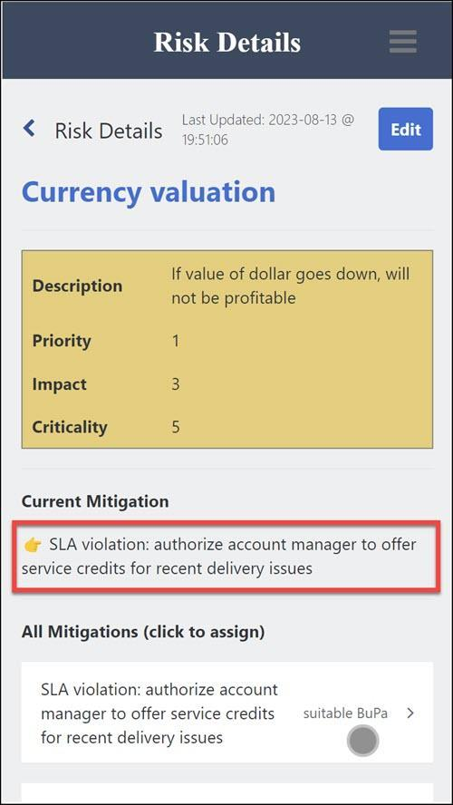
You can click Edit and change some of the fields.

You will not see anything yet since you are not authorized. In the next tutorial, we will test it from SAP Business Application Studio, and in the following tutorial you will access it from SAP Build Apps.
- The destination for your service – so that other services like SAP Build Apps can call it – was already created. But if you needed to create it yourself, you would do so by getting information about your service.
Go back to the previous page, and on the left click Service Bindings, and then click RiskManagement-uaa.
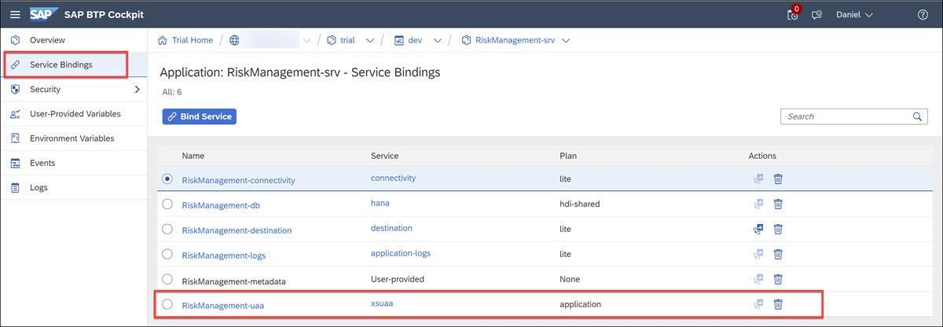
On the right you will see a service key, and by clicking View you will get the client ID, and secret and other information for this service that would be needed to create a destination.
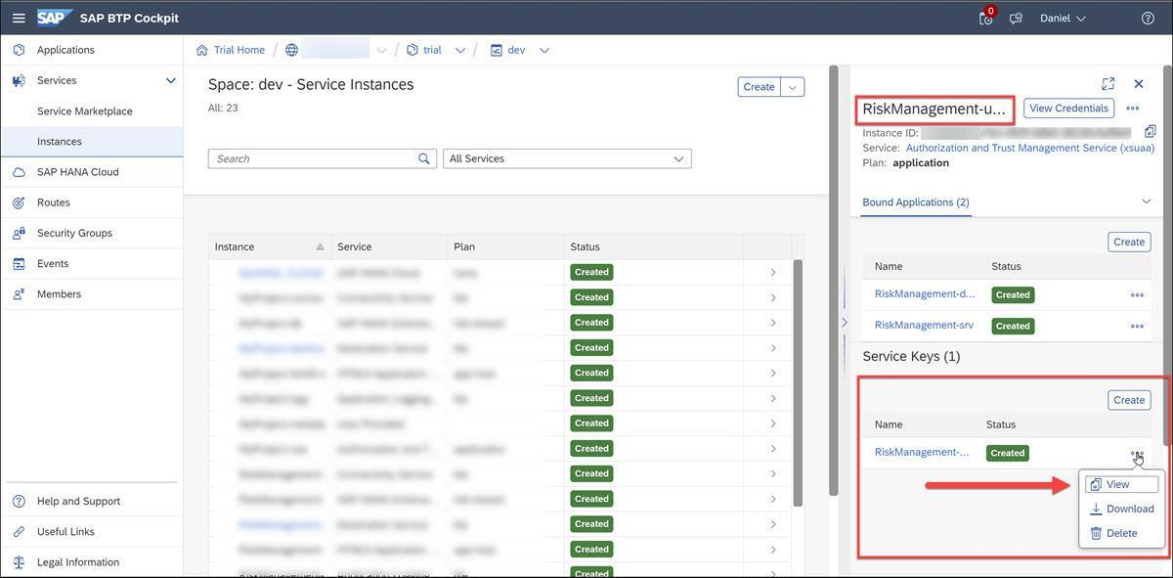
- Open your SAP BTP cockpit and navigate to the Cloud Foundry space where your service is deployed.
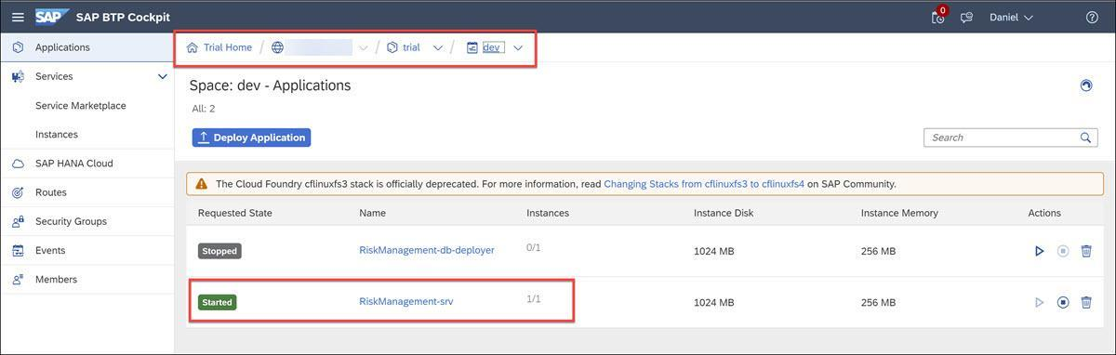
Click on the service, and then click on Service Bindings. Here you will RiskManagement-uaa
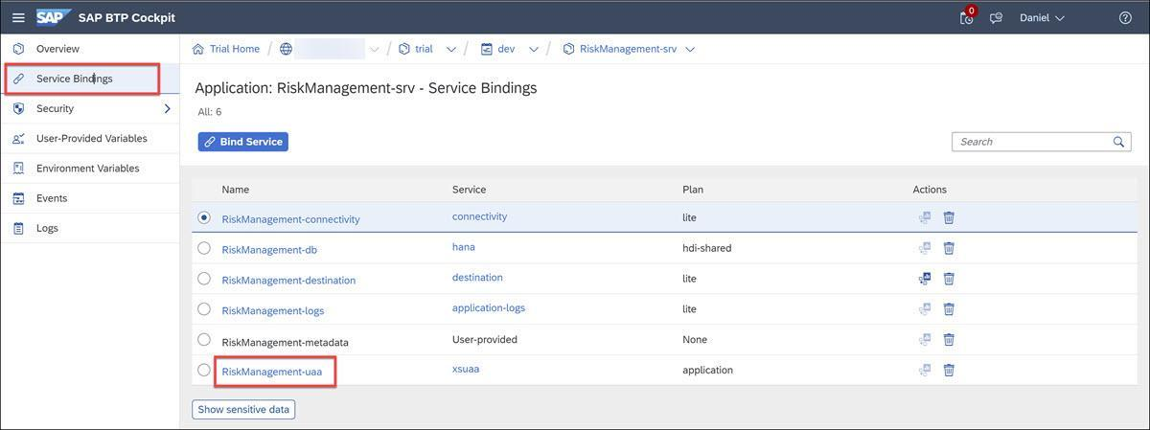
Finally, click on RiskManagement-uaa, and you will see a service key on the right, for which you can click View to get all the information that was used to build the destination.
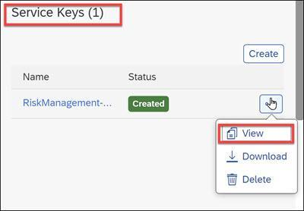
You won’t need this information now, but if you make certain changes to the destination, you may need to provide the client secret, which is found in this file.
Done
- Step 2
View destination
  - Navigate back to your subaccount (trial if you are in your trial account).
  - Go to Connectivity > Destinations.
  - Select the destination RiskManagement-RiskManagementService.
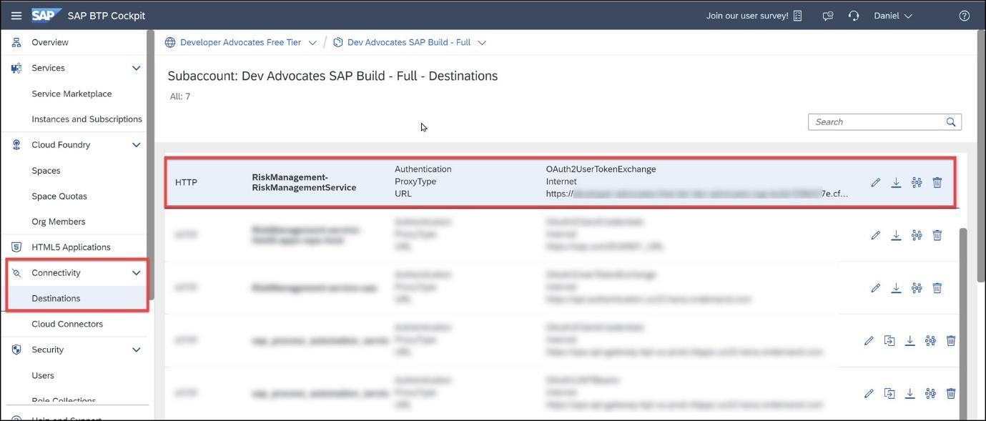
At the bottom of the page you will see all of the settings for this destination.
Notice the additional properties that make it available to SAP Build Apps and SAP Build Process Automation.
Field | Value
Appgyver.Enabled | true
WebIDEEnabled | true
HTML5.DynamicDestination | true
sap.processautomation.enabled | true
sap.applicationdevelopment.actions.enabled | true
And notice that the authentication type is OAuth2UserTokenExchange, which enables the service to know what user is calling it. Most of the other settings for authentication come from the service key.
Done
- Step 3
Give your user roles
  - In the cockpit, go to Security > Users.
  - Find your user for the custom IDP, and on the right, click Assign Role Collection.
  - Search for risk, select both roles you created with your service, and click Assign Role Collection.
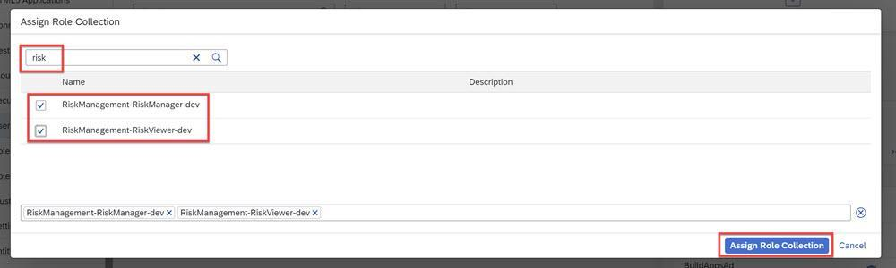
Why do we need to create a destination for the CAP service?
  - So that SAP Build Apps can access the CAP service
  - So that the CAP service can access other SAP BTP services
  - So that the CAP service has the necessary information to start itself each day
  - So that the cockpit is aware of the CAP service
Check answer
- Step 4
Test service
  - Go back to SAP Business Application Studio.
It must be the BAS located on the same subaccount as your service and SAP Build Apps.
  - Open a terminal window.
Either go to hamburger menu Terminal > New Terminal or View > Terminal.
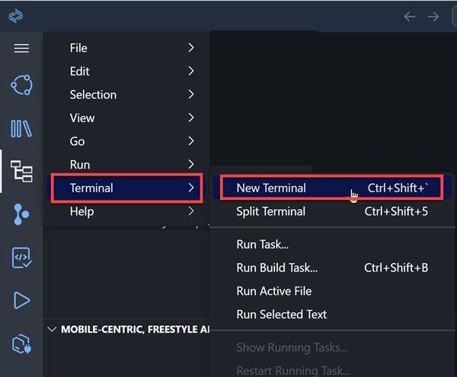
  - In the terminal, run the following commands separately:
Bash
Copy
curl http://localhost:8887/reload
Bash
Copy
curl https://RiskManagement-RiskManagementService.dest/Risks
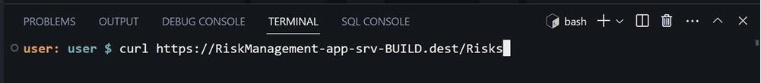
You should get the service document of the service.
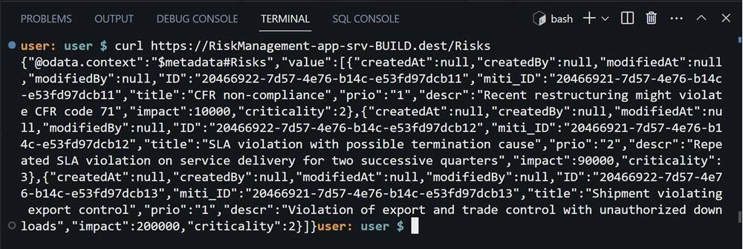
IMPORTANT: If for some reason you do not get a response from terminal, continue on with the rest of the tutorial.
  - If you remove the roles from your user, immediately you will see that you get a 403 error.
