RECALIBRATE
Week 2
Energy & Wellbeing - your workbook
Welcome to Week 2! This workbook is your chance to go deeper into this week's exercises and get properly specific about what's actually giving you energy, and what's taking it away.
In the same way as Week 1, feel free to use whichever exercises and lenses feel right. Just one exercise, or work through all three.
There are no right or wrong answers - take your time, be honest, and come back to your answers as often as you need. Let's dive in.

Step 1: The four types of energy
Objective: A framework for seeing energy as more than just “tired vs. not” - physical, mental, emotional and spiritual (Loehr & Schwartz, The Power of Full Engagement):
- Physical energy - the foundation: how well-fuelled, rested, and recovered your body is.
- Mental energy - your capacity to focus, think clearly, and make decisions without feeling foggy or scattered.
- Emotional energy - the quality of your mood and relationships: whether you feel steady, connected, and supported, or drained by tension and conflict.
- Spiritual energy - your sense of purpose and alignment: whether your day-to-day connects to what actually matters to you.

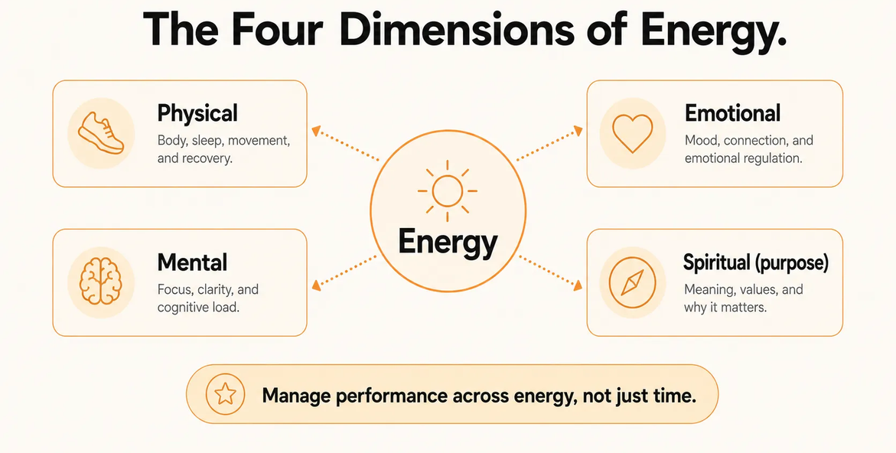
1.1 Physical
Body, sleep, movement, and recovery.
- How would you rate your physical energy right now, and why?
- What's one thing currently helping it, and one thing currently hurting it?
- What would meaningfully improve this, even slightly?

1.2 Mental
Focus, clarity, and cognitive load.
- How would you rate your mental energy right now, and why?
- What's currently cluttering your focus, or drawing on your mental bandwidth?
- What helps you think clearly?

1.3 Emotional
Mood, connection, and emotional regulation.
- How would you rate your emotional energy right now, and why?
- What's currently affecting your mood, day to day?
- Who or what helps you feel emotionally steady?

1.4 Spiritual (purpose)
Meaning, values, and why it matters.
- How would you rate your spiritual/purpose energy right now, and why?
- Does what you're doing right now feel connected to what matters to you? (worth revisiting your Week 1 answers here)
- What would make this feel more meaningful?

Bringing it together
- Which of the four types of energy feels lowest for you right now?
- Which one do you find hardest to protect?
- Based on everything above, what's one thing you want to focus on this week?

Step 2: Energy audit
Objective: Get a clear, honest read on where your energy actually goes - this week, and going forward.
Energy is a better leading indicator than motivation. Motivation follows energy, not the other way round.
- Where does your energy actually go each week?

- Does that match where your priorities are?

- On a scale of 0–10, how would you rate my energy levels right now?

Energising (+)
- What are 3 things currently energising you?

Draining (−)
- What are 3 things currently draining your energy?
Tip: don't edit yourself here - a messy, honest list beats a tidy, censored one. No scoring, no action step this time, just naming what's true right now.

Your weekly energy tracker
Turn this into a habit - revisit this table each week to notice your patterns over time, not just a one-off snapshot. Feel free to personalise this table and map your energisers and drainers against the four dimensions of strategy seen in exercise 1.

Week of | Top energiser(s) | Top drainer(s) | Energy score (0–10)

Step 3: Energy boundaries
Objective: Get clear on what you need to protect, and where you might need to say no.
A few types of boundaries to consider:
- Time - e.g. protecting set hours for job searching, or hours away from it.
- People - e.g. limiting draining conversations, saying no to certain asks.
- Tasks - e.g. not taking on extra work during a season that doesn't have room for it.
- Digital - e.g. protecting time away from LinkedIn, job boards, or your inbox.

A few examples to get you thinking - boundaries aren't just “no emails after 6pm”:
- If you're between roles: having no job can be just as draining as having a demanding one - a lack of routine or structure removes the natural rhythm that usually carries your motivation. A boundary here might be building a loose daily structure even without somewhere to be.
- If you're job searching: protecting set hours for job hunting rather than letting it bleed into every waking hour - or the opposite, protecting time away from job boards and LinkedIn.
- If you're employed: not checking email after a certain time, protecting your calendar from back-to-back meetings, saying no to extra work during a season that doesn't have room for it.
- General: boundaries around always being available to others, or around comparing your pace to everyone else's.

- Looking back at your drainers from the energy audit, which of those are actually within your control?

- What's one thing you need to protect your energy from right now?

- What's one boundary you know you need to set, but haven't yet?

- What's stopping you from setting it?

- Based on your answers above, what's the one boundary that would make the biggest difference right now?

- On a scale of 0–10, how confident do you feel about actually setting it?

- Is there any action, or anything you want to do NOW, to move towards setting this boundary?

Reflection & next steps
Now that you've worked through this week's exercises, take a moment to step back. Use the table below to note how confident and clear you feel from each exercise, and any next step that could help.

Exercise | Confidence (0–10) | Actions / next steps
1. The four types of energy
2. Energy audit
3. Energy boundaries

Share any learnings, outcomes or actions in the HerCircle community for accountability - and can’t wait to see you next week for Week 3: Mindset & Confidence.

