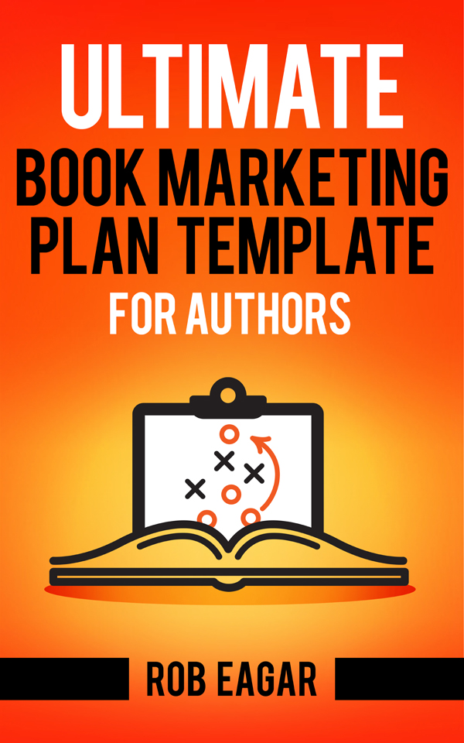

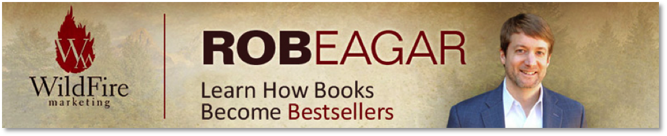
The Ultimate Book Marketing Plan
Template for Authors

Most authors spend 80% of their time writing a book, but only 20% preparing to market it. Yet, it’s the marketing part that determines if your book reaches its full sales potential.

I’ve worked as a book marketing consultant for over 10 years and trained more than 450 authors, including several New York Times bestsellers. Plus, I’m the published author of five books. My Ultimate Book Marketing Plan Template distills all of my experience into an easy-to-follow guide.

The material is designed to help you plan an effective book launch, regardless if you’re an indie author or traditionally-published, write fiction or non-fiction, a first-time author or an established veteran.

Directions:
Use this document to develop a professional-quality marketing plan for your next book. Fill out as much of this template as possible. There may be some areas that do not apply to your situation, but strive to implement everything that is listed. The template contains two parts:

a. Book Marketing Plan Template (15 sections)
b. Marketing Activity Timeline

The Book Marketing Plan Template uses 15 sections to help you identify essential tactics to promote your book. Each section includes concise instructions with checklists to follow.

The Marketing Activity Timeline on the last page will help you schedule the right activities at the right time between now and your book launch date.

After you fill out this template, you’ll have a step-by-step plan to walk you through an effective book launch.

To your success!

Rob Eagar
Wildfire Marketing

Book Marketing Plan
Directions: Read the instructions to complete each section. Then, delete my text to create your own document. Use as much space as needed to fill in all of your details.

Book Details
Title:
Subtitle:
Author:
Publisher:
Publication Date:

Book Hook
Develop a provocative sentence or question that you will use as a hook to grab a reader’s attention for your book.
Insert your book hook here…

For help creating an effective book hook, download my FREE guide, “Mastering Book Hooks for Authors” at: https://getbook.at/MasterBookHooks

Book Description
Insert a brief description of your book’s premise or story in 300 words or less. This is the marketing language that will appear on your back cover or your book’s Amazon page.
Insert your back cover copy here…

For a complete guide to write a sizzling book description, read my book, “The Author’s Guide to Write Text that Sells Books” at: https://getbook.at/WriteTextSellsBooks

Target Audience
Audience Characteristics:
Your book is NOT for everyone. Effective marketing occurs by identifying the readers who would be MOST INTERESTED to buy your book. Use this section to describe the specific interests, felt needs, and demographics that characterize your primary readers and where they congregate.
Describe the characteristics of your ideal reader here…

Use these 5 questions to list where your target audience congregates online:
- What websites do my target readers frequently visit?
- What social media groups are dedicated to my genre (Facebook, LinkedIn, etc.)?
- What active forums discuss my book’s genre?
- What blogs review books based on my genre?
- What online book clubs cover my genre?
List your answers here…

Author Website / Book Landing Page
Your author website is your book marketing headquarters. It’s where readers will find you after conducting a Google search or looking for your book online. Use the following checklist to make sure your website or book landing page contain these elements:

❑ Author Website URL Address:

❑ Email List Signup: Do you have a homepage sign-up form and pop-ups in place to invite people to join your email newsletter?

❑ Book Details: Is your book cover, marketing language, and video trailer displayed?

❑ Author Bio: Does your bio explain your history of helping or entertaining people?

❑ Retailer Links: Display logos and purchase links to all major online retailers

❑ Links to Social Media: Display social media logos so people can connect with you

❑ Social Media Share Page: Provide one-click social media posts people can share

❑ (Optional) Blog: Provide valuable content and/or stories—along with book updates

❑ (Optional) Pre-order Redemption & Thank-You Pages: Is there a form for readers to submit proof of ordering and a thank-you page to claim the incentives you offer?

Amazon Presence
Amazon sells more books than anyone, so you need a strong presence on their site. Your book’s product page will determine if people decide to buy. Your author page can help cross-promote other titles in your library. Use this checklist to cover the bases:

Amazon Book Page:
❑ Does your book cover look attractive and legible at a thumbnail size?

❑ Does your book marketing description start with strong hook in bolded text?

❑ Do you have any endorsements or industry reviews displayed?

❑ Do you have readers ready to write Amazon reviews (see Launch Team section)?

Amazon Author Central account and Author Page:
Create your free Author Central account at: https://authorcentral.amazon.com/
❑ Did you add all of your books to your author library?

❑ Is your author headshot displayed?

❑ Is your author bio displayed with the URL to your website?

❑ (Optional) Is your author blog and Twitter feed connected to Amazon?

❑ (Optional) Are your book trailer videos displayed?

Online Advertising
Amazon, Facebook, and BookBub offer affordable advertising for authors. For details and tips to buy effective online ads for your book, use these resources:
- Facebook Ads Online Course: https://www.facebook.com/blueprint
- Author’s Guide to Market Books on Amazon: https://getbook.at/MarketBooksonAmazon
- How to Buy BookBub Ads: https://insights.bookbub.com/category/bookbub-ads/

Select the platforms where you (or your publisher) will purchase online advertising:
❑ Amazon ❑ Facebook ❑ BookBub ❑ Other:

List the keywords below you will use to target your book ads to the right people:

Competitive Author Keywords:
List the author names here who write bestselling books in your genre…

Competitive Book Title Keywords:
List the book titles here that are bestsellers in your genre…

Reader Interest Keywords:
List the interests, hobbies, or clubs that typify your readers here…

For more details about using Amazon ads to promote books, read this free resource:
http://www.startawildfire.com/7-reasons-authors-use-amazon-advertising

Publicity & Online Influencers
It’s easy to increase sales when influential people promote your book to their audience. Use this section to identify connections you’ve secured with various types of influencers:

❑ Y/N: Do you have a book press release completed to solicit publicity interviews?

❑ Y/N: Do you have an email script ready to use to request online interviews?

❑ Y/N: Will you manage your influencer interview schedule? If not, who will help?

Online Influencers:
Major Podcasts: List potential and confirmed podcast interviews here…

Big Bloggers: List potential and confirmed blog interviews here…

Book Reviewers: List potential and confirmed book reviewers here…

Publicity and Media Influencers:
Television appearances: List potential and confirmed TV interviews here…

Radio interviews: List potential and confirmed radio interviews here…

Personal Influencers: Friends, Family, Colleagues, etc.
List anyone you personally know who is willing to help promote your book on their blog, social media pages, provide an endorsement, or post an Amazon review here…

Endorsements
List any endorsements received from business leaders, celebrities, musicians, pastors, athletes, etc. If waiting to receive an endorsement, put names on a separate list:
List any received endorsements here…

Email List
Email is the most effective tactic for selling books on this entire marketing plan. Use the following checklist to make sure you have the necessary tools in place:

Total subscribers on your email list: Avg. new subscribers per month:

List the sign-up incentive(s) you will offer to entice new subscribers:
1.
2.

❑ Y/N: Is your website optimized to get signups on home page?

❑ Y/N: Autoresponder series – Do you have a sequence of pre-written emails about your book that get automatically sent to new email subscribers?

For help creating email signup incentives and newsletters, read these resources:
http://www.startawildfire.com/2017/05/the-irresistible-incentive.html

The Author’s Guide to Email Marketing: https://getbook.at/AuthorEmailMarketing

Social Media
Studies show social media is not the best way to sell books directly to readers. Instead, social media is best for capturing email subscribers, driving traffic to your website, and spreading word of mouth. Use this checklist to monitor your social media activity:

Select the social media platforms that you use and list the current number of followers:
❑ Facebook: ❑ Twitter: ❑ Instagram:
❑ YouTube: ❑ LinkedIn:

❑ Y/N: Does a picture of your book appear in your social media page header images?

❑ Y/N: Are you purchasing lead generation ads on Facebook to build your email list?

❑ Y/N: Do you have 10 book quotes with images premade to share on social media?

To use social media with the right perspective and get best results, read this resource:
https://www.startawildfire.com/2018/10/the-secret-to-selling-books-with-social-media.html

Bulk Sales
List the people and organizations who could place orders for 100 copies or more:

Individuals: List individuals to contact here…

Organizations/Schools: List organization representatives to contact here…

Pre-Orders
If you are trying to hit a bestseller list, gain influence with retailers, or generate early cash flow, accepting pre-orders for your book 90 days before launch can be a good strategy. Use the following checklist to plan the details:

List at least two incentives you are prepared to offer to encourage pre-orders:
1.
2.

List two incentives will you offer for purchases of 5 copies or more:
1.
2.

❑ Does your website have a pre-order form and thank-you page that enables readers to confirm early purchases and claim the incentives you’re giving away?

❑ What date will you start your pre-order campaign?

Book Launch Team
Create a launch team of fans to spread word of mouth during your book campaign. Put fans on a separate email list for easy communication. Select where will you recruit fans:

❑ My email list ❑ My Facebook fans ❑ My friends & family ❑ Other:

How many people are committed to your Launch Team? _______

❑ Y/N: Is there a page on your website to provide one-click social media sharing tools?

Select the marketing activities that you will ask your Launch Team to complete:
❑ Post reviews of your book on Amazon and other online retailers

❑ Share book quotes and images on social media

❑ Promote your book on their blog, newsletter, podcast, etc.

❑ Buy a copy of your new book

❑ Other:

Public Speaking & Live Events
Public speaking is the best way to get PAID as you promote your book. You can earn a speaking fee and sell books during events – live and online. List your plans to create a speaking tour and/or speak via video from home:

Public speaking:
Confirmed events and dates: List here…

Potential event and primary contact person: List here…

Online speaking:
Webinar: List any planned dates here…

Facebook Live: List any planned dates here…
Marketing Activity Timeline
Use this checklist to schedule various activities of your Book Marketing Plan. Follow the suggested lead times below to ensure that you don’t miss key windows of opportunity:

6 – 12 Months in Advance:
❑ Contact organizations to schedule public speaking events
❑ Build author website and book landing page

3 – 6 Months in Advance:
❑ Submit book galley to industry book reviewers
❑ Contact organizations and individuals that can buy books in bulk
❑ Contact online influencers, including podcasters, bloggers, etc.
❑ Hire PR firm or contact national radio / TV programs for interviews

1 – 3 Months in Advance:
❑ Create pre-order incentives and launch pre-order campaign (optional)
❑ Recruit book launch team
❑ Continue booking media interviews and speaking engagements

30 Days Before Launch:
❑ Escalate pre-order campaign
❑ Send 1 - 2 emails per week to your email list that feature your book
❑ Speak in public, conduct online webinars, or host video chats with fans
❑ Send advanced reader copies (ARCs) to your launch team and create social media share tools

Launch Day and 30 Days Afterwards:
❑ Ask launch team to post Amazon reviews
❑ Send 2 promotional emails per week to your email list featuring your book
❑ Buy online advertising (Amazon, BookBub, Facebook, etc.)
❑ Speak in public or conduct online webinars to promote book
❑ Thank launch team and ask them to use social media share tools

Ongoing Activities After Launch:
❑ Send email newsletter with book campaign updates
❑ Buy online advertising (Amazon, BookBub, Facebook, etc.)
❑ Post weekly blog (optional)
❑ Offer incentives to entice more sales (discounts, bonuses, signed books)

How many additional books
could you sell with expert help?

Now that you have a copy of my Ultimate Book Marketing Plan Template, you know what it takes successfully launch a new book.

As a marketing consultant, I’ve coached over 450 authors and helped clients hit the New York Times bestseller list three different ways, including fiction, non-fiction, and backlist. In addition, I’ve worked with well-known publishing houses, spoken at industry conferences, published five books, and also achieved success as an indie author.

I’m fortunate to make a living doing what I enjoy, which is helping authors like you. But, it wasn’t always easy. I started out like most authors with no platform, no experience, not much money, and a whole lot of questions. I spent many years figuring out how to sell books from scratch, build my business, learn what works, and what doesn’t. But, you don’t have to learn the hard way like I did. I’m here to share the most up-to-date strategies and tactics to sell more books and increase author income.

Use the links below to visit my website and learn more about my books, video courses, and consulting services for authors:

https://www.StartaWildfire.com

Build your book marketing reference library with
The Author’s Guide Series from Rob Eagar

Purchase at: https://amzn.to/2OB3qXc
Get the e-books for only $4.99 each!

