Deliver Your First SAP Fiori Launchpad Site

STEP 1
Access your trial account
  - Log onto SAP BTP and click Go To Your Trial Account.
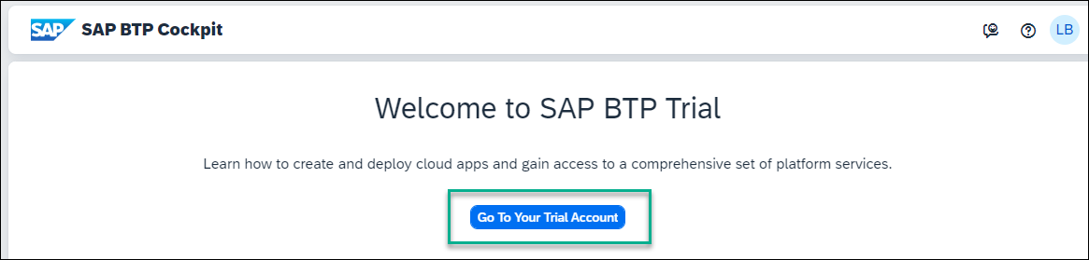
If this is your first time accessing your trial account, you’ll have to configure your account by choosing a region (select the region closest to you). Your user profile will be set up for you automatically.
Wait until your account is set up and ready to go. Your global account, your subaccount, your organization, and your space are launched. This may take a couple of minutes.
  - Click Continue if you get this popup.
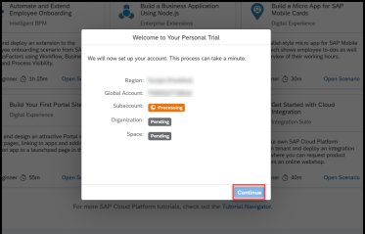
  - Click the trial tile to navigate to your trial subaccount in the SAP BTP cockpit. If you’re using your own subaccount, you can select it instead.
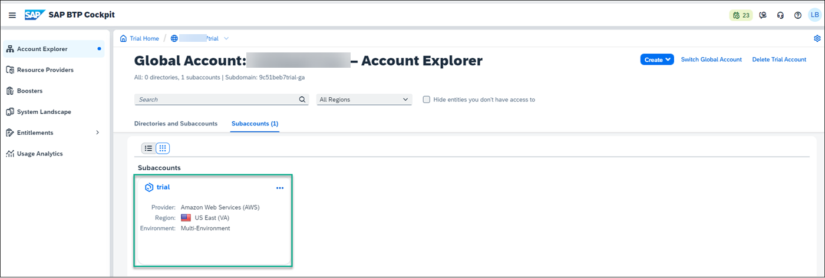
Done
- STEP 2
Get an SAP Cloud Identity services tenant
To access SAP Build Work Zone, standard edition you need to first create a SAP Cloud Identity tenant for managing user access and authentication. To get an SAP Cloud Identity Services tenant, you need to create one manually as follows:
  - Click Service Marketplace in the left navigation panel.
The Service Marketplace provides you access to all services and applications that you can access from the SAP BTP cockpit.
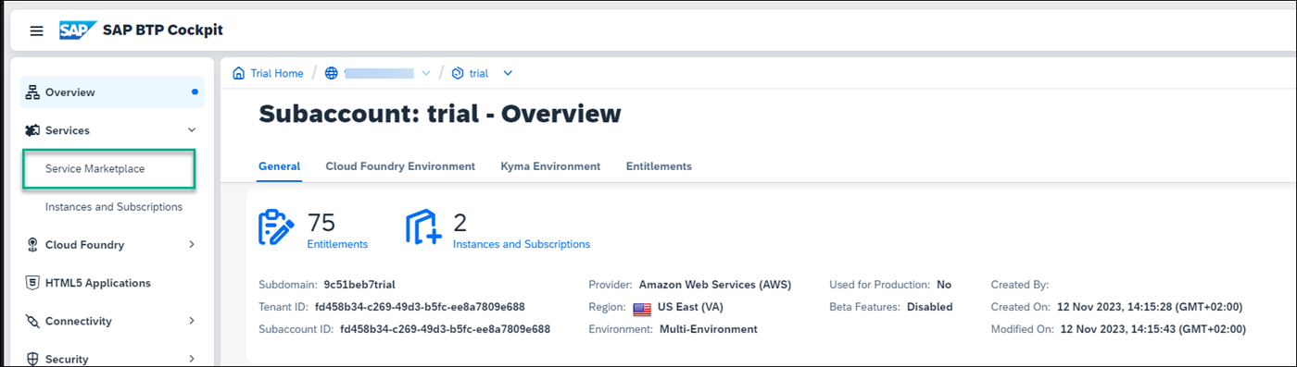
  - In the Service Marketplace, search for the Cloud Identity Services tile.
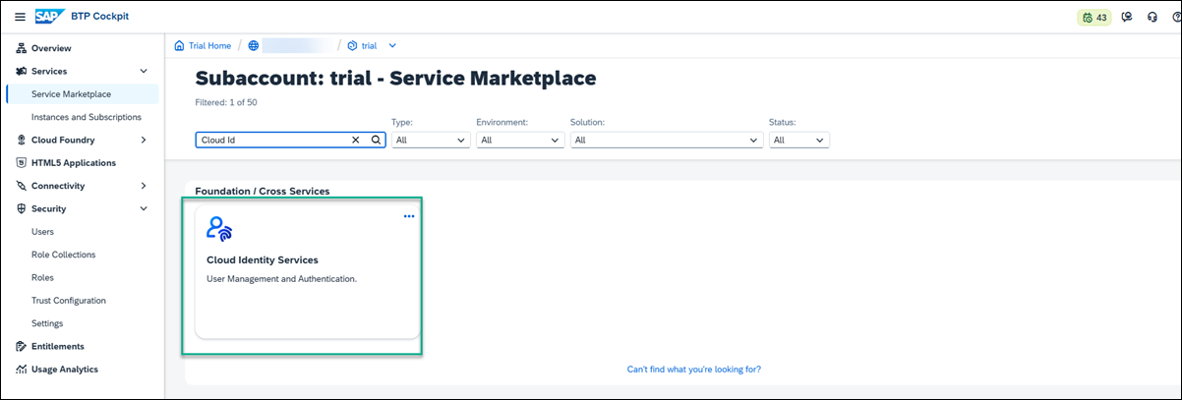
  - Click the tile and then click Create.
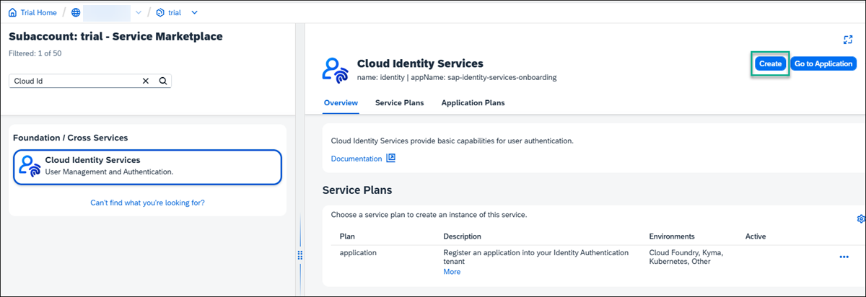
  - In the New Instance or Subscription screen, under Subscriptions, select the default plan and click Next.
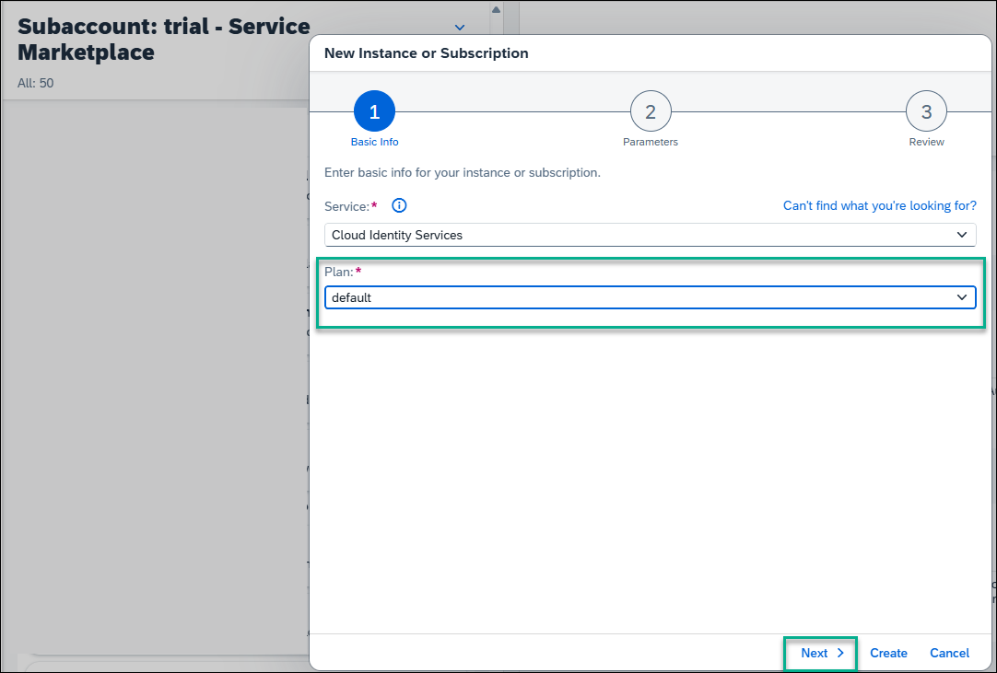
  - Navigate to the next steps and then click Create.
  - You’ll receive an email to activate your account. Once you’ve activated your account and press Continue, the Cloud Identity Services Administration Console opens.
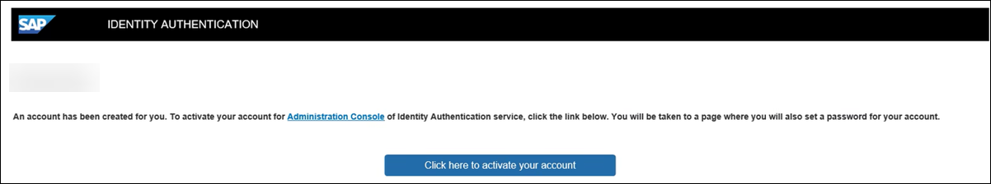
  - In the Administration Console, under the Users & Authorizations tab, select Groups.
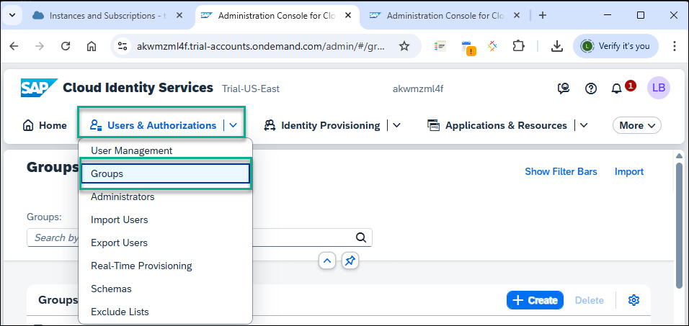
  - Click Create Group
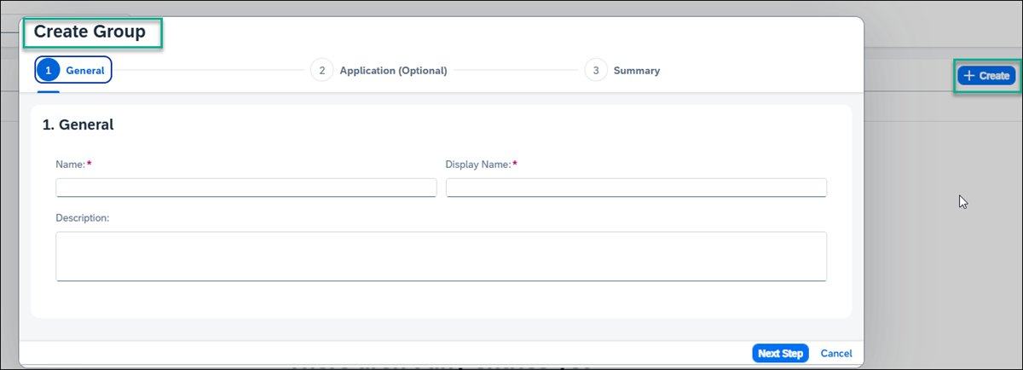
  - Name the group whatever you prefer. For this tutorial, let’s name it Admin and under Display Name, re-enter Admin.
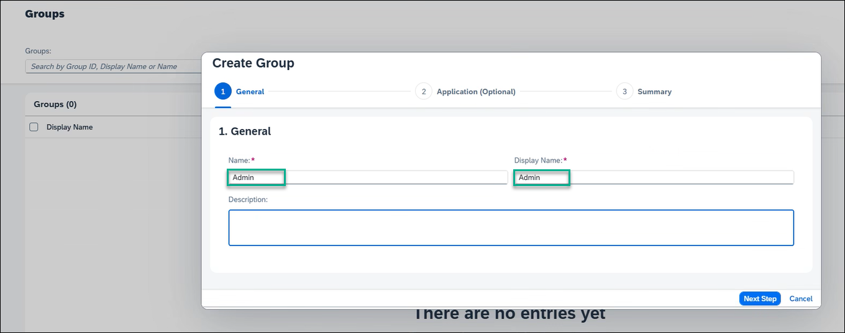
  - Click Next Step, and then Next Step again, and then Finish.
  - Still under the Users & Authentications tab, select User Management and add your user by clicking + Add.
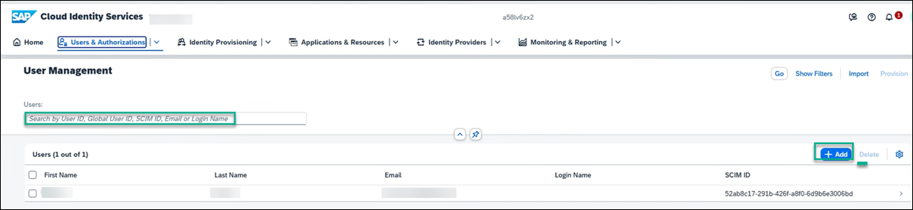
  - Whether you add a new user or use an existing one, you must assign the group to this user. Click your user details, select Groups, and assign your user to the Admin group.
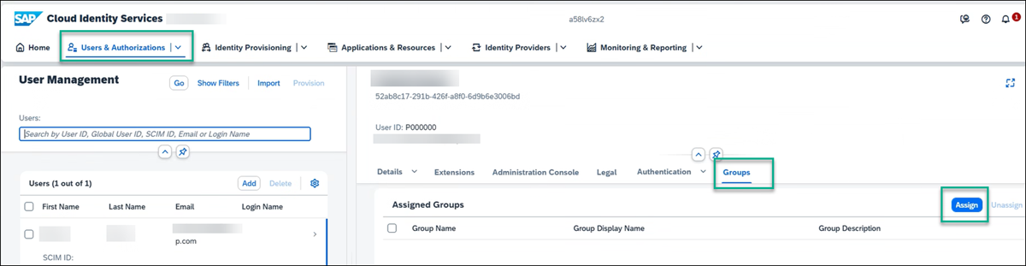
You now have a SAP Cloud Identity tenant.
Done
- STEP 3
Create a trust between SAP BTP and the tenant you created in SAP Cloud Identity services
  - In the SAP BTP cockpit, go to Security -> Trust Configuration and click Establish Trust.
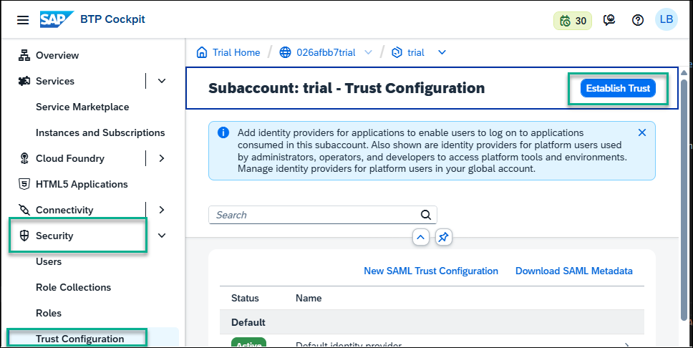
  - In the Configure Tenant screen, select your SAP Cloud Identity tenant that you created and click through the wizard until you get to Finish.
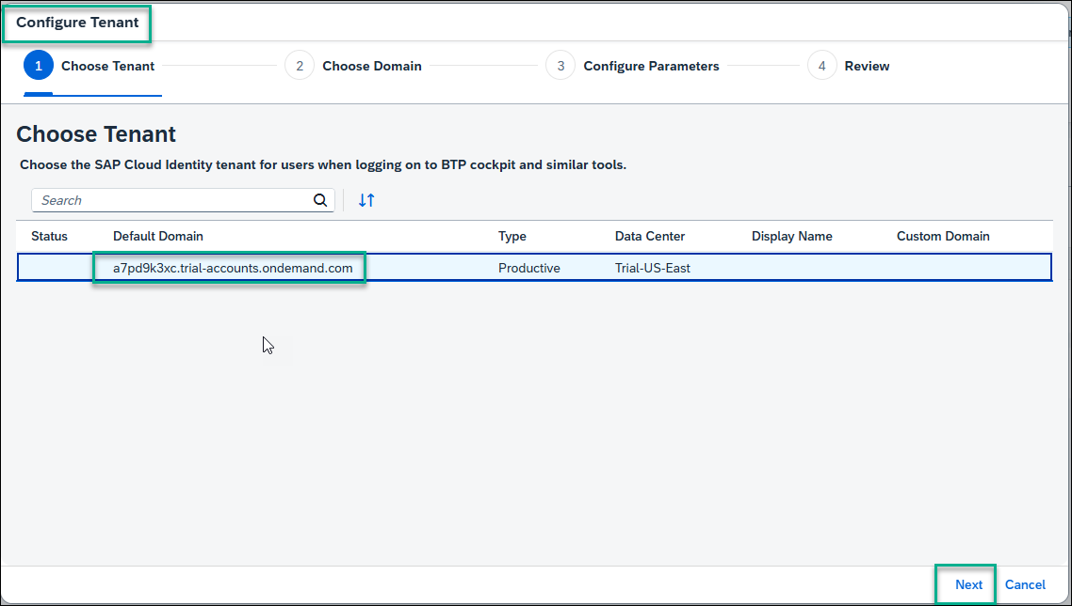
You now have a trust between your SAP Cloud Identity services tenant and SAP BTP. You will see the following message:
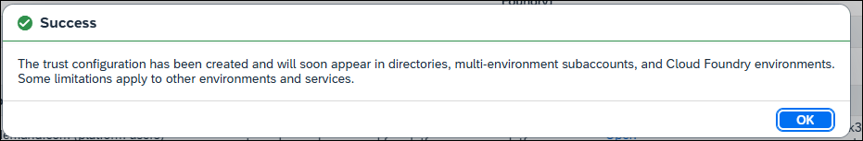
Done
- STEP 4
Subscribe to SAP Build Work Zone, standard edition
Before you can access SAP Build Work Zone, standard edition, you first need to subscribe to it and expose the required Launchpad_Admin role.
SAP Build Work Zone, standard edition offers 2 types of standard plans. The Applications Plan which is used to access your applications from a site. In this case, you need to create a subscription to SAP Build Work Zone, standard edition, which you will do in this step. The 2nd plan is the Service Plan which is used to integrate with other services. This plan is not required for the scope of this tutorial.
  - From your trial subaccount, go to the Service Marketplace from the side panel and search for SAP Build Work Zone, standard.
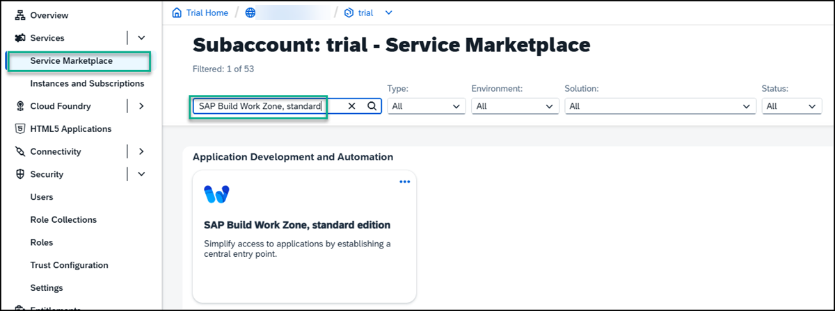
If you aren’t able to find the SAP Build Work Zone, standard edition tile, or if you can’t access it, you may be using an older trial account. You can easily add it to your account via the Entitlements area. Click Edit and then Add Service Plans. Search for SAP Build Work Zone, check the standard (applications) plan, and click Add 1 Service Plan. Don’t forget to save in the next screen.
  - Click the tile. The SAP Build Work Zone, standard edition Overview tab is in focus.
  - Under the Applications Plans tab, click the Actions icon (…), and select Create to create a new subscription.
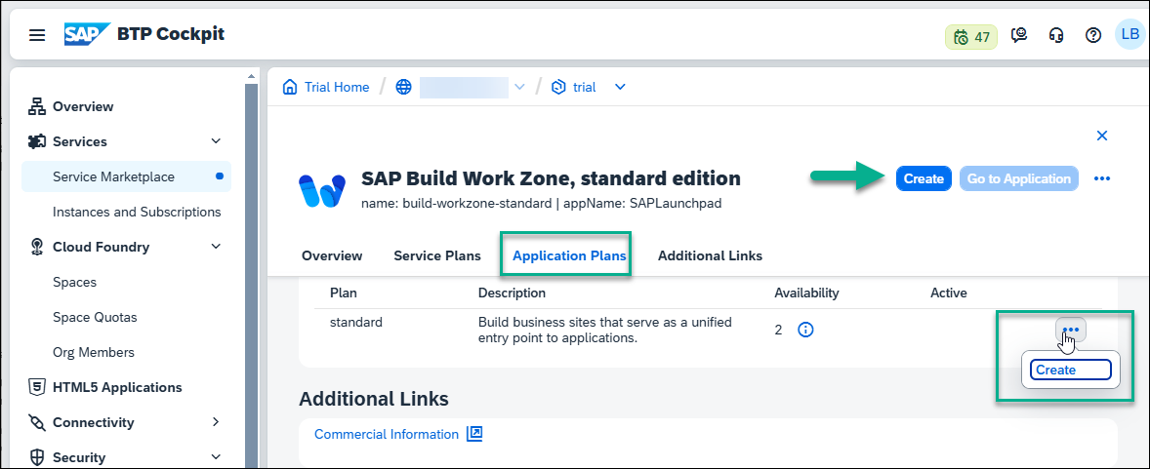
You can also use the Create button at the top right of the screen.
  - In the New Instance or Subscription dialog box that opens, leave the basic information that appears there and click Create.
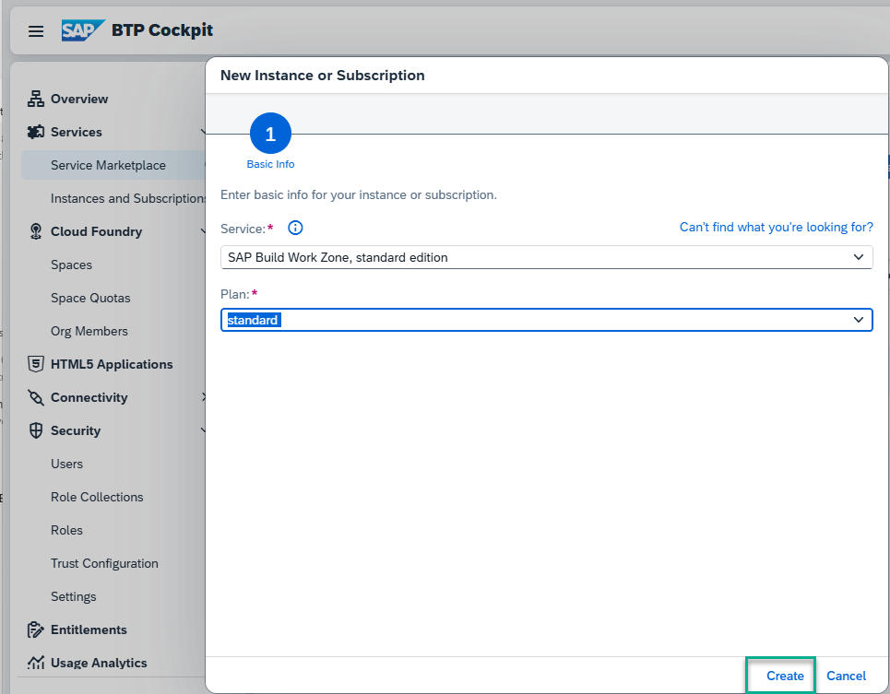
Note that to work in SAP Build Work Zone, standard edition, to integrate content from the backend, you need to create a subscription. If you also want to integrate custom developed apps or plugins, you need to also create an instance.
  - You’ll get confirmation that your subscription is being created. Click View Subscription to see the progress.
This step will redirect you to the Services -> Instances and Subscriptions screen. This screen provides you with an overview of all services and applications that are currently active.
  - From the Instances and Subscriptions screen, you’ll see that you are subscribed to SAP Build Work Zone, standard edition.
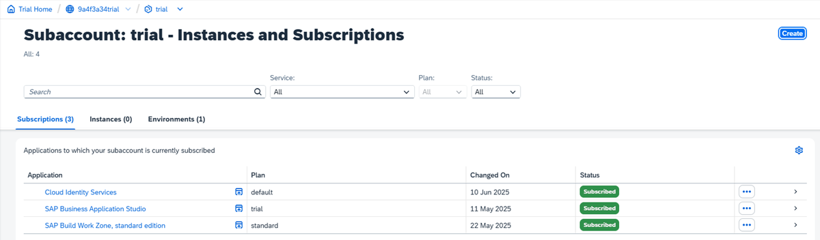
Now that you have a subscription, all the SAP Build Work Zone, standard edition role collections are exposed in the cockpit. You can now proceed to the mapping between the role collection and the group that you created in SAP Cloud Identity services.
Done
- STEP 5
Map the Launchpad_Admin role in SAP BTP with the Identity Services group
  - From the side panel of the cockpit go back to Security -> Trust Configuration.
  - Click the tenant that you created in SAP Cloud Identity services.
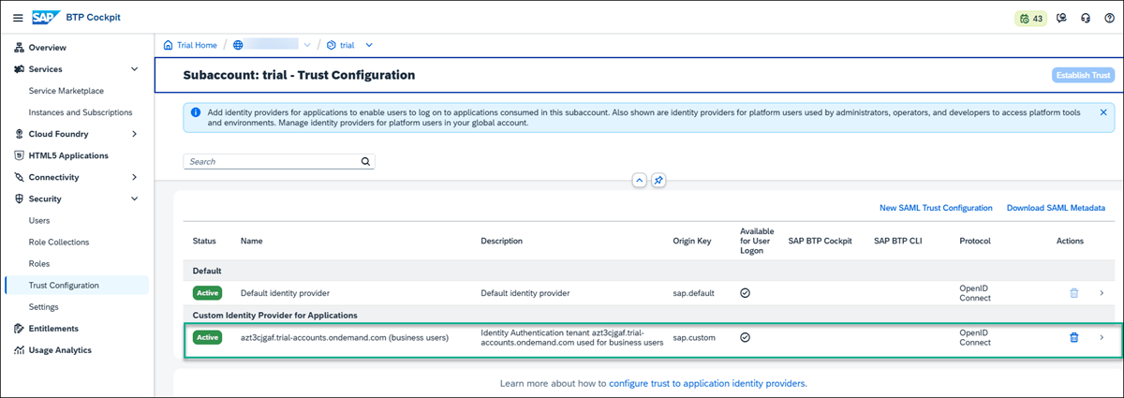
  - On the right, in the screen that opens, click on the Attribute Mappings tab, and click Edit.
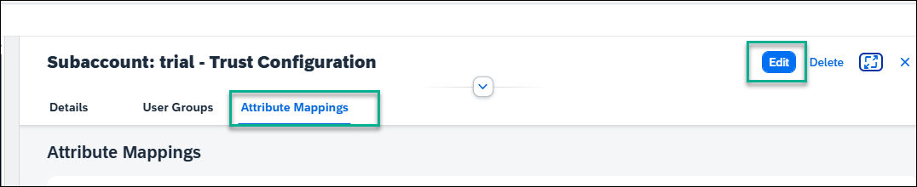
  - Under the Role Collection column, search for the Launchpad_Admin role from the dropdown list.
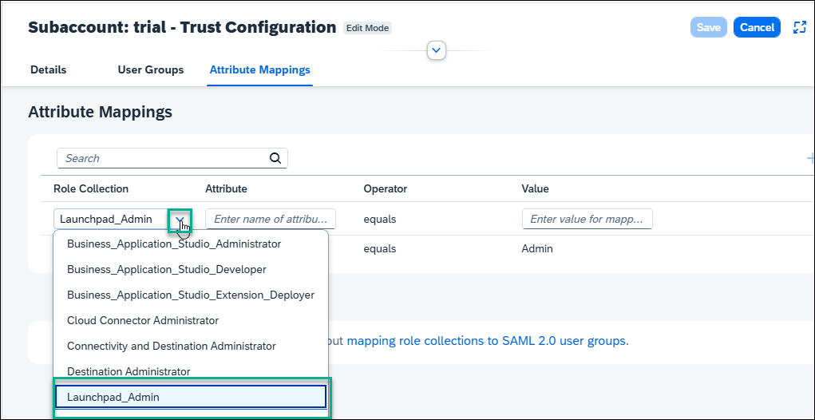
  - Enter the Attribute as Groups and enter the Value as Admin. Now click the + to add the attributes and Save.
The mapping is complete. You can now go ahead and access SAP Build Work Zone, standard edition.

Access SAP Build Work Zone, standard edition
- From the side panel, click Instances and Subscriptions.
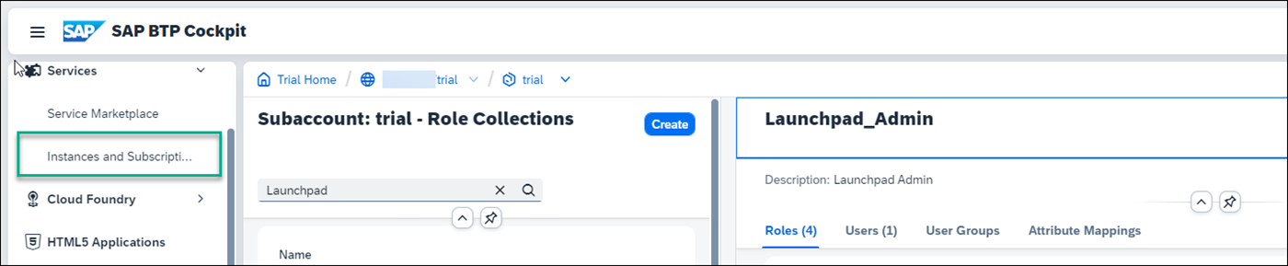
- Under the Subscriptions tab, click SAP Build Work Zone, standard edition. Click Go to Application on the right.
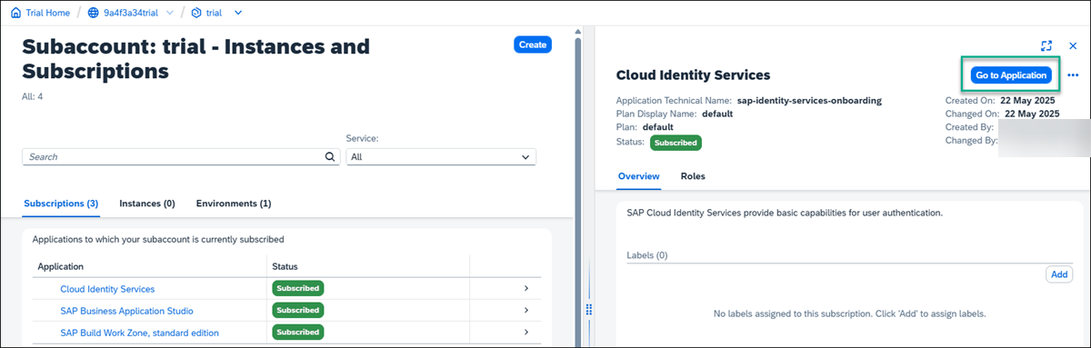
The Site Directory opens. From here you’ll create and manage your sites.
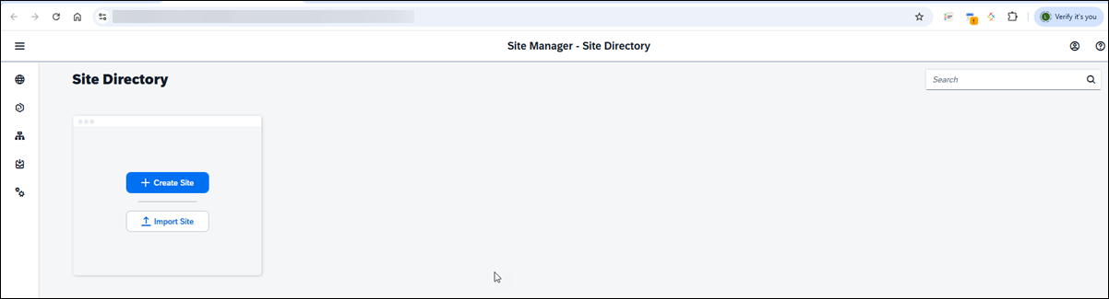
Create a site
When you access the SAP Build Work Zone, standard edition, the Site Directory is in focus. From here you’ll create your new site.
In the side panel, you’ll see five tools. The Site Directory where you’re going to create a new site. All sites that you create will be displayed here. The Content Manager where you’ll manage cross-site content such as business apps, groups, spaces, pages, roles and catalogs. The Channel Manager where you manage different channels that expose business content that you can integrate into your sites. The fourth icon opens the Transport Manager where you can track the status of your imports. The fifth icon opens Settings where you can configure various settings related to your subaccount.
- Click Create Site.
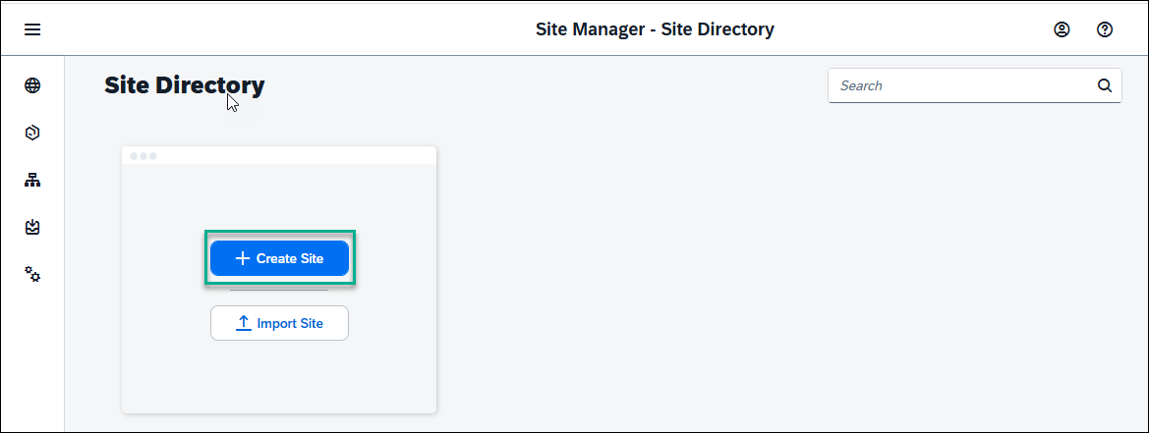
- Enter JobCore as the site name and click Create.
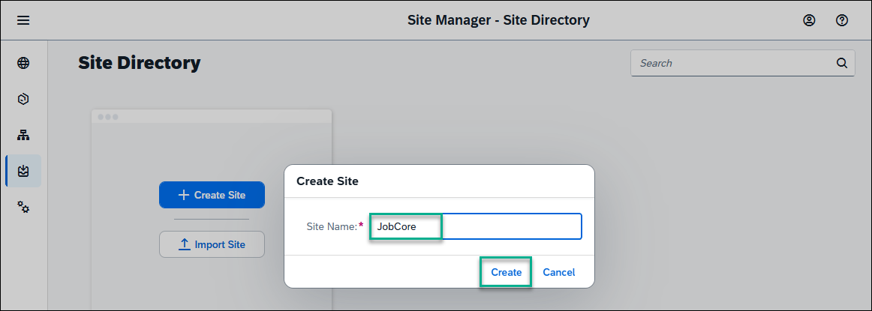
You’ve just created a site called JobCore.
When you create a site, you are directed to the Site Studio Site Settings screen. In this screen, you’ll select the new experience view mode.
By enabling Spaces and Pages – New Experience view mode, you’ll be able to create spaces and pages locally in dedicated editors. You’ll also be able to design your pages by adding sections with UI integration cards and app tiles. If you integrate spaces and pages from remote content providers, they will be displayed side by side with spaces you manually create.
- Click Edit in the top right corner of the screen.
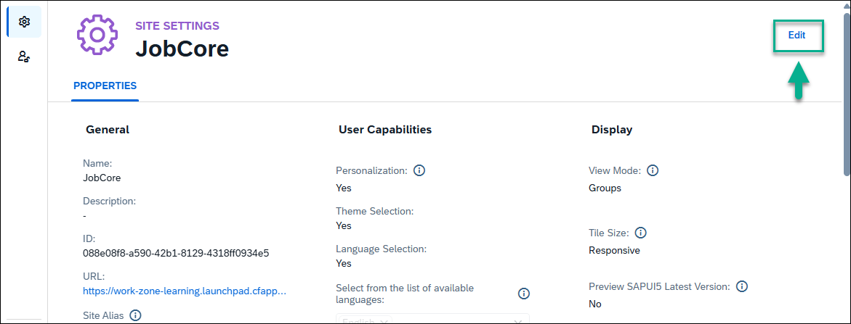
- Under Display, select Spaces and Pages - New Experience.
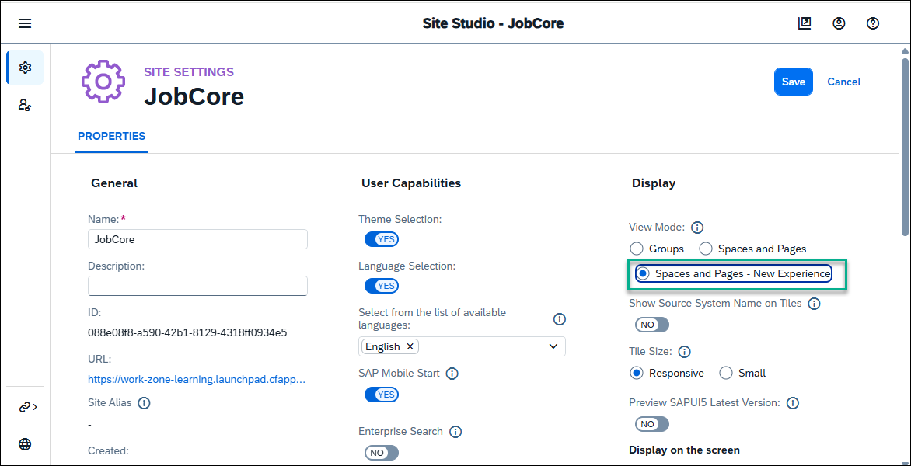
- Click Save.

Go to the Site Directory to view the site tile.
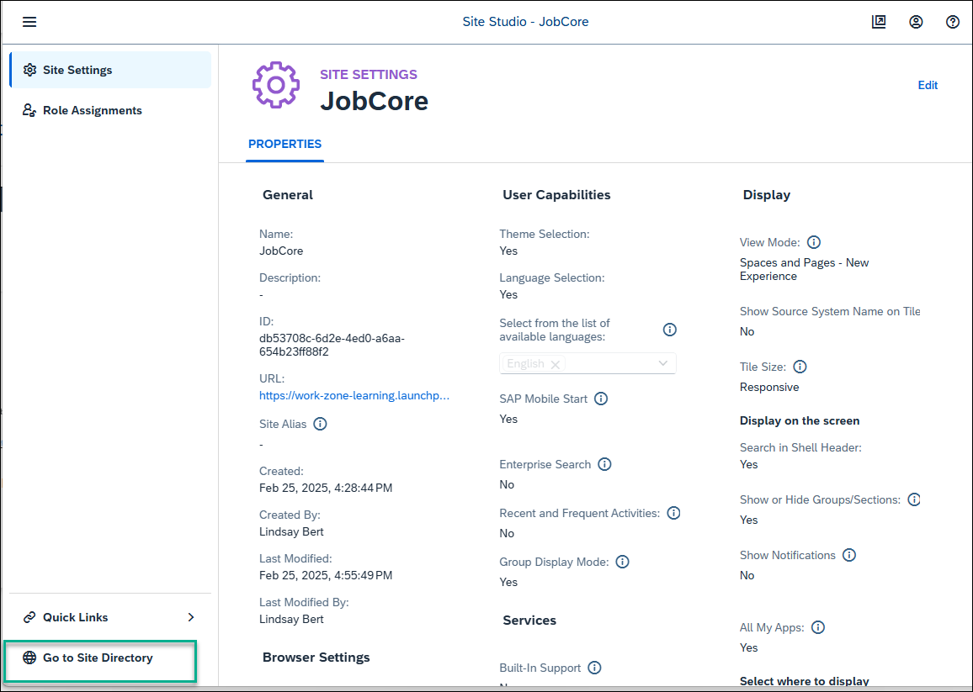
Your site is empty for now. In the next tutorials, you’re going to add business apps to your site.

- Open Content Manager
Click the Content Manager icon in the side panel to open the Content Manager.
When you open the Content Manager you’ll see a list of content items that have been added to your subaccount. From here you can manually configure new content items and view any other available content items. You can also access the Content Explorer where you can explore exposed content from available channels, select the content, and add it to your own content.
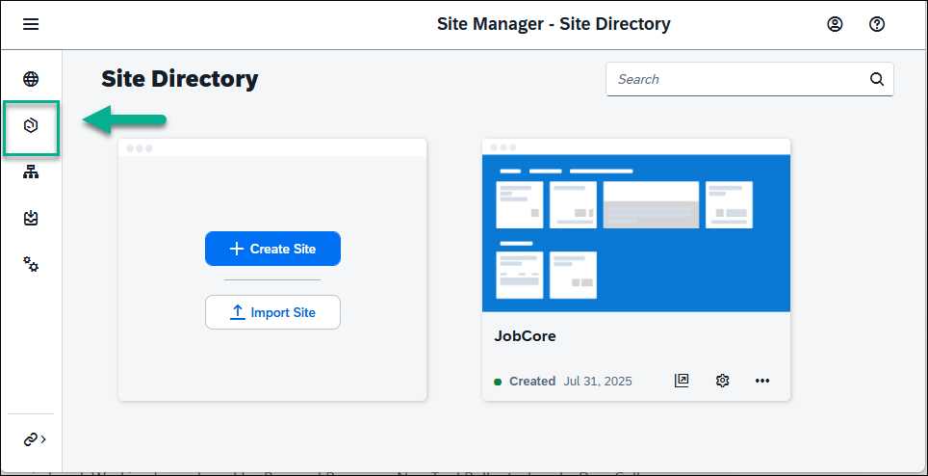
Done
- STEP 2
Create and configure new app
  - Click Create and select App from the list.
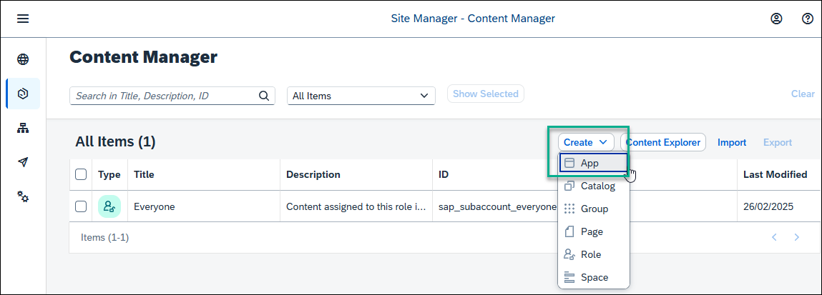
  - In the header area of the app editor, enter a title New Orders.
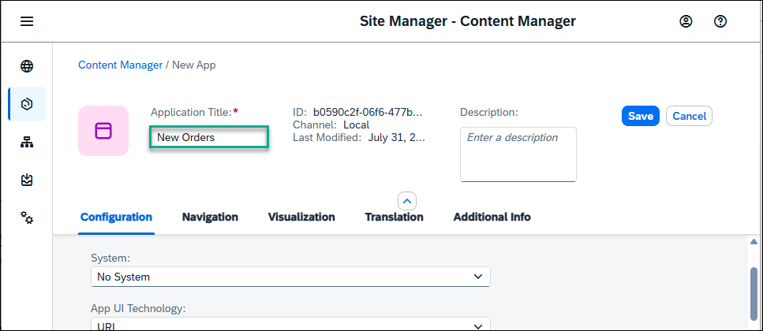
  - Under the Configuration tab, enter the following values (some will already be there by default):
    - Open App: In place
    - System: No System
    - App UI Technology: URL
    - URL: https://sapui5.hana.ondemand.com/test-resources/sap/m/demokit/cart/webapp/index.html
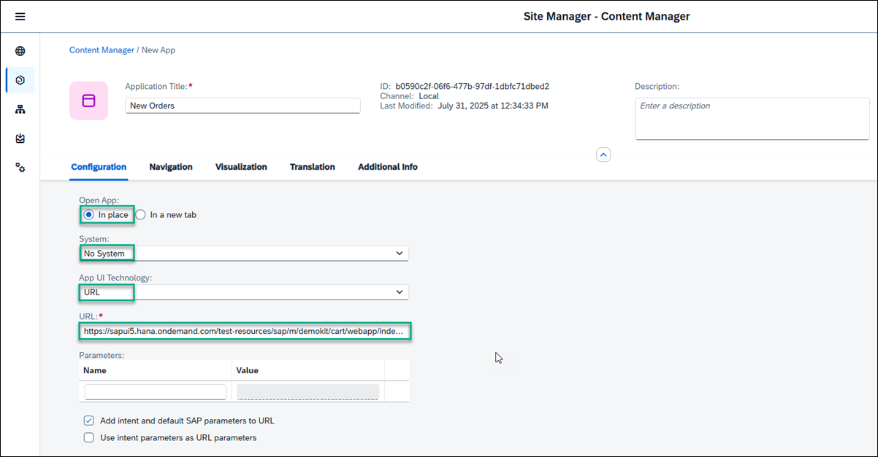
When working in your own environment, it’s better to integrate SAPUI5 apps by configuring a destination to the relevant system and setting the app properties to use this destination. In this case, in the App UI Technology dropdown list, you would select SAPUI5. This configuration allows you to better manage your content in the Dev-QA-Prod lifecycle.
  - Click the Navigation tab to specify the intent of your app.
The unique combination of a semantic object and an action is called an intent. It’s used to define navigation to an application.
  - Enter the following values:
    - Semantic Object: Order
    - Action: Display
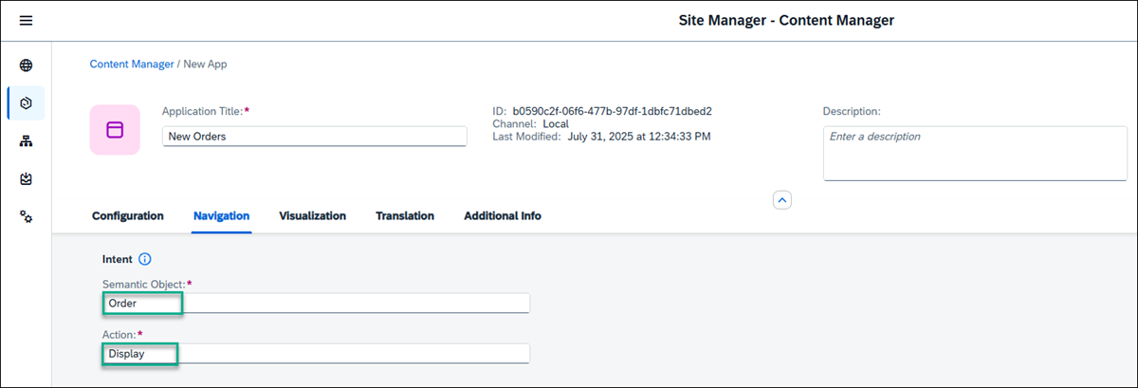
  - Click the Visualization tab.
In this tab, you specify how the app will be displayed in the site.
  - Enter the following values:
    - Subtitle: Shopping Cart
    - Information: Order Now!
    - Icon: Click the browse icon, type my-sales-order, and click on the displayed icon to add it to your tile.
  - On the right, you can see a preview of the tile with all the properties you entered. Click Save.
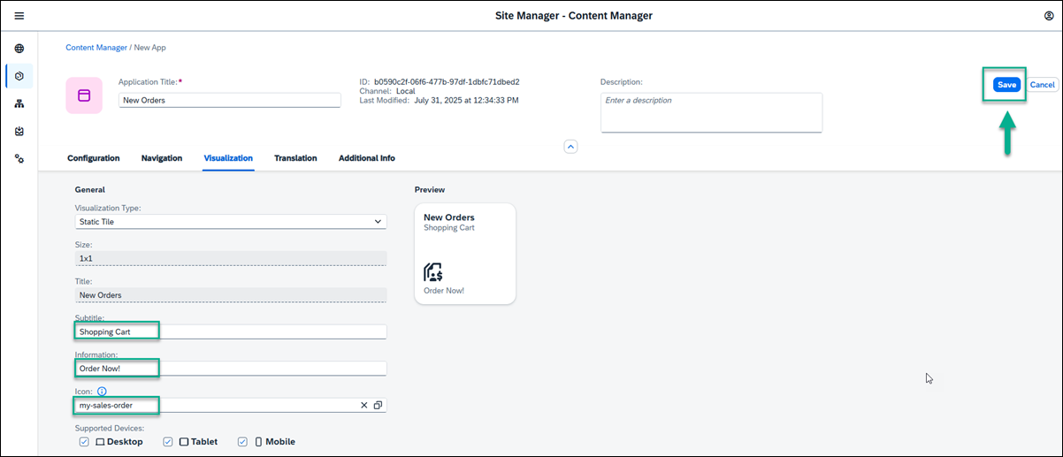
Done
- STEP 3
View the app that you created
Go back to the Content Manager by clicking on the breadcrumbs.
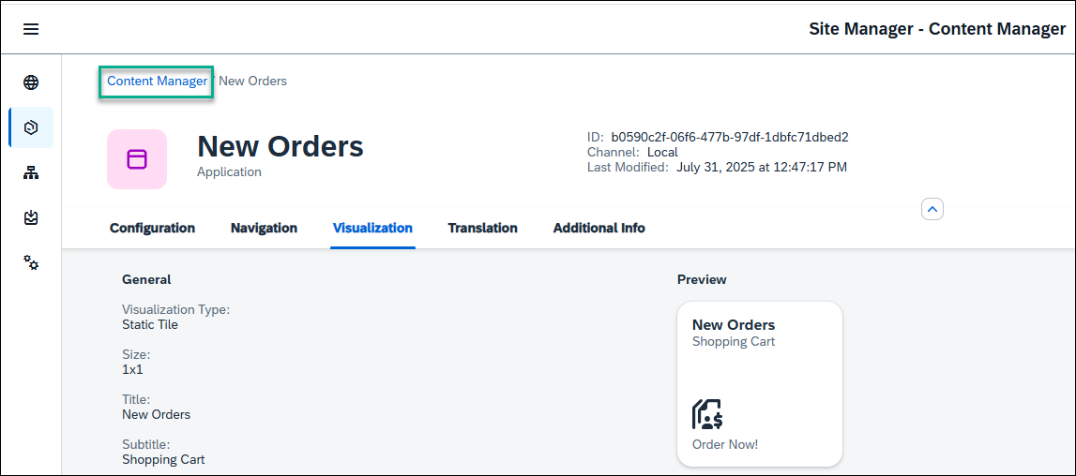
You can see your app in the list of content items:
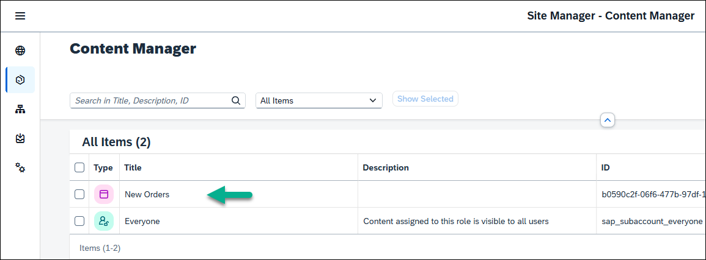
For end users to access the app in runtime, you must assign the app to a role.
Done
- STEP 4
Assign the app to the Everyone role
Content assigned to the Everyone role is visible to all users.
  - Click the Everyone role.
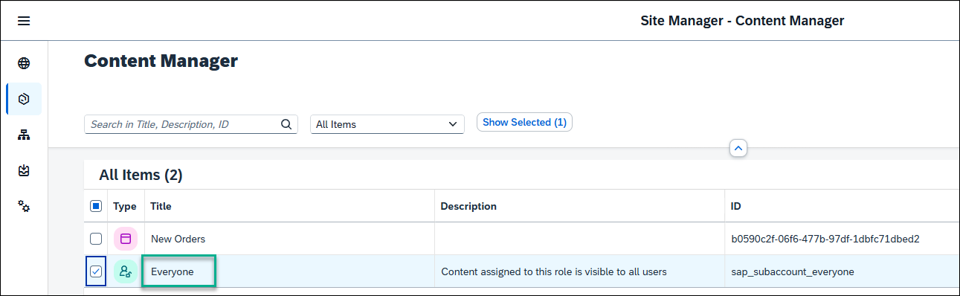
  - Click Edit.
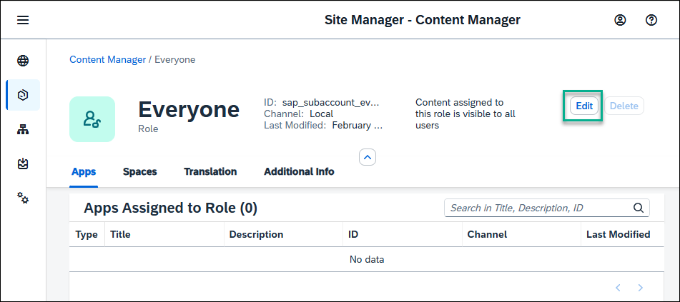
  - Under the Apps tab, you’ll see that your New Orders app has a red X in the Assignment Status column. Click the toggle to change the icon to green and then click Save. This action assigns the app to the Everyone role.
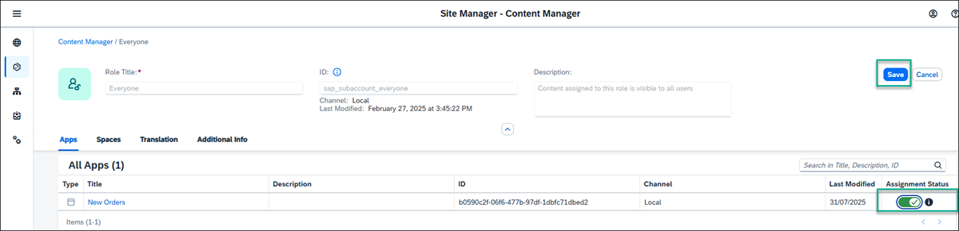
If you have many apps, you can type some letters of your app name in the search bar, (for example, Or) to search for the app.
You’ve successfully created an SAPUI5 app. In the next tutorial, you’ll create another app (URL app) and then you’ll add both apps to a page.
- From the Site Manager, click the Content Manager icon from the left panel to open it.
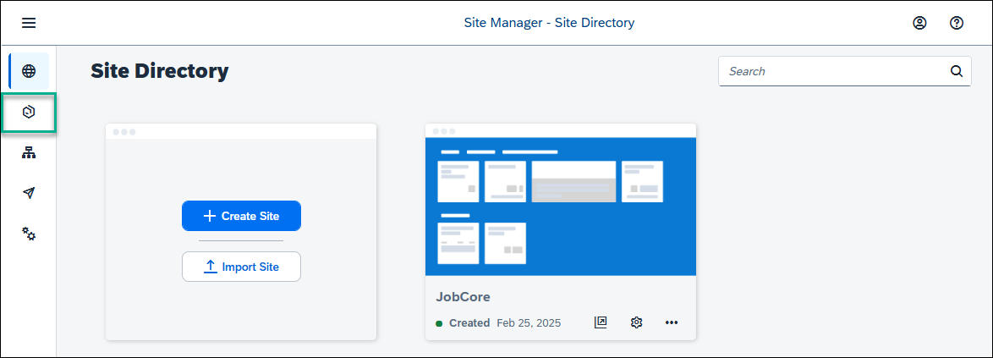
Done
- STEP 2
Create and configure new app
  - Click Create and select App from the list.
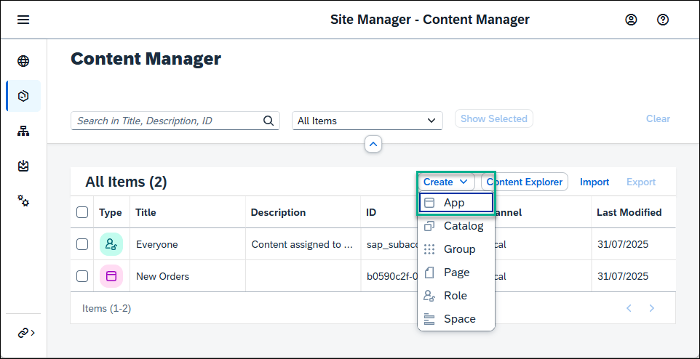
  - In the header of the app editor, enter a title External Community.
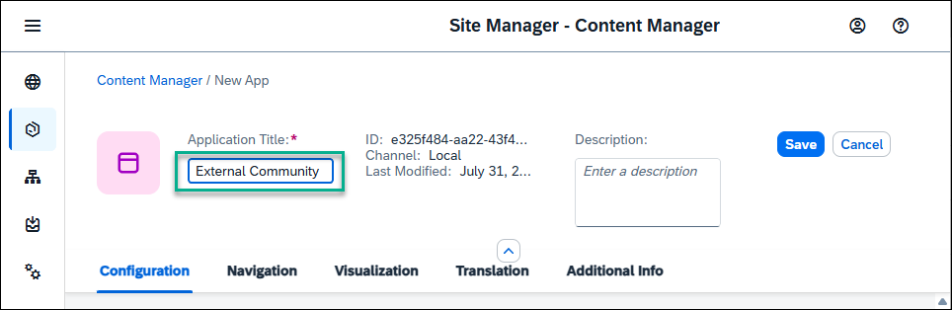
  - Under the Configuration tab, enter the following values (some of them are already there by default):
    - Open App: In a new tab
It’s preferable to open apps in place, but this time, we’ll open the app in a new tab.
    - System: No System
    - App UI Technology: URL
    - URL: https://community.sap.com/topics/work-zone
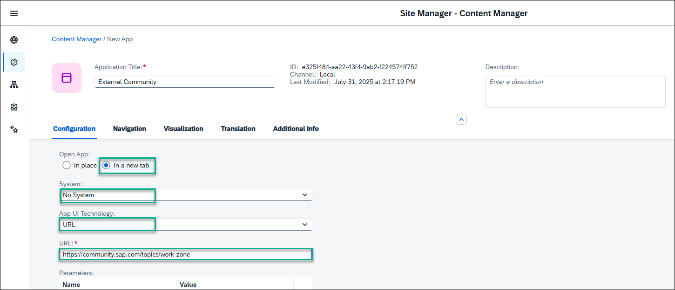
  - Click the Navigation tab and enter the intent of your app.
The unique combination of a semantic object and an action is called an intent. It is used to define navigation to an application.
  - Enter the following values:
    - Semantic Object: Home
    - Action: Display
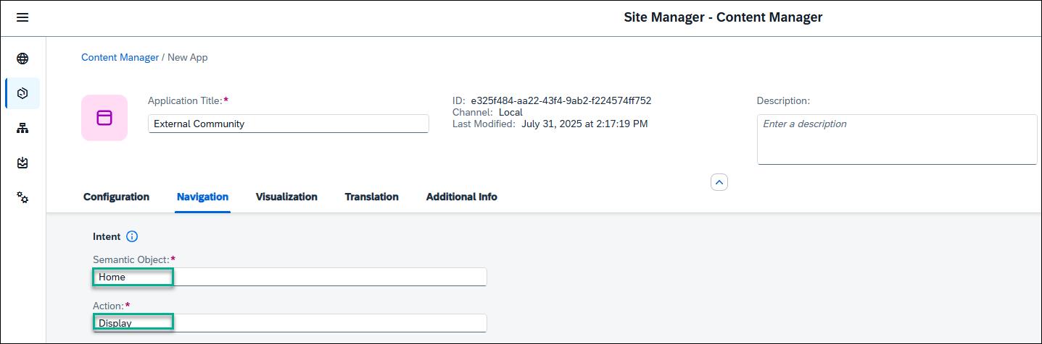
  - Click the Visualization tab.
In this tab, specify how the app will be displayed in your site.
  - Enter the following values:
    - Subtitle: About Us
    - Information: Learn about JobCore
    - Icon: Click the browse icon, type visits, and click on the displayed icon to add it to your tile.
You see a preview of the tile with all the properties you entered.
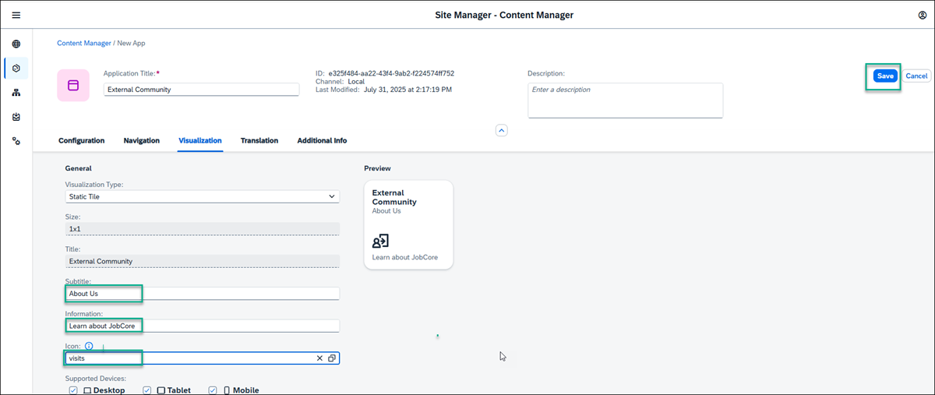
  - Click Save.
You have configured the URL app and in the next step you’ll go back to the Content Manager to see it in the list of content items.
Done
- STEP 3
View the app that you created
  - Go back to the Content Manager using the breadcrumbs.
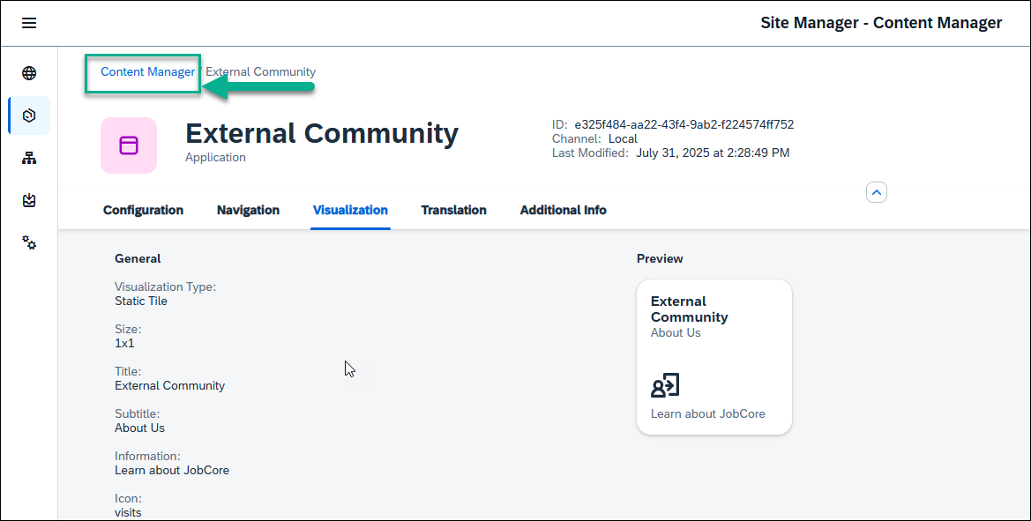
  - In the Content Manager, you can see your app in the list.
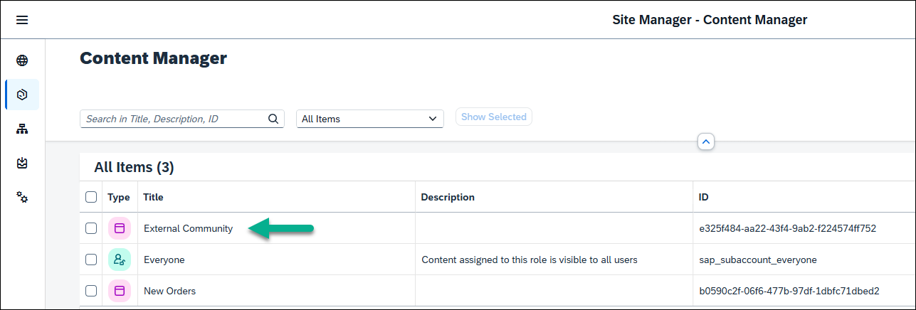
To view the app in runtime, you must assign the app to a role.
Done
- STEP 4
Assign the app to the Everyone role.
Content assigned to the Everyone role is visible to all users.
  - In the Content Manager, click the Everyone role.
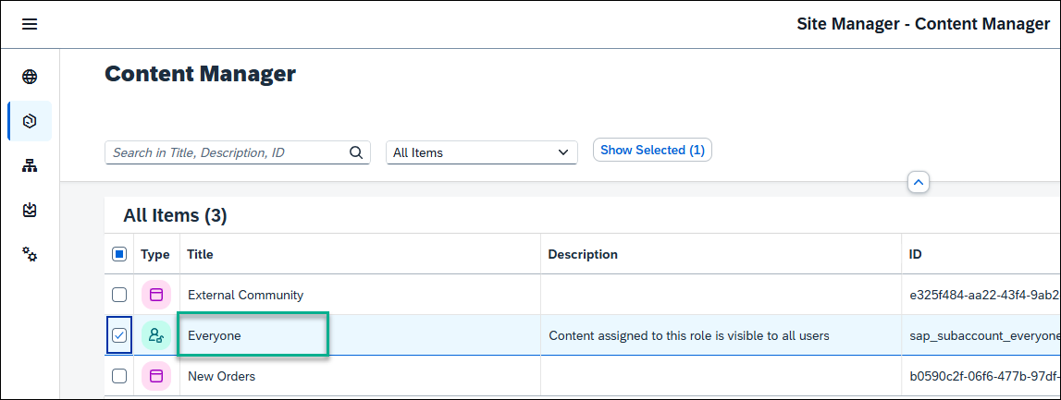
  - Click Edit.
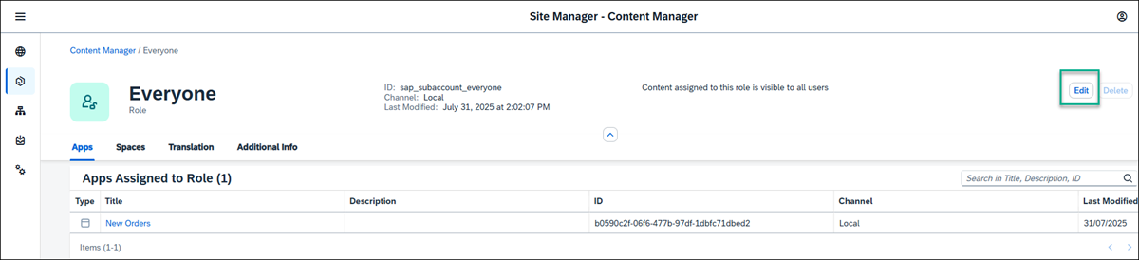
  - All available apps are shown in the editor. In the Assignment Status column you can see that the External Community is red and is not assigned to the role. Click the toggle to change the toggle to green and click Save to assign the app to the Everyone role.
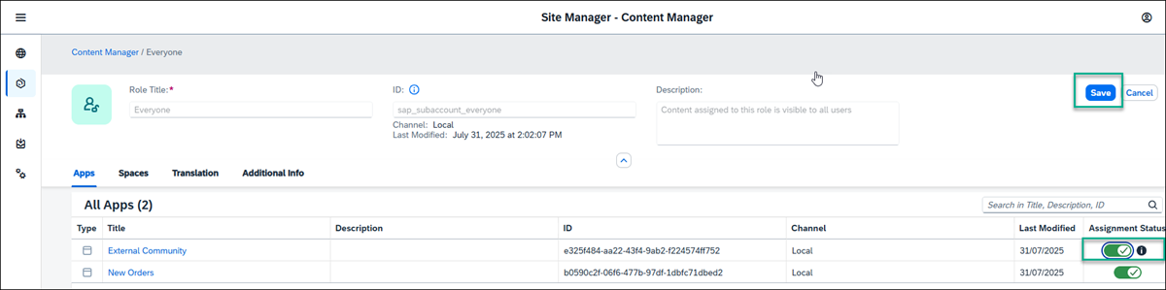
Congratulations you’ve created a site with two apps.
In the next tutorial, you’re going to add this app, and the one you created in the tutorial before to a page in your site

  - Open the Content Manager.
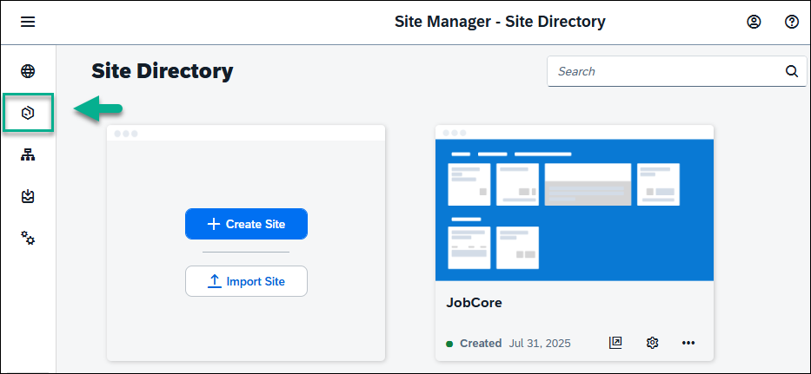
  - Click Create and from the dropdown list, select Page.
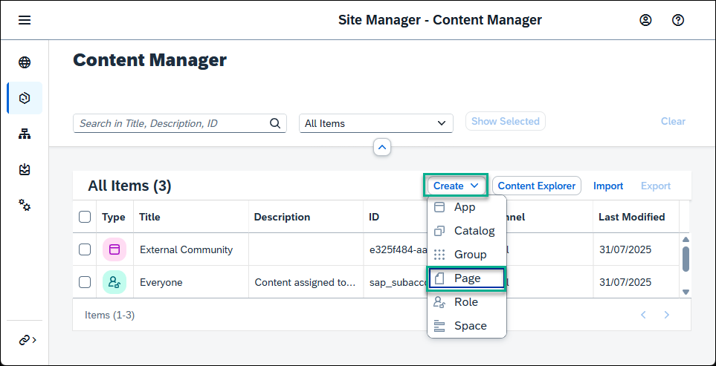
  - Enter a title for the page: Overview.
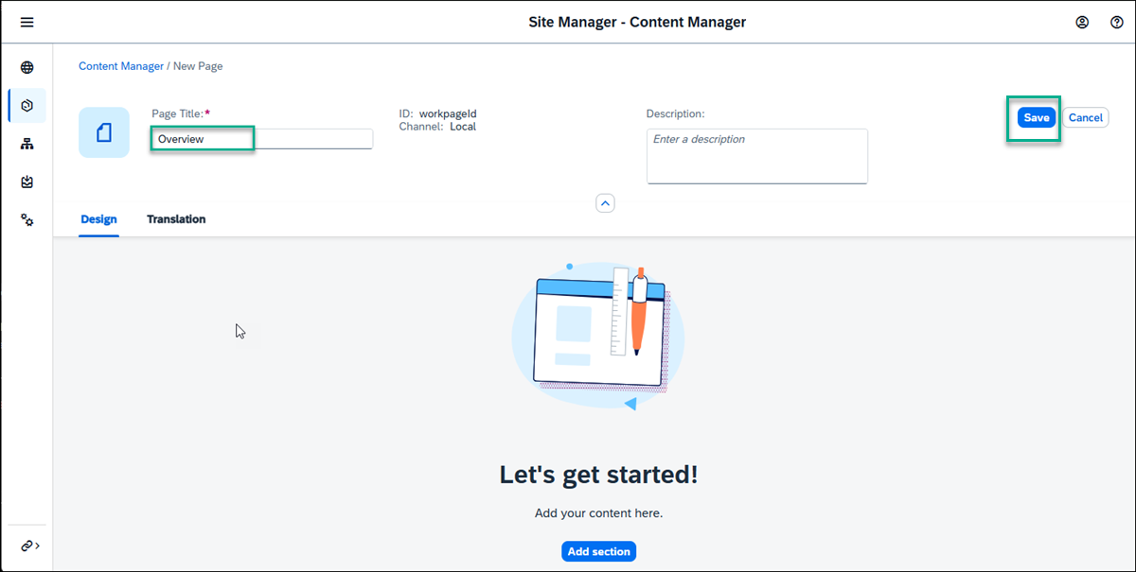
- Done
- STEP 2
Add apps to the page
  - Click Add Section
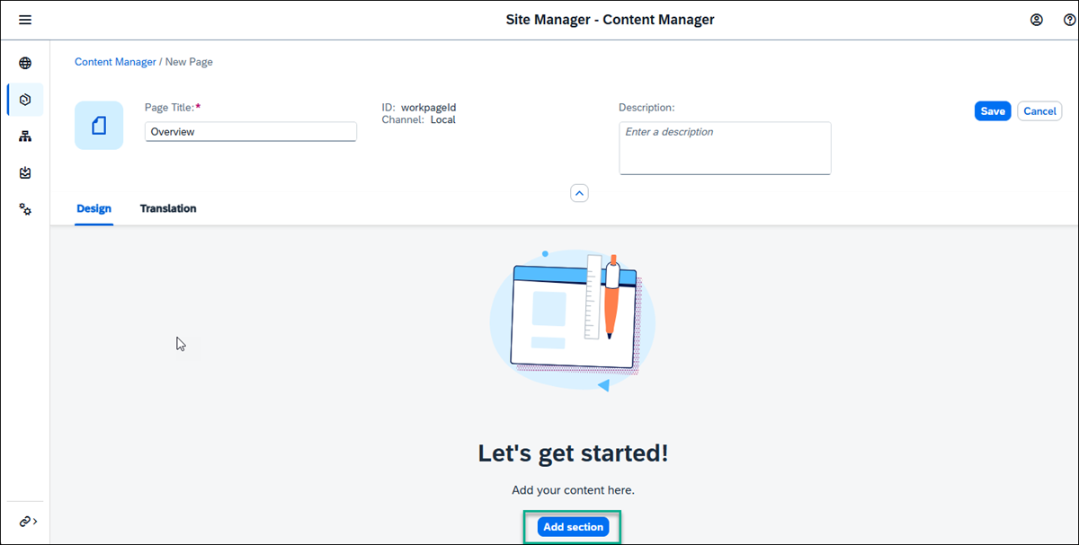
  - For the header enter My Apps, and click Add Widget.
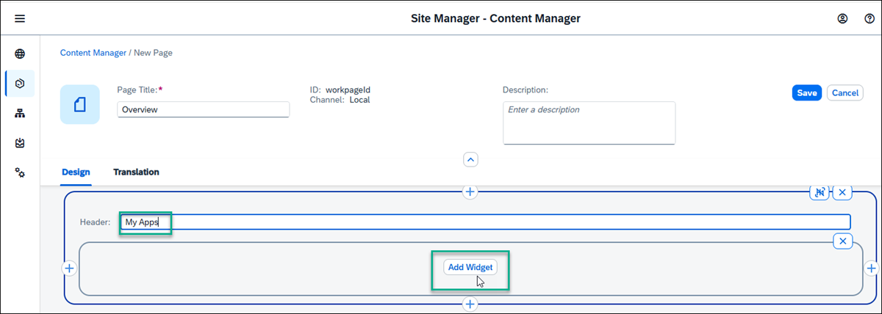
  - In the Add Apps screen, select the New Orders and External Community apps that you created and click Add.
In this screen you’ll see all the apps that you can access from your subaccount - so far we only have 2 apps in our subaccount.
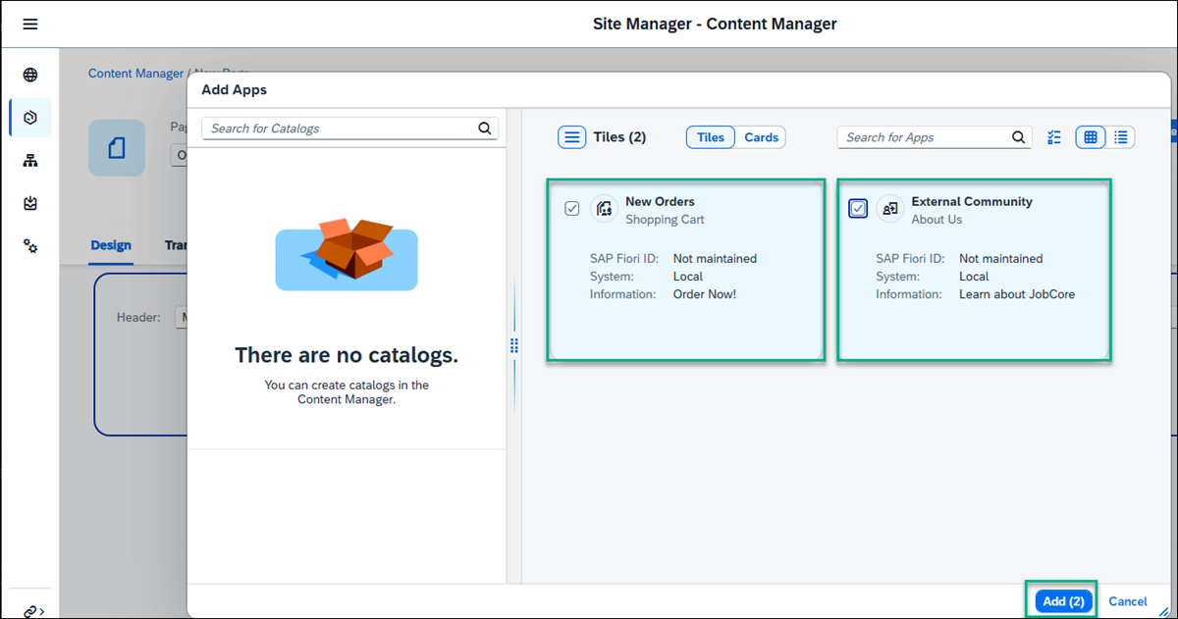
You can add more apps to your page - they will display side by side in a section.
  - Click Save. This is how your page looks:
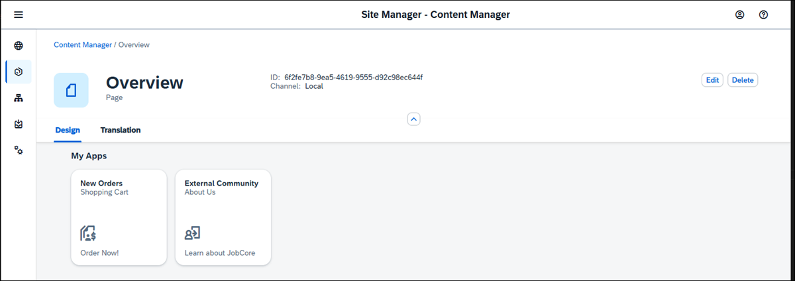
  - Go back to your Content Manager using the breadcrumbs at the top.
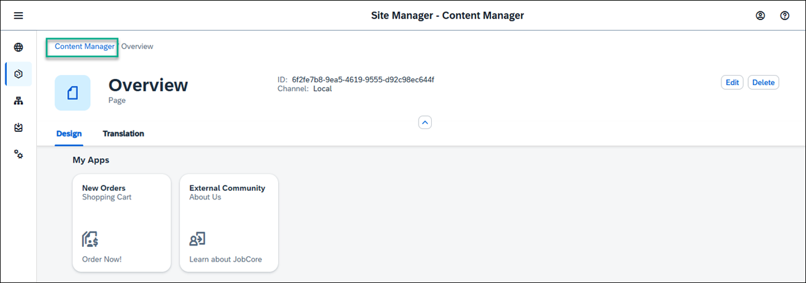
  - See that the page you created is in the list of content items.
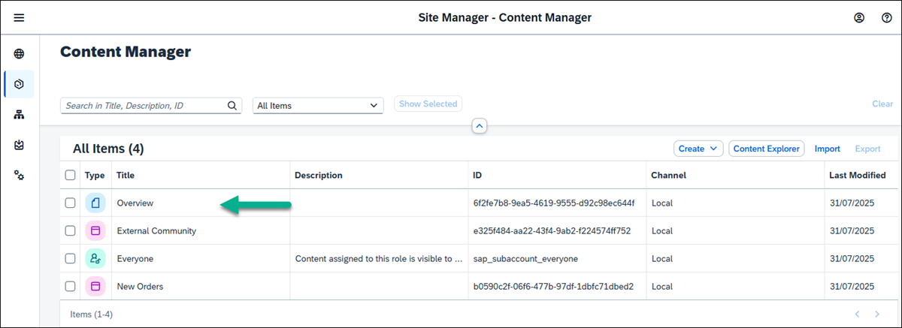
Done
- STEP 3
Create a space
  - In the Content Manager click Create and then select Space.
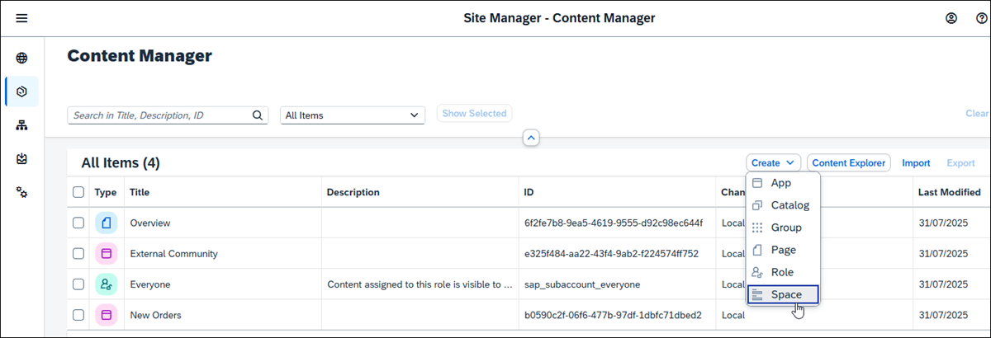
  - Enter a title for the space: Home.
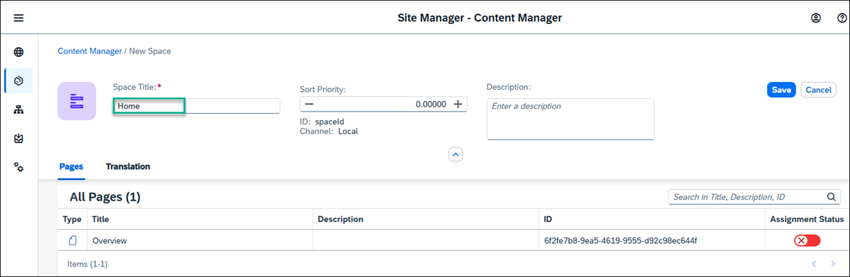
  - In the Pages tab, you’ll see a list of pages and from here you can assign as many pages as you want to the space. We only have 1 page - the Overview page. In the Assignment Status column, you’ll see the toggle is red meaning that the page is not yet assigned to the space. Click the toggle to assign the Overview page to the Home space and click Save.
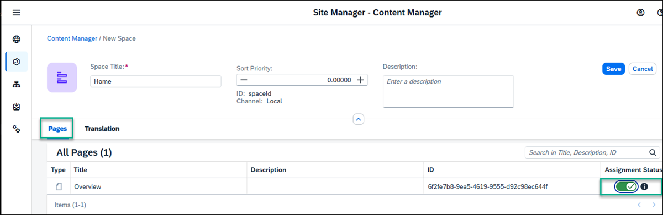
  - Go back to the Content Manager using the breadcrumbs at the top. You’ll see that the space you created is added to the list of content items.
Done
- STEP 4
Assign the space to a role
In this step, you’ll assign the space to the Everyone role.
Spaces are assigned to a role and users assigned to a specific role are able to access the space and see the relevant pages assigned to it. Content assigned to the Everyone role is visible to all users.
  - From the Content Manager, click the Everyone role.
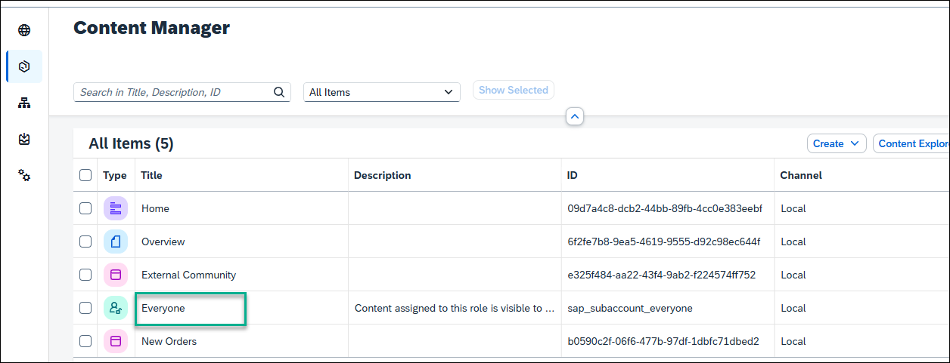
  - Click Edit.
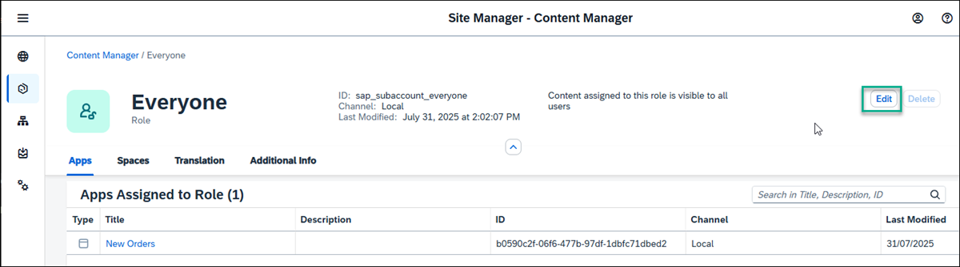
  - Under the Spaces tab, you’ll see the Home space you just created. Click the toggle to assign the Home space to the Everyone role.
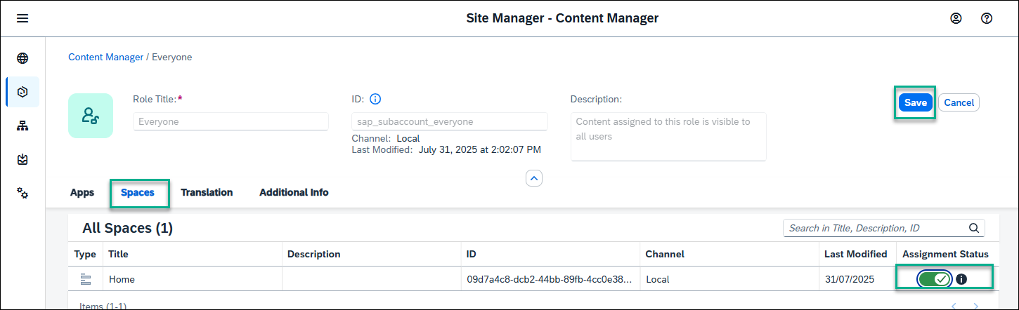
  - Click Save.
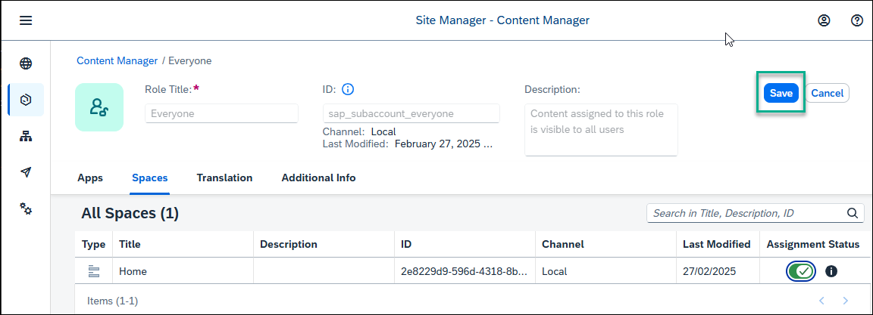

View the runtime site
- Open the Site Directory.
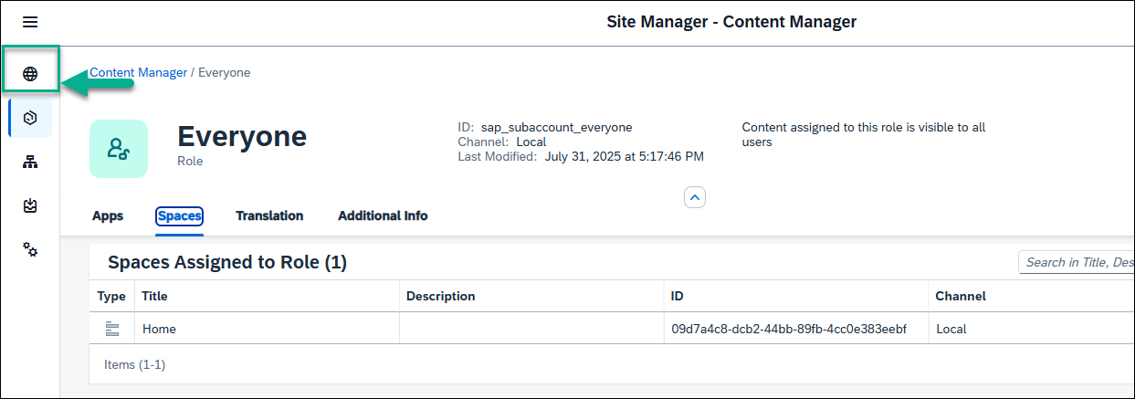
- On the JobCore tile, click the Go to Site icon.
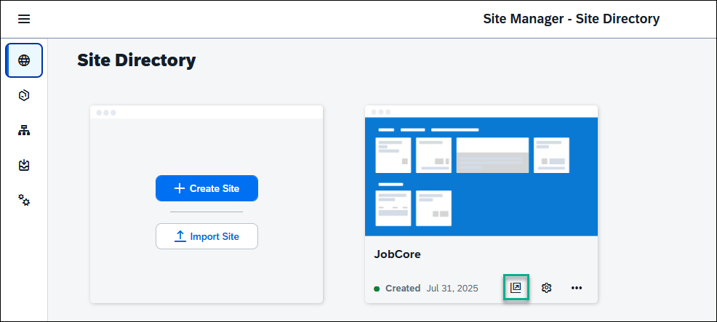
- This is what you’ll see - under the Home space, you have the Overview page. In the My Apps section, you have the 2 apps External Community and New Orders that you added.
