Pumpkins Lesson
Learning Objectives:
Students will be introduced to the fall season and why we see pumpkins during this time of the year.
Materials & Preparation:
- Pumpkins power point (included)
- Pumpkins Match (multiple levels included)
- Pumpkins Picture Writing prompt (included)
- Youtube: Where do Pumpkins come from?
- Pumpkin picture for tallying/bar graph activity (included)
- Bar graph & tally sheet (included)
Instruction:
- What season is it? What kind of things do you think of when the fall starts? What do you think of when you think of pumpkins?
- Pumpkins power point
Full Class Activity:
- Watch brief clip on where pumpkins come from. Students can see how they are grown. Discuss the video and let students start their work.
- Pumpkin tallying/bar graph activity
Independent Working Time:
- Pumpkin Match
- Writing picture prompt
Wrap up/Closing:
- Review pumpkins and their impact on the fall season.
Other Ideas for Activities:
- Carve pumpkins! I love doing this every year. Get a big pumpkin, have students take turns scooping out the seeds (so they can feel it). Vote on what kind of eyes, nose, smile, face you want for the pumpkin. Carve it. If you’re lucky enough to have a stove in your classroom, make some pumpkins seeds!
- Some years we were lucky enough to take a field trip to a pumpkin patch (you can tie in many skills and make connections for why this is educational).
- Make Pumpkin Pie in a Bag (check in the cooking section for our easy lesson on how to make this!)

Name _________________________________________ Date_______________________
Draw a line to match the picture to the word

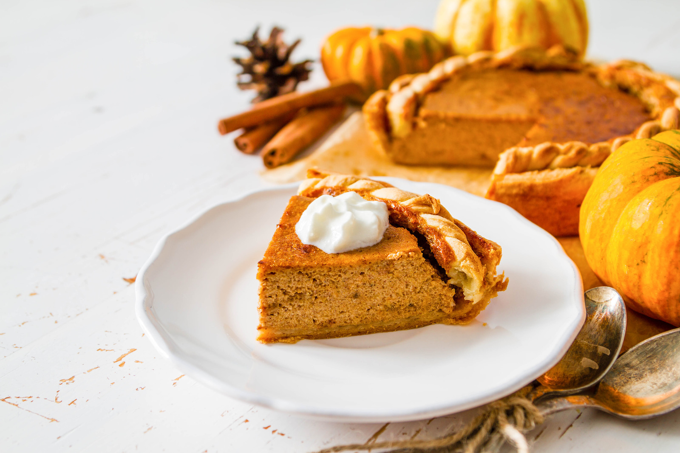
Planting seeds

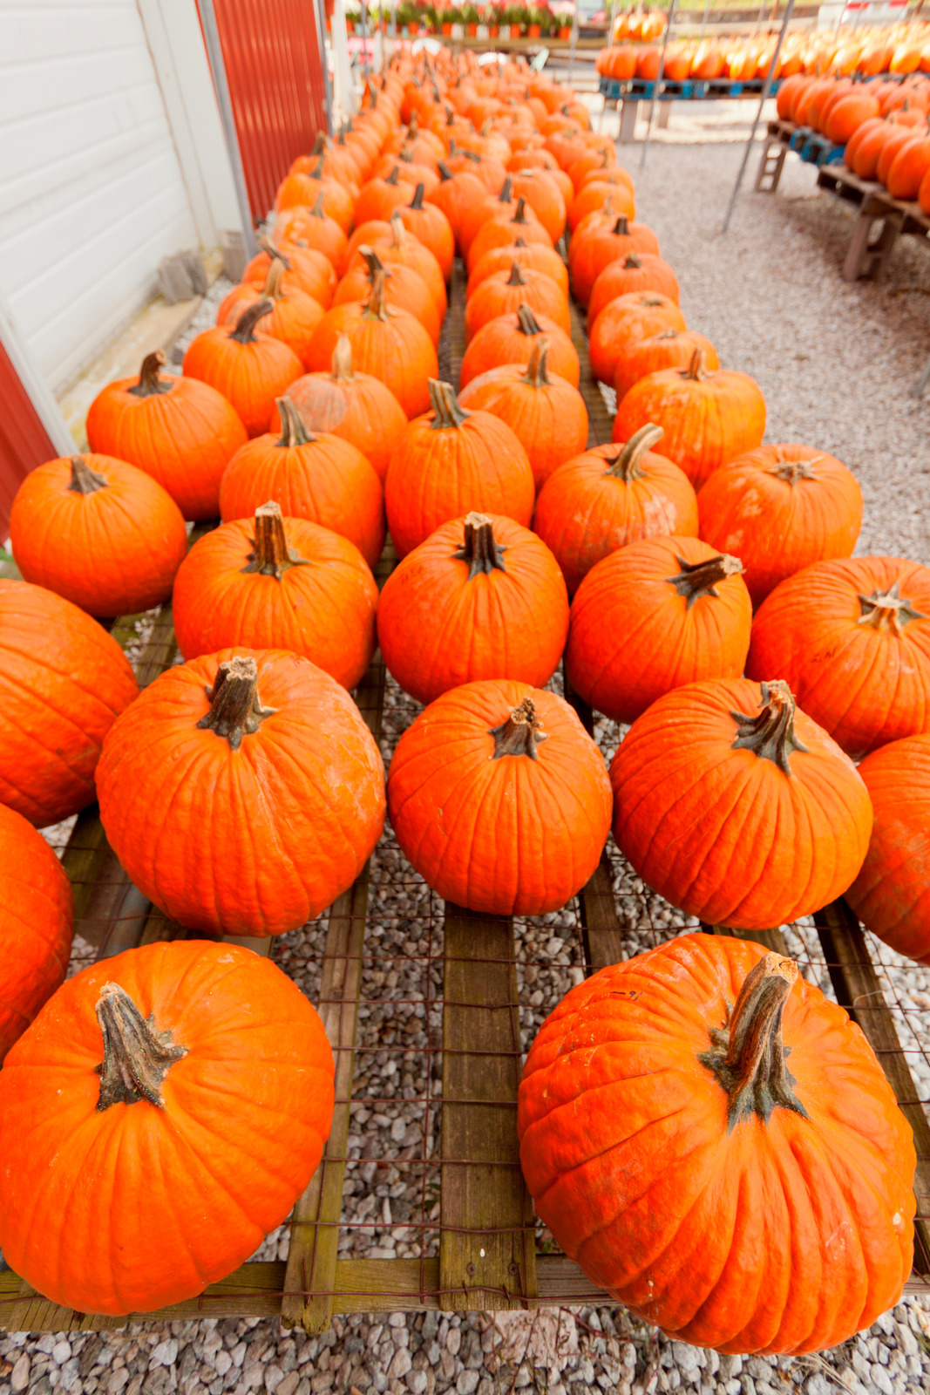

White pumpkins

Carved pumpkin

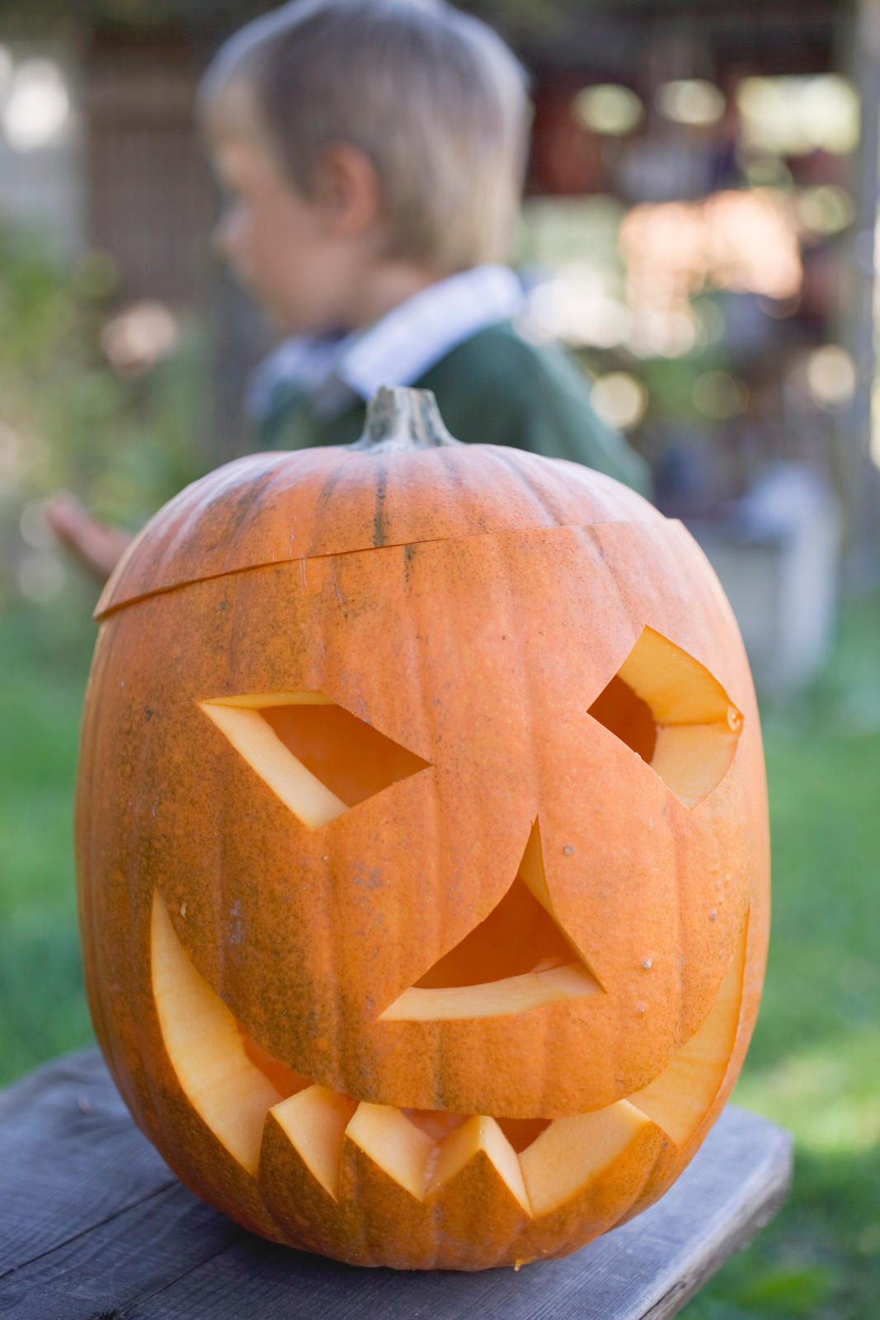

Pumpkin pie

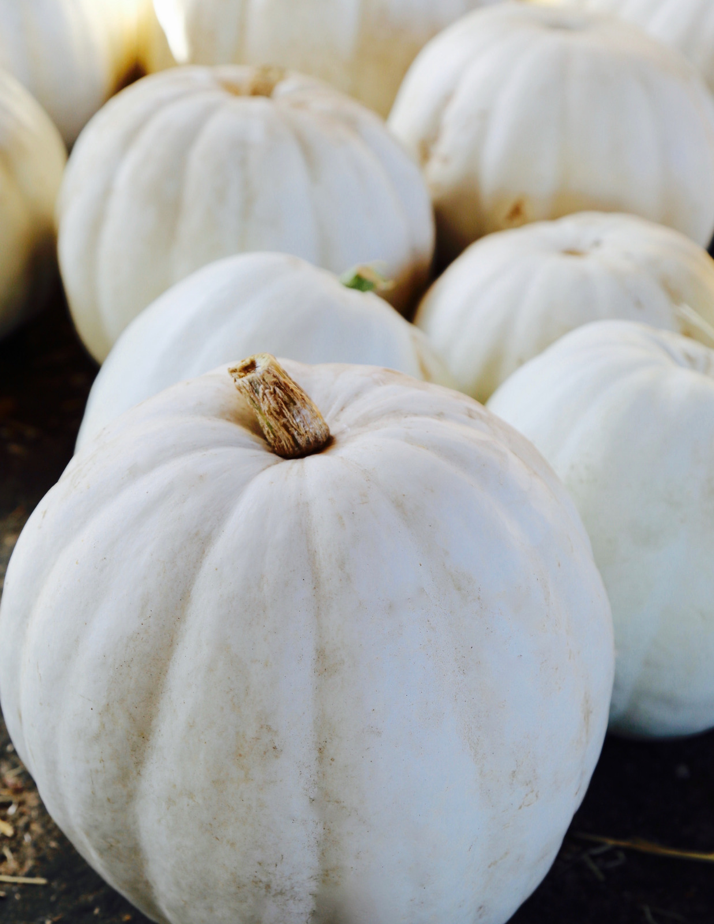
Orange pumpkins

Name _________________________________________ Date_______________________
Draw a line to match the same picture.

Use this picture for the tallying and bar graph activity.
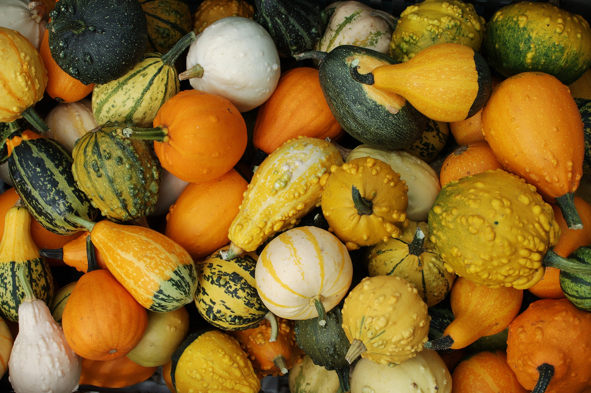

Name _____________________________________ Date__________________________

Tally Sheet for Pumpkins!

Orange ___________________________________________

White ___________________________________________

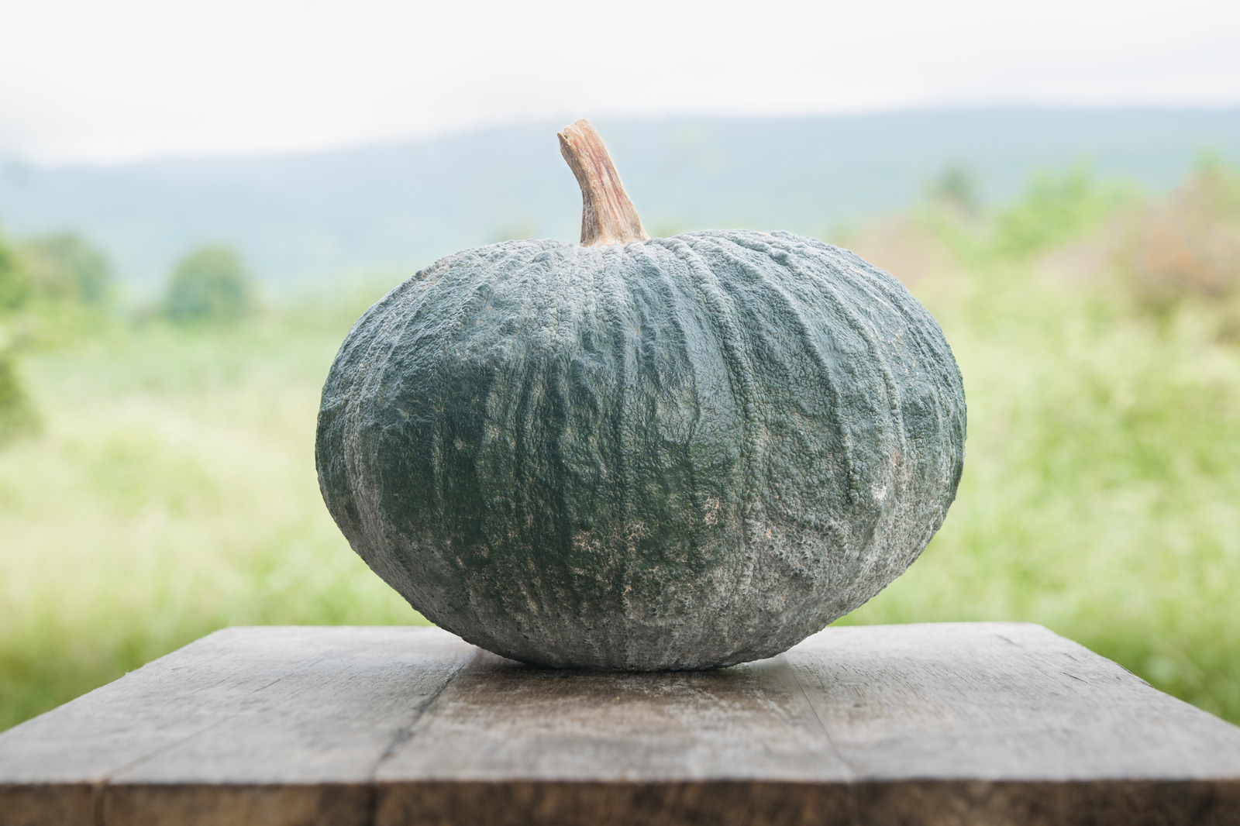
Green ___________________________________________

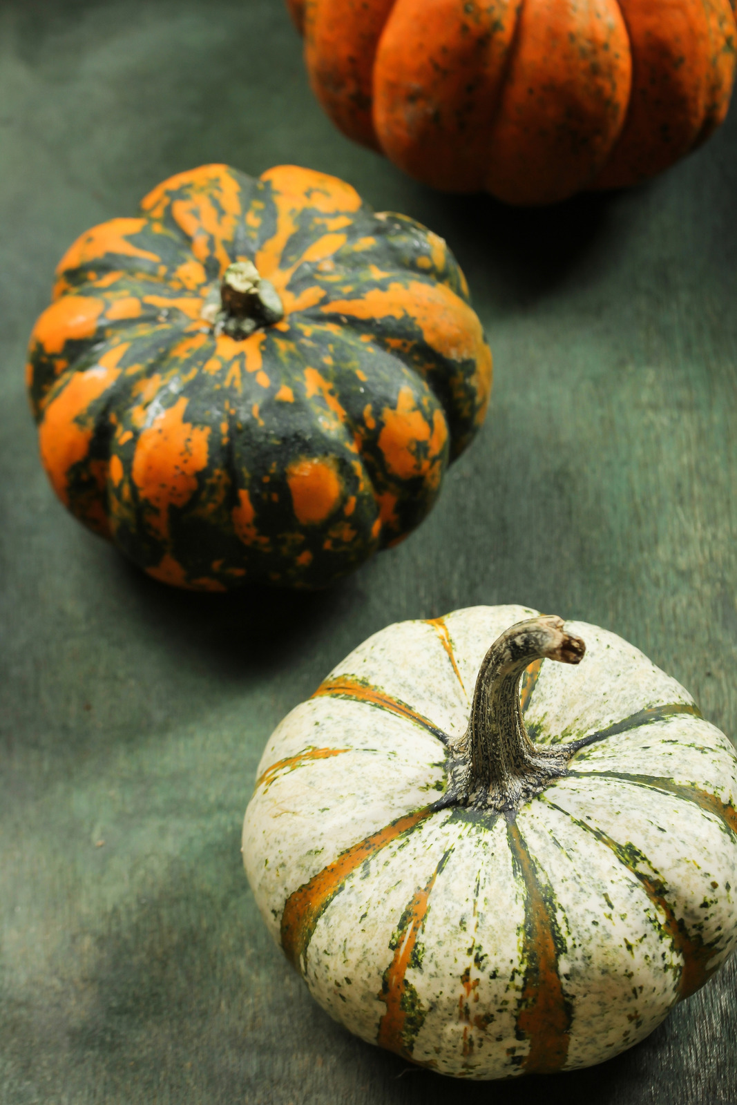
Mixed __________________________________________

Pumpkin Bar Graph
17

16

15

14

13

12

11

10

9

8

7

6

5

4

3

2

1

 | Orange | White | Green | Mixed

Name_______________________________________ Date________________________
Write 3-5 sentences about the picture.




