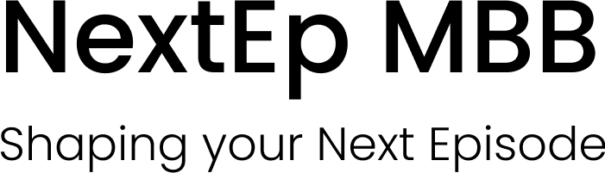
Cover letter template
BEFORE STARTING
Thank you for choosing this book as part of your preparation.
If you want to keep sharpening your skills with short, practical tips straight to the point, join our FlashTipsfree insights delivered to your inbox to help you stay sharp between practice sessions.
Scan the QR code to join:
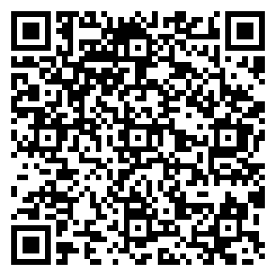
Join FlashTips →
Many thanks, and best of luck with your preparation!

INTRODUCTION

This Cover Letter template is built to help you write a one-page document that stands out. The format is already setfont, size, spacing, and structure, so you can concentrate on the story you want to tell.
The template guides you to answer the three questions firms care about most: Why Consulting, Why This Firm, and Why You. By following this approach, your letter will be concise, personalized, and aligned with what consulting recruiters value.

WANT TO TAKE YOUR PREPARATION FURTHER?
Visit our complete guide on the NextEp website, where you’ll find complete recommendations, examples, and tips to write a Cover Letter that truly stands out.
Full Name
[School] Candidate 20[…] | […]@gmail.com
[Address], Country | +49 […]
Hiring Manager
McKinsey & Company
[TBD]
80333, Munich, Germany

Dear Sir/ Madam,

[WHY CONSULTING] – [3-4 lines].

[WHY YOUR FIRM & OFFICE] – [4-6 lines]

[WHY ME – 3 reasons (optional)] – [4-6 lines]

[CLOSURE] – [2 lines]

Sincerely,

[Name and signature]

THE PREP PLATFORM
Everything it takes to get the offer
Seven steps, from your CV to the final round. The whole method in one place, in the order that actually matters. The only thing left is the work.
Why buy one book at a time? On the Prep Platform you get every book, every audio lesson and every practice tool in a single access, organized as the seven steps of the process. You always know what comes next.
What will you find inside?
• 36 documents, 22 practice cases, 10 practice tools and 8 audio lessons, all organized step by step.
• 6 books with 750+ pages of theory and exercises.
• 27 realistic test exams: the nine firms, with the real clock and the real marking.
• 45 framing exercises: warm ups, openings and solutions for every case type.
• 4,000+ math drills across sixty progressive sessions, plus a generator that never repeats.
• 400+ practice items across the ten tools: exhibits, data requests, closings, industries and FIT.
• All in one place and it keeps growing while you are inside.

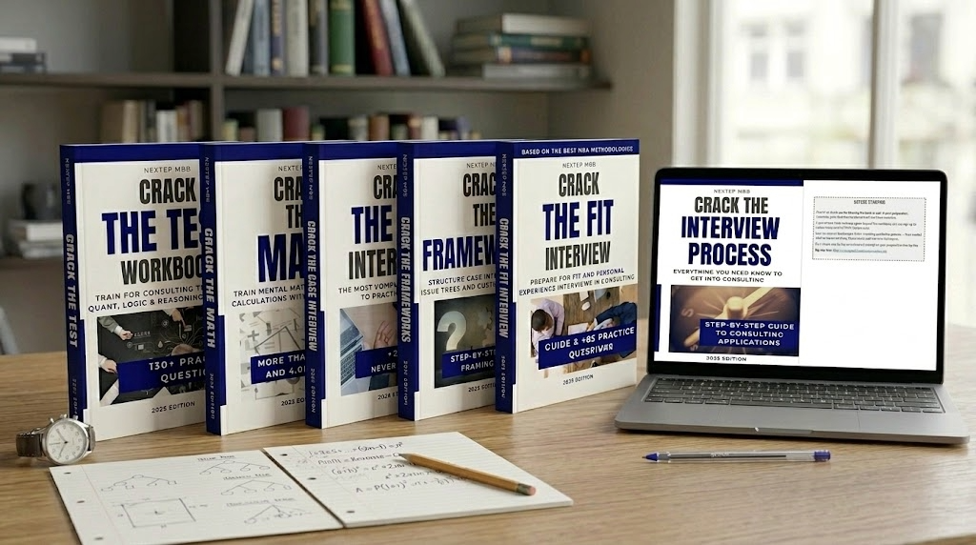 | GET IT NOW  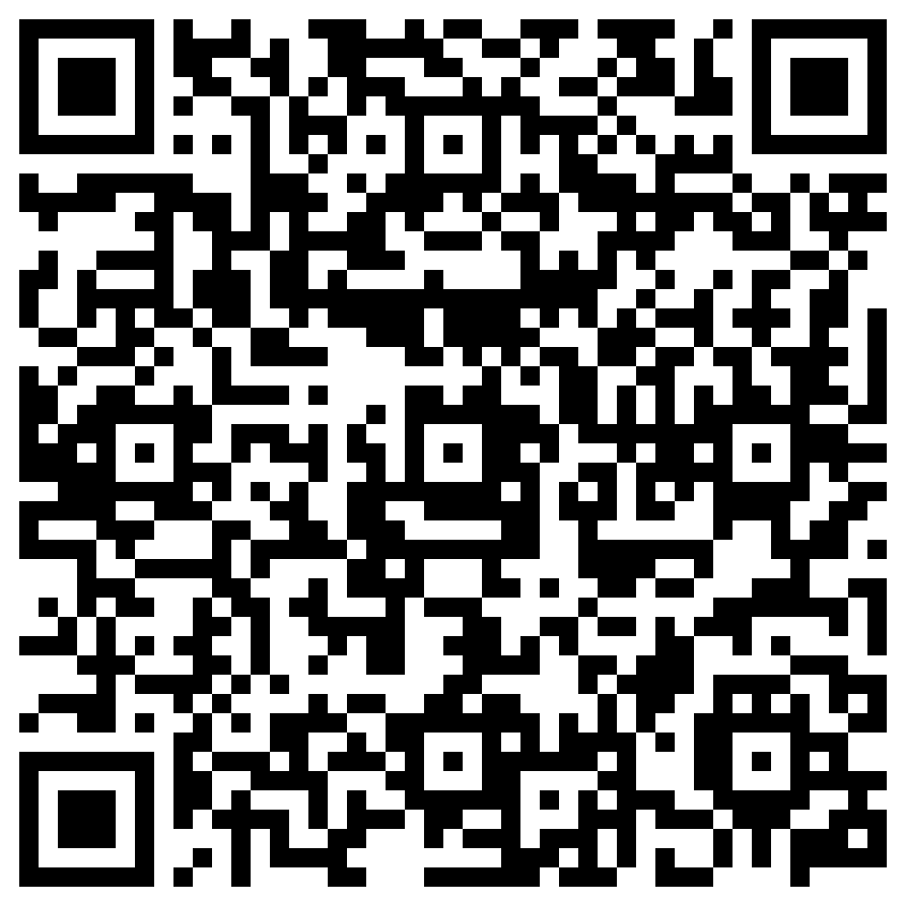  From $49 USD  One-time payment · 15% off with code READER15
nextepmbb.com/en/prep-platform
All of it for less than two of the books cost separately.
Join our FlashTips: short, practical insights to improve every day:
Join FlashTips →

Got feedback for future editions? Share it here:

Send feedback →

