
Curriculum Vitae template

BEFORE STARTING
Thank you for choosing this book as part of your preparation.
If you want to keep sharpening your skills with short, practical tips straight to the point, join our FlashTipsfree insights delivered to your inbox to help you stay sharp between practice sessions.
Scan the QR code to join:

Join FlashTips →
Many thanks, and best of luck with your preparation!

INTRODUCTION

This CV template is designed to help you create a consulting resume that meets the standards of top firms. It provides a ready-to-use formatwith font, size, spacing, and layout already defined, so you can focus on the content rather than the design.

With this structure, you will learn how to frame your achievements in an output-driven way, highlighting leadership, analytical skills, and measurable results.

The goal is simple: a CV that passes the screening filter and captures the recruiter’s attention.

WANT TO TAKE YOUR PREPARATION FURTHER?

Visit our full guide on the NextEp website, where you’ll find detailed advice, examples, and additional resources to strengthen your consulting CV.

COMPLETE NAME
[…]@gmail.com / +34 [[…]

SUMMARY
As a final-year student of Industrial Engineering at […], I am pursuing a career in a top-tier firm to have the opportunity to work in a dynamic environment that requires a high level of determination. Passionate about creating value for companies that are making the world a better place. I am self-managed but a team player and a hard worker, always looking to go the extra mile.

EDUCATION

[…] Madrid, Spain
Bachelor’s Degree in Industrial Engineering September 20[…] – Present
- Annual course completion – Currently enrolled in the fourth year
- […] oriented track
- Advanced extracurricular course in […]
- Associations: Active Member of […]

Courses at […] New York and Toronto, USA
Immersion in American Education 20[…] & 20[…]
- […] College 3-month program. English, entrepreneurship, and leadership
- University of […] 3-month summer program. English & Sport

[…] Barcelona, Spain
High School Education September 20[…] – June 20[…]
- Technological High School Diploma – Final Grade 9.6/10
- High School Graduation Project – CUM LAUDE 10/10

[…] Barcelona, Spain
University Entrance Exam July 20[…]
- Final Grade 9.2/10

PROFESIONAL EXPERIENCE
[…] (Spanish company dedicated to the development of real estate promotions) Barcelona, Spain
Summer Intern Summer of 20[…]
- Provide support and assistance to the engineering team, including fieldwork and site visits.
- Perform auxiliary tasks for […].

[…] Barcelona, Spain Support assistant September 20[…] – June 20[…]
- […]
- […]

LANGUAGES
SPANISH: Native / ENGLISH: High – Intermediate / FRENCH: Intermediate

VOLUNTEER EXPERIENCE
- Regular attendance at charitable actions at […]
- Assistance in event coordination for […]
- Regular contributor to […]

OTHER ACTIVITIES
- Instructor at […]
- Advanced User of Matlab, Excel, GAMS, AutoCad, Programing language C++
- Sport: Captain of […]
- Other areas of interest: traveling, embracing new cultures, a bias for action, family & friends first.

THE PREP PLATFORM
Everything it takes to get the offer
Seven steps, from your CV to the final round. The whole method in one place, in the order that actually matters. The only thing left is the work.
Why buy one book at a time? On the Prep Platform you get every book, every audio lesson and every practice tool in a single access, organized as the seven steps of the process. You always know what comes next.
What will you find inside?
• 36 documents, 22 practice cases, 10 practice tools and 8 audio lessons, all organized step by step.
• 6 books with 750+ pages of theory and exercises.
• 27 realistic test exams: the nine firms, with the real clock and the real marking.
• 45 framing exercises: warm ups, openings and solutions for every case type.
• 4,000+ math drills across sixty progressive sessions, plus a generator that never repeats.
• 400+ practice items across the ten tools: exhibits, data requests, closings, industries and FIT.
• All in one place and it keeps growing while you are inside.

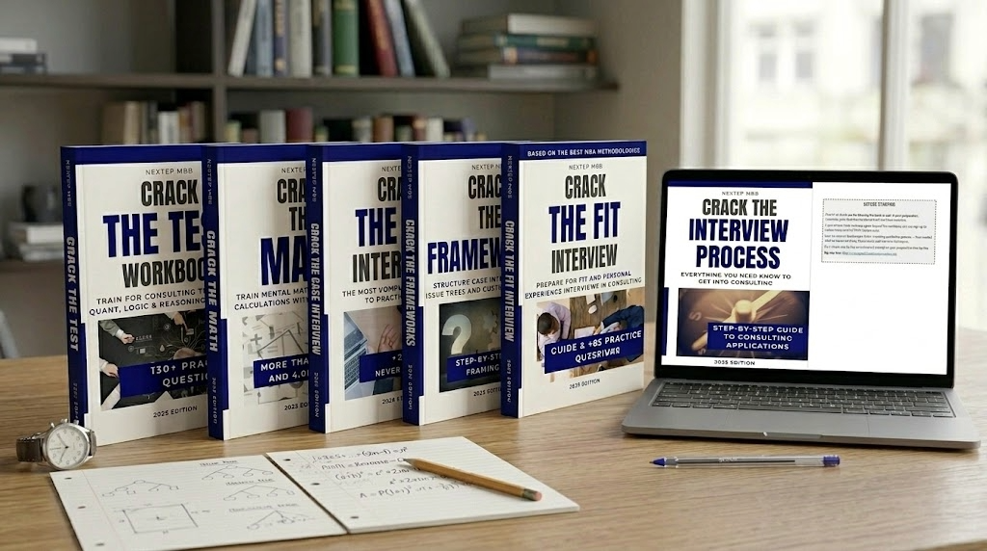 | GET IT NOW    From $49 USD  One-time payment · 15% off with code READER15
nextepmbb.com/en/prep-platform
All of it for less than two of the books cost separately.
Join our FlashTips: short, practical insights to improve every day:
Join FlashTips →

Got feedback for future editions? Share it here:

Send feedback →

