CRE DealPRO Mastermind Questions: 072526

Marty C., FL
(JV)
I am a member of your JV Partner Program. I have successfully completed all the training, been to every zoom call and have started working the program. I have found commercial properties that meet the programs criteria. I have submitted one LOI that was not accepted.
Problem. I do not feel confident that I can determine estimated yearly rent in my area.
For example, here are four actual square foot rental charges for three properties and real estate brokers averages of rents in my area.
Property A: $55.00 per square foot.
Property B: $36.00 per square foot.
Property C: $ 27.00 per square foot.
Brokers claim and I concur that the area is really growing. Their consensus is that commercial rents are $45.00 per square. This area, Port Saint Lucie Fl., is the second fastest growing city in the state and the fifth fasted growing city in the country. This is per the last census.
Based on this information what would you determine the estimated yearly rent should be? Love you guys! 10:01am

Abdul A., Detroit MI
NEW (JV)
Hi Cherif. I have a question about the business credit strategy you taught using Certificates of Deposit.
I watched the training again, and I think I understand the mechanics, but I feel like I'm missing a critical piece. As I understand the process: 10:09am
1. Form an LLC (or C-Corp) and open a business bank account.
2. Use a personal credit card (for example, $25,000) to inject capital into the business.
3. Deposit that $25,000 into the business account.
4. Purchase a $25,000 Certificate of Deposit (CD) at Bank #1.
5. Borrow 100% against that CD and receive a $25,000 cashier's check.
6. Take that cashier's check to Bank #2, purchase another $25,000 CD, then borrow against it again.
7. Repeat this process through several different banks.
8. At the last bank, use the final $25,000 loan proceeds to pay off the original personal credit card that funded the entire process.
If I've understood the process correctly, my confusion is what happens next. Once the credit card has been paid off, I would now have several CD-secured loans outstanding at different banks. Even though each loan is fully collateralized by its respective CD, the loans still require monthly payments.
My question is: Where does the cash flow come from to service those loans during the first six months while you're building the business credit profile? In other words, if the final cashier's check was used to pay off the original credit card, I don't see where the money comes from to make the monthly loan payments until the banks are willing to extend unsecured business lines of credit.
Is the expectation that the business already has operating income, the borrower contributes additional cash each month, the loans are structured in a way that minimizes or defers payments, or is there another step in the process that I'm missing?
Also, is this strategy still viable today? I know the training was recorded a few years ago, and I'm wondering whether banks still allow this type of CD-secured lending in the same way, or if underwriting practices have changed.
I feel like I'm understanding about 95% of the strategy, but I'm missing the piece that explains how the debt is serviced during those first several months. I'd really appreciate it if you could clarify that. Thank you!

Basil G, NY
(JV )
- We’re currently blasting out a property we have under contract and have gotten a lot of feedback from tenants/tenant reps regarding purchasing the property. Can we just assign the property over to them if we agree on a price? 10:13am
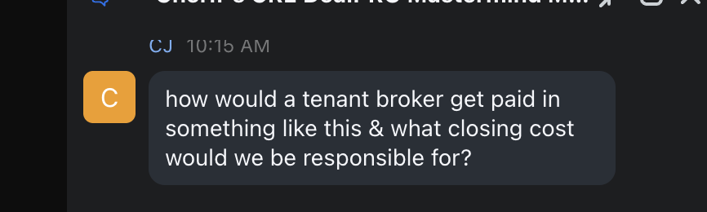10:16 am
- How often do you use option agreements when negotiating with a seller. If so is the due diligence the same process? 10:17am (Due diligence is everything….) great reel about WEDDINGS and into RE
- We live in new york and there are always tons of mixed use retail spaces available for lease in the city. We have been considering trying to sub lease these spaces to potential tenants. What are your thoughts on something like this and how would the broker(s) be compensated ? 10:20am
- Some tenants want to knock down buildings that are over 20 years old even if they’re renovated. How are you negotiating these with sellers to make the numbers work for a possible BTS ? 10:22am (Demoralize the seller- bring them to reality)
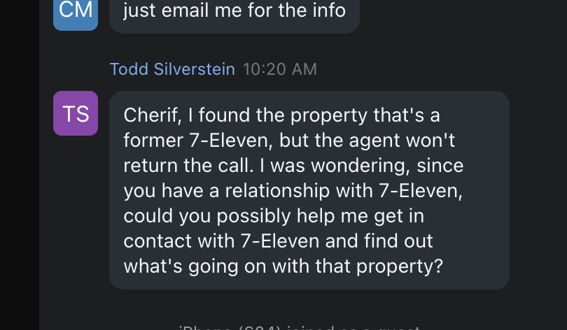
Ishon M, FL
(JV Rockstar)
1. I'm working on a Bank deal that is Outparcel to a Publix that has a bidding process due in August (So nobody has it under contract yet). I reached out to a potential national tenant about it and they say they are working with a developer to transition this Bank into an urgent care. Would it be smart to get it under contract and then go back to the tenant and or developer? The Bank's broker believes it will sell for 1.4M-1.5M and they want a 10% deposit and 30 days for Due Diligence and 30 days to close. 10:25am

2. Would like to discuss this deal and get your thoughts (see attached.) It is a Walmart outparcel. The site FL 33823 (owner would not sell the property) is a small 0.15 acre lot with a car dealership paying $2400/mo. and the tenant would sell the business for 100k. The land behind it is 1.05 acres (Walmart owns it) and it is for sale for 200k. Can I purchase the back parcel and have a big national tenant come in and develop and do a lease then sublease on the front parcel for a big spread? 10:26am (lease-sublease) (assembly deal) When you cut this reel cut out Todd’s blank space and focus on Cherif and Ishon.
3. How does the transactional funding work? 10:30 am

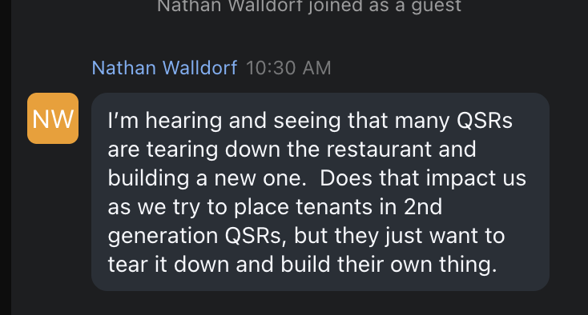10:38 am

Deek X., TX
- What type of questions should you ask when loaning a partner on a real estate deal or a bridge loan? Can this type of deal be done without a lawyer? 10:39am
What are the 3 Cs on loaning??
- When should an investor set up a fund? What are the signs in your business or the mile markers to aim for? 10:44am great clip for CTC He repeats it at 10:47aam
Pablo M., PD
(CRE DealPRO- Uncle knows you from bank, he is a retired CRE Mortgage Broker)
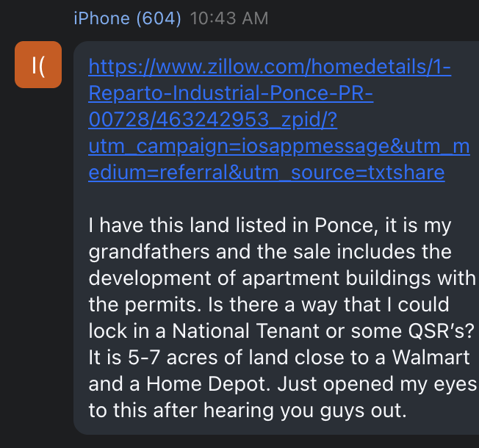 10:49am
1. When do you know is the perfect time to start a Real Estate Fund? I have been very interested in that model but the problem on Puerto Rico is mostly deal flow. Wanted to know if there is another way to capitalize on creating a Real Estate Fund here on Puerto Rico and use it to fund other RE projects from other people? Wanted to see your take on the different routes that can be pursued with the Real Estate Fund to see if it would be a good fit for me on my position. 10:52am

2. Also, would love to see your take on PR Real Estate and where do you think it is heading and the opportunity that you see here. 10:54am AGE aggressive pursuit…. 11:01am

Gigi R., GA
(Potential Fund Manager)
Discuss the different ways to look at a deal or a contract or negotiating. Can you show sample contracts? 11:04am GREAT REEL. Break it in sections as we don’t want to give it all away. This should be a video that we say type OPTION for the other 2 sections. This should be a lead gen. THEN WE have a CTA to join the August 8 CRE DealPRO to cover a SUBLEASE Agreement,
Then we can sell a $97 guest pass and utilize the Try Before You Buy campaign. A full marketing funnel
11:20 match their pace- negotiating

Salvador M., CN
(CRE DealPRO)
I have watched most of your youtube channel and I find your thoughts impactful and impressive. I have a few questions based on my fave videos.

1. What is success according to you and your life and experience? 11:31am great reel
2. How do you use Ai? 11:36am The 4 things Cherif uses Ai
3. What is risk and what are 5 ways to avoid it or handle it in RE? 11:43am FORMULA OF RISK, 6 Principles
4. I have a dinner meeting with my boss next week. Any words of advise? 11:46 am Business, Dinner Meeting & Personal Dinner scenarios

 AJ will set up private call

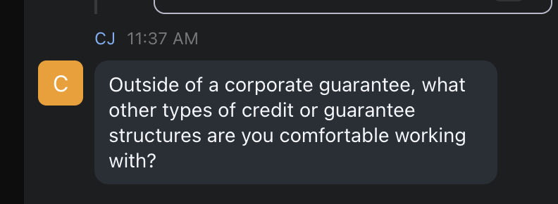 11:40am
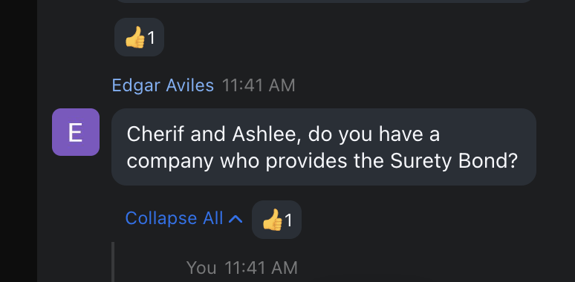 11:42am

CHERIF’s FINAL TOPIC IN CLOSING:

Cherif’s PHILOSOPHIES ON NEGOTIATING
Cherif’s NEW philosophy on “Structure” vs “Strategy”
How to work your money
You need intelligence and capital, but what about "networking". Explain.

