CSEC HUMAN & SOCIAL BIOLOGY
Homework Assignment 3
Section B: Nutrition
1) a) Complete the table below:
Nutrient | Main Sources | Function | Deficiency Disease
iron | Spinach, liver | Makes haemoglobin in red blood cells | anaemia
Vitamin A | Cod liver oil, carrots, spinach | Maintains healthy mucous membranes and allow night vision | Night blindness
Vitamin C | citrus fruits, green leafy vegetables | Strengthens immune system, for wound healing | scurvy
Vitamin D | Butter, sunlight, animal fats | Needed for the absorption of calcium | rickets
- marks)

b) Calculate the BMI of a man who is 1.86m tall and weighs 105kg. Show the formula used. Based on a BMI chart, is the man underweight, normal weight, overweight or obese? (2 marks)
BMI: Weight (kg)/height²(m)
105kg/(1.86m)² = 30.35 Based on the BMI chart, the man is overweight.
2 a) Make a labeled drawing of a tooth showing its structure and layers. (5 marks)
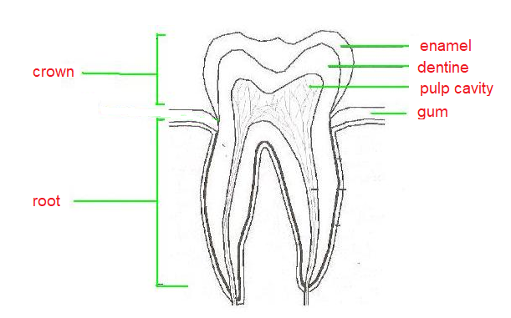
b) Outline TWO ways to take care of your teeth and suggest the main nutrients necessary for strong, healthy teeth. (4 marks)
Two ways to take care of teeth are brushing with toothpaste and flossing. Also using mouthwash and taking regular visits to the dentist for checkups. Main nutrients needed for healthy teeth include calcium, phosphorus, protein, magnesium and Vitamin D.
c) Discuss the consequences of poor dental care. Include an explanation of how a person may develop a toothache. (3 marks)
If you do not take proper care of your teeth, plaque and oral bacteria can build up and contribute to tooth decay. A toothache develops when the bacteria feeding on the sugars on the teeth produce acids that degrade the enamel of the tooth forming a cavity. Overtime this cavity can reach the dentine and the pulp where the nerves and blood vessels are. When the hole forms in the pulp, the nerves are exposed to conditions such as cold and hot temperatures and the individual can experience greater sensitivity and pain.

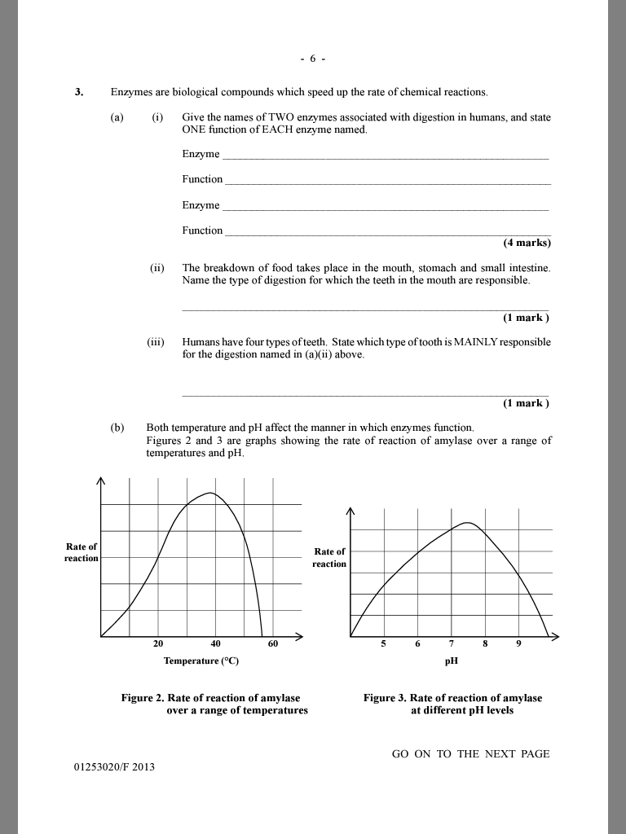

Amylase
Speeds up the breakdown of starch into maltose
Pepsin
Speeds up the breakdown of protein into peptides

Mechanical digestion

molars

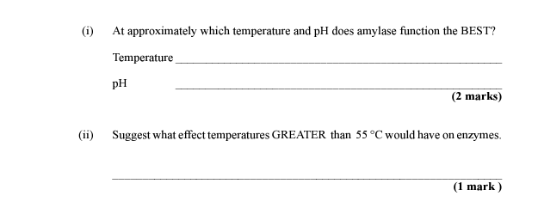

38° C
7.5

Enzymes become denatured at high temperatures.
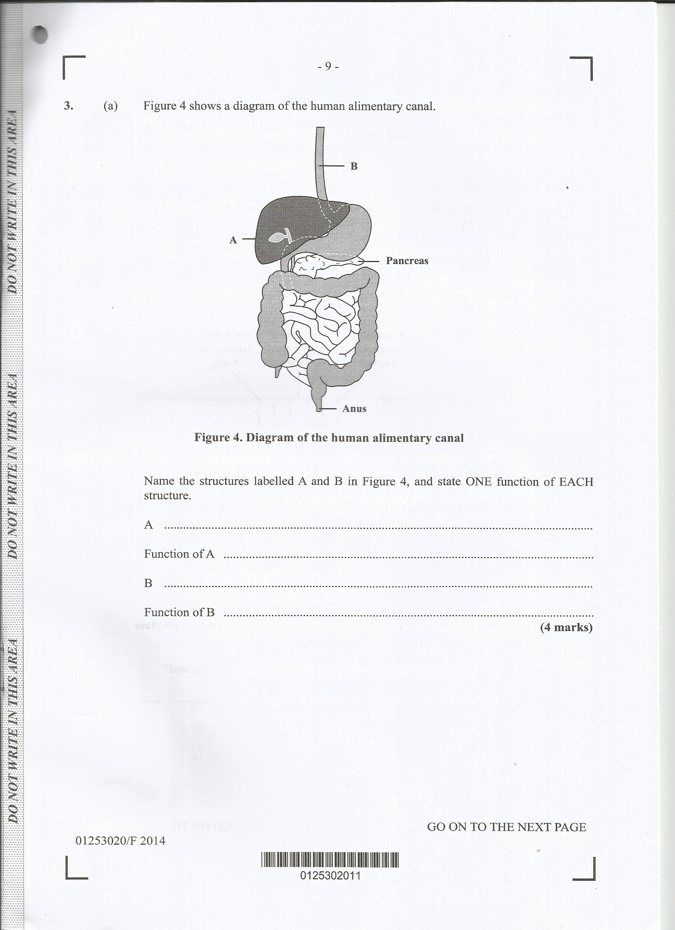
4)

Liver
Processes nutrients, toxic substances and makes bile
Oesophagus
Long muscular tube taking bolus of food from throat to stomach
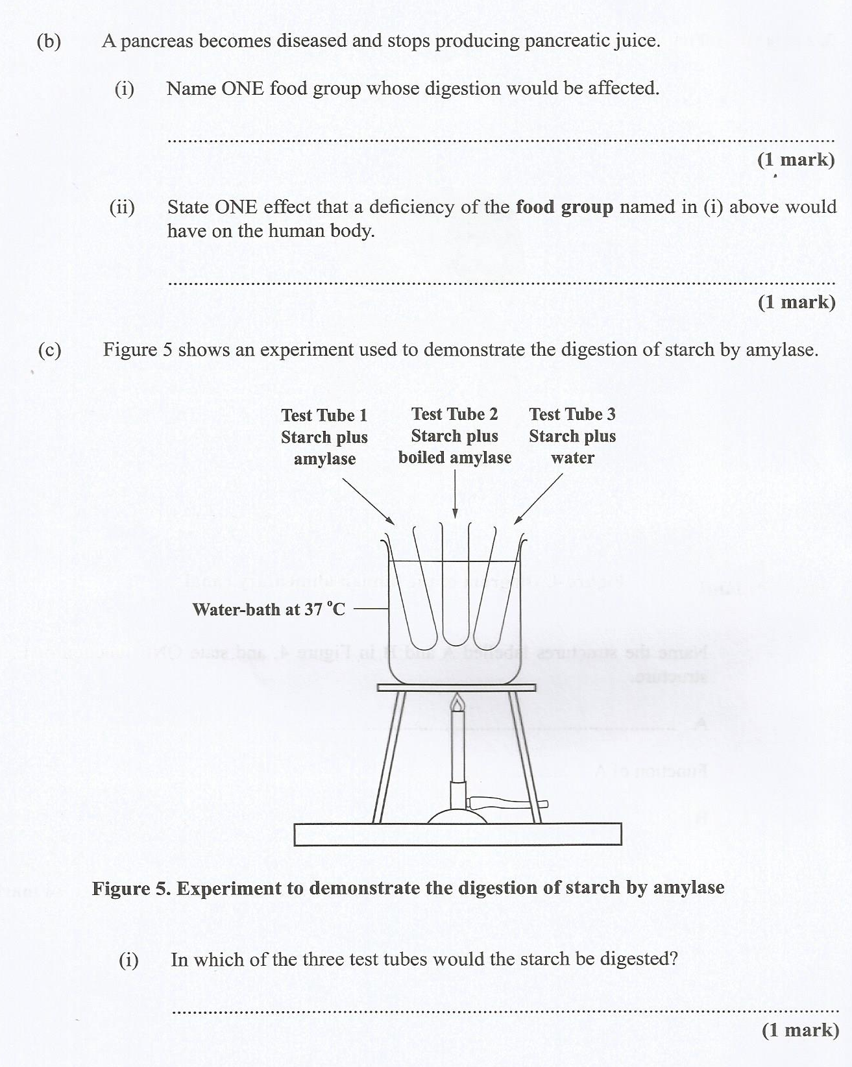

Staples OR food from animals OR fats

Reduced energy levels. Staples are rich in carbohydrates, the energy rich nutrients

Test tube 1

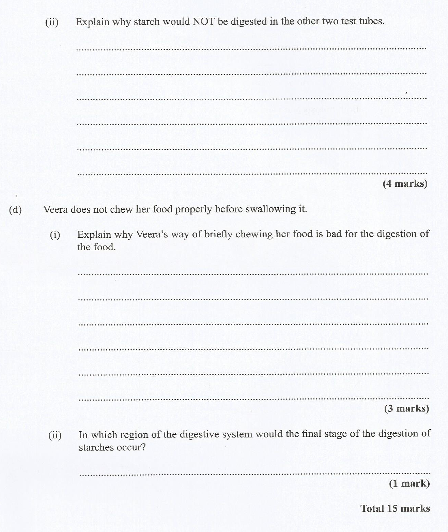
Test tube 2 has in starch and boiled amylase. Amylase that is heated/boiled will be denatured and will not function. Therefore starch will not be digested in test tube 2.
Test tube 3 has starch and water. Water alone cannot digest starch. The enzyme amylase is needed.

Chewing food properly is important for the food particles to be broken down by teeth into small pieces (mechanical digestion) and saliva in the mouth can mix with food particles to help with swallowing and digestion by enzymes (chemical digestion) Enzymes operate best to break down large nutrients into smaller nutrients when the food particles are smaller.

The stomach also has to work harder to churn and mix large particles of food.

Small intestine

TOTAL MARKS: 50

