Christmas Art Licensing Proposal Demo
About This Class
Art licensing work is a bread-and-butter job for most graphic designers, and the process is surprisingly manageable. The objective for this class is to witness and learn the real process, from concept to print. This class is only about 1 hour long, and in the hour you will learn how an experienced designer would take on the challenge of creating a seasonal Christmas line of products, beginning with illustration and ending with mock-ups for several products. I literally go through this real-world process with you, as this is a project I am currently working on.
With that in mind, this project is one of the most delightful examples of seasonal content for Christmas. Learning a few skills with insider tidbits, you can easily pull this off! I use Procreate for most of this class, with the last lesson on mockups done in Photoshop. This is my preference, but you can definitely do the entire project in Procreate if you so choose. I will teach you how I go about fulfilling the requests of a client. This class is suitable for someone who has design skills and a basic understanding of Procreate, so let’s plunge in and get this project started!
In this class I’ll walk you through:
- my step-by-step method for taking a seasonal artwork and applying it to different products
- tips for creating compositions for a varied and appealing design using brushes
- my workflow for use of layers and other great features like snapping
- adjusting designs to perfect the flow and adding elements in the second iteration of the design
- methods for keeping the design fully editable for later adjustments and/or recoloring

If you’re an aspiring designer with a good basic knowledge of Procreate, you’ll be able to go through all the steps. This class will benefit anyone who wishes to simplify creation of designs for art licensing.

The key concepts I will include:
- review of my methods and adjustments in Procreate, including the use of adjustments like hue and saturation and curves
- a look at Procreate layering techniques and the use of masks and clipping masks
- approaches you can take in your creative work

This is an ideal class for you, even if you are not sure what you will use the art for, whether it be the design for products you will sell for POD, or to submit for art licensing! Learning new Procreate workflows is always desirable. I guarantee you will create something really appealing. It’s like doing a puzzle, and you will get the hang of it after a little bit of practice!
Intro to Christmas Art Licensing Proposals Demo
This short intro will give you an overview of the class.

Lesson 1: Discussing the Overview and Objectives
In this lesson, I will show you the objectives for class and explain that this is a real-time project that I am working on for an art licensing contract. I pepper the class with anecdotes from my agent, as well as from the client.

Lesson 2: Creating the Deer Silhouette
In this lesson, I will break down the process of producing a silhouette from a photograph. I discuss brushes with you and give you a general explanation about the project at hand.

Lesson 3: Clipping Masks vs Alpha Lock Pros and Cons
In this lesson, I will explain the two different methods I tried for adding the motifs to the deer silhouette. I discuss the pros and cons of each. Then you can watch as I go through and add motifs. I explain how to colorize motifs as well, in this lesson.

Lesson 4: Plaid Border, Frame and Wood Background
This is the lesson in which I teach you about creating the seamless tile for the plaid. This will enable us to do the plaid border. Then I show you how to insert the wood and put a red border around that. I have a few tips and tricks to share in this process.

Lesson 5: Adding Details for Interest
In this lesson, we are getting to the finish line for the border. You will see me use several different techniques to add interest and detail. I show you the brushes I have created, and I explain the settings and how to use automatic selections and fill in some of the motifs with color. Throughout the process you learn much more.

Lesson 6: Final Pattern Testing and Correcting
At this stage, we pull our layout together, and I will correct the small details that make it work. I show you the type tool in Procreate and explain why I switch to Photoshop at this stage.

Lesson 7: Conclusion, Mock Up and Next Steps
We will conclude everything in this lesson where I show you a quick mock-up with the napkin design and we end with a chat about next steps.
Concepts covered:
Concepts covered include but are not limited to Procreate pattern design, layering, transparency, Procreate brush stamps, Procreate canvas settings, Procreate snapping and guides, art licensing, working with an agent, marketing and promotion for artists, creating original brush stamps in Procreate, the Brush Studio in Procreate, adjusting Procreate brushes, sizing of documents and brushes, compositions with brush stamps, adding texture brush stamps, procreate brushes for adding interest, workflow best practices, Procreate composites, quick tracings of photos, techniques with paints and blending, importing into Photoshop, creating mockups, and much more.
You will get the bonus of…
- 1 hour of direction from an instructor who has been in graphic design business and education for over 40 years
- knowledge of multiple ways to solve each design challenge
- an outline with links to further research
- a list of helpful online sites to further your education into surface pattern design

Project Description
Your project for today’s class is to create a seasonal artwork. It doesn’t need to be for Christmas. Pick any season and try to come up with motifs that could complement it. Also, create a quick plaid to use as a background or border. I can visualize a cute pink and soft blues and green plaid border for Easter or spring! Now create an appealing product. Start with something simple like a mug or a floor mat. Show it on a mock-up or two. Good luck and have fun with it. You will now have a wonderful new piece for your portfolio.

IMPORTANT INFO FOR UP AND COMING DESIGNERS:
- Building a body of work with a consistent, signature style is the best way to become recognized.
- Things may not happen quickly but keep moving forward with your skills.
- You must be willing to build your portfolio and be a versatile and willing participant in your journey.
- Remember that “overnight” success is a myth. Even the great graphic design artists out there had to start somewhere. Research as many as you can and heed their advice. Their stories can be really inspirational. Start with teachers such as Shannon McNabb. Shelley Seguinot, Bonnie Christine, Sandra Bowers, Jamie Bartlette, Mel Armstrong and Elizabeth Olwen, and others, too numerous to mention. Try ALL the techniques until your find one that is just right for you.
- Most artists take several years to build a successful business. Take the steps necessary to get there. Take as many courses as you can! Carve out a small portion of each week dedicated solely to educating yourself.
- Publish in as many venues as possible. Start building your passive income streams, like Creative Market, Zazzle, Red Bubble, Society 6, Art of Where, etc. Open online-stores and keep fresh art going on to your products on a regular basis. Test. Test. TEST!
- Experiment until you find what works for you and your particular style of art.
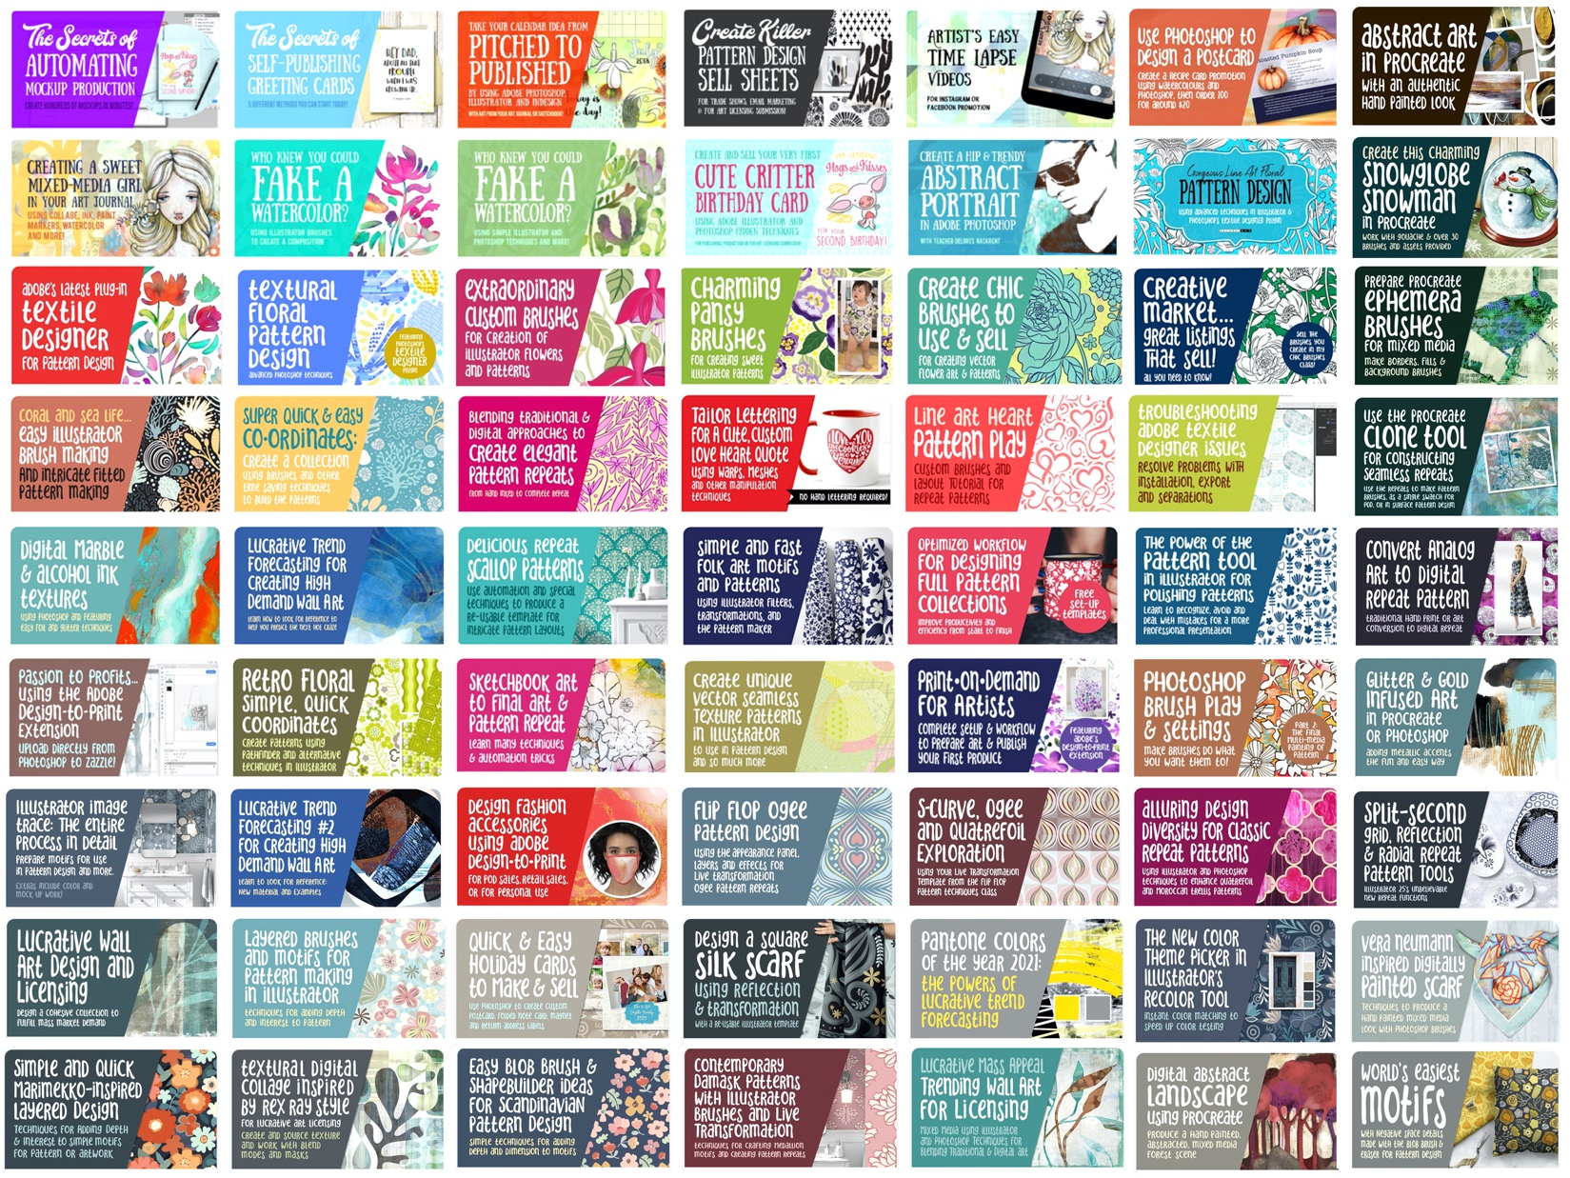
- You must be patient and keep your nose to the grindstone. Make progress and keep your mind and heart open! Good luck!
Follow me and check out my Pinterest pages
Deloresart - Delores Naskrent and Teacher Delores Naskrent for tons of resources for artists!

Find me at deloresartcanada on both Instagram and facebook and join my mailing list on my store site at deloresart.ca



