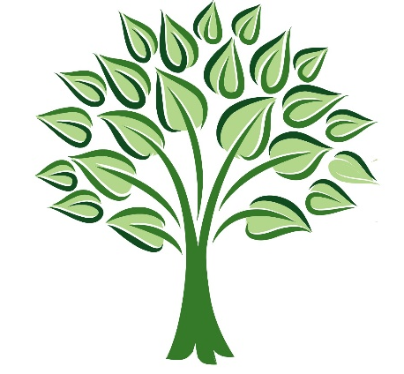

10 STEPS TO FINANCIAL FREEDOM
Get to know Yourself

Word Template: This resource is in a word format for you to easily edit and personalise it:
Finding your full identity is a lifelong process that will take many years, but as you implement and develop what you already know, the rest starts to flow and the journey becomes easier
You do not have to have everything on the table to start
JUST START!
Write down everything you know about yourself and what you have heard others say. Use the headlines in this document to guide you and to get the process of discovering flowing.
Ponder and meditate on each headline, ask to Holy Spirit what He says about it. Also, research and use all the powerful tools available on the internet to help you identify you`re personality trades, spiritual gifts, love languages etc.
Be creative and enjoy the process, make it part of you MoneyWise Lifestyle. Set yourself calendar reminders to remind you to write about yourself, at the beginning not less than once a week and thereafter say once a month. Don’t spend more than one hour per session to do this, you will find that this process of discovering can become very tiring and it drains a lot of energy out of you, emotionally as well as physically – be kind to yourself- this is not a race and there are no demands or deadlines, rather it is just a commitment to start to love yourself by spending time with yourself.

TIP: Ask your spouse to assist, they know you better than you think, but be warned! You must have the right attitude if you ask for their assistance, if you are going to perceive their inputs as criticism and if you don’t take criticism very well, rather let them complete the form on their own and then you can have a look at what they are saying on your own. It is important to involve your spouse(and other people who are close to you and know you well) so rather change your attitude about it and do it in good humour and good faith. – The truth will set you free !
Getting to know myself
Date:
My name:

My surname:

The meaning of my name:(If you don’t know the meaning of your name or surname, research it on Google)

The meaning of my surname:

My personal Vision

My personal Mission

My Why?

My What?

My How?

My personality style:

D – ______%
I – ______%
S – ______%
C - ______%
(Google: Free DISC personality testing)
My personality structure:
I am task orientated ____ % vs people orientated ____%
My task execution:

Structured ____% vs Unstructured ____%
My relationships:
Structured ____% vs Unstructured ____%
My 5 strongest personality trades:

My 5 weakest personality trades

My passions: (one or more)

My other qualities that I am aware of: (one or more, as many as you can think of right now)

My brain capacity: (Once again do a Google search to find a tool suitable to you but be careful don’t waste your time on this you can get lost in time and the results isn`t of big significance – you are clever enough!)

My spiritual gifts: (strongest to the weakest expressed in %)
_____________________– ____%
_____________________– ____%
_____________________– ____%
_____________________– ____%
_____________________– ____%
_____________________– ____%
_____________________– ____%
_____________________– ____%
_____________________– ____%
_____________________– ____%
My name that the Lord is calling me by, and its meaning: (if you are not aware of a specific name that God is calling you by, ask Him to reveal it to you through His spirit)

Scriptures about my calling: (one or more or as many as you have)

My prophecies: (one or more or as many as you have)

My love languages: (Google the 5 Love Languages by Gary Chapman)

Some general questions:

Who am I in my spirit?

Who am I in my soul?

Who am I in my body?

How I want to live

Do I want to study?

What do I want to study?

Am I still dreaming?

What am I dreaming about?
For myself?

For my spouse?

For my children?

My interests

What are my hobbies?

Do I spend enough time on my hobbies?

When last did I go on holiday?

Where do I want to go on holiday?

How many times per year do I want to go on holiday?

Who do I want to take on holiday?

What car am I driving?

The car I would like to drive

Where I am staying

Where I want to stay

Do I like to travel?

How I would like to travel?

Am I traveling enough?

Am I spending enough time with my kids?

What would I like to change with my parenting style?

As mentioned in the intro this document is a means and to awaken what is inside of you. There is no wrong or right answers, the purpose of this exercise is to get to know yourself.
Feel free to change to order of the headlines, changes the headlines or ad new headlines. You can throw out all the headlines and just write out everything that comes from within you. Just let it flow bring it all to the outside, good and bad!
Build on the good and deal with the bad!
Everything you will ever have is already inside of you, only you can discover it and bring it to the surface, to have it manifest on the outside.
For you to get it out of you need to know who you are, what is your identity?
Once again revert to bonus, one and two about identity. Also have another look at Bonus 4 Dealing with disappointment
Study into yourself and grow out of yourself: From the inside out!
Enjoy the journey and remember to set reminders to continue writing a book about yourself.
Take action: Diaries one hour with yourself to in a weeks’ time sit with yourself and continue this process of discovering

